**Introduction**

* Importance of the mismatch between emergence of spruce budworm from hibernaculum and budburst of host trees
* The “time window of food quality”: the budworm can wait some time for the budburst, while the opposite is not true (if emergence occurs too late, food quality drops sharply, which affects survival and/or development and/or reproduction)
* Effects of temperatures on both processes
* Possible impacts of global warming

**Methods**

The model investigates the mismatch between spruce budworm emergence from hibernaculum and host tree budburst. Both processes are temperature-dependent. Two models are run independently. The first one represents spruce budworm development until emergence from hibernaculum. The second model represents host tree development until budburst. Then, we look at the mismatch between predicted emergence date and predict budburst date.

**1. Development models**

**1.1 Spruce budworm development**

Overwintering stage (*L2o*) spends several months in diapause within its hibernaculum. Daily temperature (*xt*) at any time (*t*) affects instantaneous development rate (*rt*) (Régnière et al., 2012).

|  |  |  |
| --- | --- | --- |
|  | $$r\left(t\right)=\left\{\begin{aligned}β_{1}\left[\frac{1}{1+e^{β_{2}-β_{3}^{τ}}}-e^{(τ-1)\backslash β_{4}}\right], if T_{b}&≤x_{t}≤T_{m} \\ 0, & otherwise\end{aligned}\right.$$ | (1) |

where

|  |  |  |
| --- | --- | --- |
|  | $$τ=\frac{x_{t}-T_{b}}{T_{m}-T_{b}}$$ | (2) |

Development is integrated through time:

|  |  |  |
| --- | --- | --- |
|  | $$R\left(t\right)=\int_{t_{0}}^{t}{r\left(t\right)}dt$$ | (3) |

where *R(t)* is cumulated development at time *t*. Accumulation starts at time *t0*, which is arbitrarily set at September 1st.

|  |  |  |
| --- | --- | --- |
|  | $$R(t_{0})=0$$ | (4) |

Development is completed once:

|  |  |  |
| --- | --- | --- |
|  | $$R(t_{e})=1$$ | (5) |

where *te* is time of emergence from hibernaculum.

**1.2 Host tree development**

We use a published model (Chuine, 2000). Tree accumulates forcing (heat) units *Rf(xt)* according to temperature (*xt*) at any time *t*:

|  |  |  |
| --- | --- | --- |
|  | $$R_{f}(x_{t})=\frac{1}{1+e^{b_{f}(x_{t}-c_{f})}}$$ | (6) |

Forcing unit accumulation writes:

|  |  |  |
| --- | --- | --- |
|  | $$F(t)=\int_{t_{1}}^{t}{R_{f}(x_{t})dt}$$ | (7) |

Accumulation begins at a given time *t1*, which is posterior to January 1st (Desbiens, 2007), when it is assumed that trees have accumulated enough cold to end bud dormancy:

|  |  |  |
| --- | --- | --- |
|  | $$F(t_{1})=0$$ | (8) |

Budburst occurs when *Ft* reaches a threshold (*F\**):

|  |  |  |
| --- | --- | --- |
|  | $$F(t_{b})≥F^{*}$$ | (9) |

which determines time of budburst (*tb*).

**1.3 Mismatch between emergence and budburst**

The model computes the mismatch between the day of emergence from hibernaculum (*te*) and the day of budburst (*tb*):

|  |  |  |
| --- | --- | --- |
|  |  | (10) |

A sensitivity analysis was done on both models (budworm model and tree model) using Partial Rank Correlation Coefficient associated with Latin Hypercube Sampling (Wu et al., 2013). Results for this analysis can be found in appendix 1.

**2. Parameters estimation**

**2.1 Spruce budworm model**

The budworm model requires six parameters (*β1*,*β2*, *β3*, *β4*, *Tb*, and *Tm*). They have been estimated in Régnière et al. (2012). Their values can be found in table 1.

**2.2 Tree model**

The tree model requires four parameters (*t1*, *bf*, *cf* and *F\**). They have been estimated for Balsam fir, which is one of the preferred hosts of the budworm, using a documented database (Desbiens, 2007). The database gives information on phenological status of Balsam fir in 1304 sites located across the provinces of Quebec and New Brunswick (Canada). Sites were visited several times to observe phenological stages of the trees. Since budburst occurs over a few weeks among trees, the date of budburst was set as the date when 50% of trees showed budburst. Hence, the model predicts the mid-budburst period.

The mid-budburst period was determined on the data using a linear interpolation. Then, parameters of the Chuine’s model (2000) were computed using an optimisation algorithm (Nelder and Mead, 1965). Residuals were analysed in order to check for the quality of the fitting: residuals were checked for normality, and also for presence of a potential latitudinal trend.

**3. Temperature data**

We collected temperature data from the regions used to fit the tree model. We selected sites located from 44.5° N to 49.5° N, with regular latitudinal interval. In order to keep altitude variance as low as possible, sample sites were selected at different longitudes (fig. 1).

We used daily temperatures collected during a 20-years time interval (1996-2016) to predict the emergence, budburst, and mismatch between emergence and budburst at each location and for each year. We used predicted temperatures at the same locations for a 75-years time interval (2016-2100) according to three different scenarios for global warming (RCP2.6, RCP4.5 and RCP8.5). These temperatures were used to predict how emergence, budburst and mismatch would evolve through time.

***Upon success***

* *We fitted parameters of the tree model for white spruce: a second important host for SBW*
* *Since the two hosts may react differently to climate change, so will do the mismatch between SBW and the two hosts*

**Results**

**1. Parameter estimation**

Fitting values of the parameters for the tree model can be found in table 1. The residuals follow a normal distribution (fig. 2A). No obvious latitudinal patterns can be identified on the residuals (fig 2B), which means that the model has similar accuracy across the whole range of latitudes considered.

**2. Variation od emergence, budburst and mismatch across latitude**

**2.1 Spruce budworm**

* emergence vary with latitude (i.e., temperature regime)

**2.2 Balsam fir**

Latitude (i.e., temperature regime) affects budburst date. Hence, as one moves Northern, budburst occurs later in the year. On average, a 10-days difference in budburst date is expected between Northern and Southern sites (fig. 3).

**2.3 Mismatch**

**3. Predicted emergence, budburst and mismatch under global warming**

* Both budburst and emergence vary with latitude (i.e., temperature regime), but in different ways
* Thus, the mismatch between budburst and emergence varies
* The “direction” of the mismatch (which event comes first: budburst or emergence) seems to vary with latitude, which is likely to have consequences on budworm survival
* Prediction through warming scenarios: an increase in temperature seems to increase the mismatch with Balsam fir, especially in Southern sites (budburst would occur two to three weeks after emergence)

# Discussion

* We apply the model on other sites across Canada (outside of the provinces where tree data were collected) in order to investigate a wider latitudinal gradient. Budworm populations are assumed to be homogenous due to dispersal events. However, it may not be the case for tree populations. We predicted the same trends but amplified as one move Northern.
* If the mismatch between the budworm and its host (Balsam fir) increases with climate change, then the budworm may switch to another host (e.g., black spruce)

**Appendix 1: sensitivity analysis**

## **1. Spruce budworm model**

## **2. Tree model**

Sensitivity analysis shows that the model is mostly sensitive to parameters *t1* and *bf* (fig. A2).

**Appendix addendum:**

In case of linear temperature:

x(t) = x0 + x1 t

Let’s define:

$$\left\{\begin{aligned}A=e^{b(x_{0}-c)} \\ B=bx_{1}\end{aligned}\right.$$

Then,

$$R\left(x\left(t\right)\right)=\frac{1}{1+A e^{Bt}}$$

We can find the antiderivative of *R(x(t))*:

$$\frac{d}{dt}\frac{-1}{B}\ln\left(e^{-Bt}+A\right)=\frac{1}{B}\frac{Be^{-Bt}}{e^{-Bt}+A}=\frac{1}{1+Ae^{Bt}}$$

Then,

$$\int_{t_{0}}^{t^{*}}{\frac{1}{1+A exp⁡(Bt)}dt=-\frac{1}{B}\ln\left(\exp\left(-Bt^{*}+A\right)\right)+\frac{1}{B}\ln\left(\exp\left(-Bt_{0}+A\right)\right)=F}$$

Solving for *t\**:

$$\ln\left(e^{-Bt^{*}}+A\right)-\ln\left(e^{-Bt_{0}}+A\right)=-BF$$

$$\ln{\frac{e^{-Bt^{*}}+A}{e^{-Bt_{0}}+A}}=-BF$$

$$\frac{e^{-Bt^{*}+A}}{e^{-Bt_{0}}+A}=e^{-BF}$$

$$e^{-Bt^{*}}+A=e^{-BF}(e^{-Bt_{0}}+A)$$

$$t^{*}=-\frac{1}{B}ln⁡(e^{-BF}\left(e^{-Bt_{0}}+A\right)-A)$$

Replacing for *A* and *B*:

$$t^{*}=-\frac{1}{bx_{1}}ln⁡(e^{-bx_{1}F}\left(e^{-bx_{1}t_{0}}+e^{b\left(x_{0}-c\right)}\right)-e^{b(x_{0}-c)})$$

$$t^{*}=-\frac{1}{bx_{1}}ln⁡(e^{-bx_{1}\left(F+t_{0}\right)}+e^{b\left(x_{0}-c-x_{1}F\right)}-e^{b(x_{0}-c)})$$

# References

Chuine, I., 2000. A united model for budburst of trees. J Theor Biol 207, 337–347. https://doi.org/10.1006/jtbi.2000.2178

Desbiens, M., 2007. Relation phénologique entre le débourrement des bourgeons chez le sapin baumier et l’émergence des larves de deuxième stade de la tordeuse des bourgeons de l’épinette, Choristoneura fumiferana (Lepidoptera: Tortricidae). ProQuest.

Nelder, J.A., Mead, R., 1965. A Simplex Method for Function Minimization. Comput. J. 7, 308–313. https://doi.org/10.1093/comjnl/7.4.308

Régnière, J., St-Amant, R., Duval, P., 2012. Predicting insect distributions under climate change from physiological responses: spruce budworm as an example. Biol. Invasions 14, 1571–1586. https://doi.org/10.1007/s10530-010-9918-1

Wu, J., Dhingra, R., Gambhir, M., Remais, J. V., 2013. Sensitivity analysis of infectious disease models: methods, advances and their application. J. R. Soc. Interface 10, 20121018. https://doi.org/10.1098/rsif.2012.1018

**Table 1**: Parameters values

|  |  |  |
| --- | --- | --- |
| Parameter | Value | Reference |
| *β1* | 0.194 | Régnière et al., 2012 |
| *β2* | 3.0 | Régnière et al., 2012 |
| *β3* | 5.94 | Régnière et al., 2012 |
| *β4* | 0.034 | Régnière et al., 2012 |
| *Tb* | 2.5 | Régnière et al., 2012 |
| *Tm* | 35 | Régnière et al., 2012 |
| *t1* | 84 |  |
| *bf* | -0.1936 |  |
| *cf* | 10.99 |  |
| *F\** | 13.63 |  |

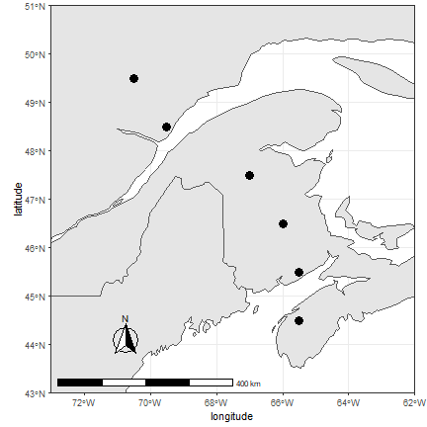

**Figure 1**: Localisation of sample points for which temperatures were estimated in the past and the future to run both budworm and tree models. Dark points are the different sites used across Canada. They range from 44.5° N to 49.5° N, with regular latitudinal interval. Sample sites were selected at different longitudes in order to keep altitude under reasonable variation.

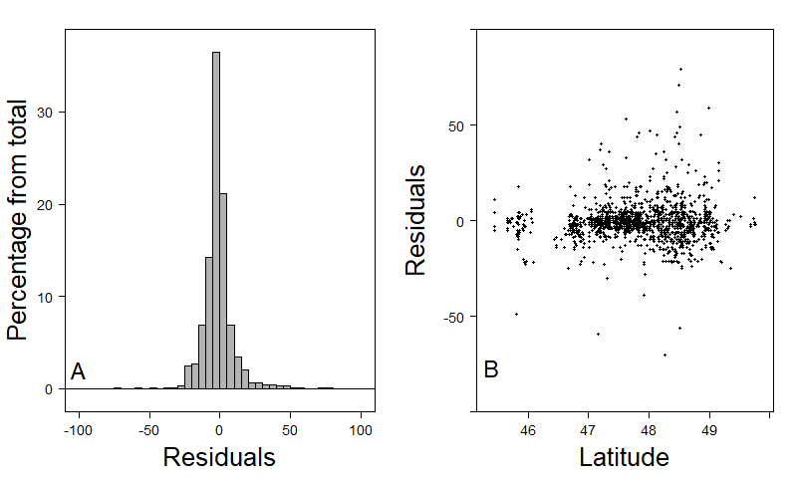

**Figure 2**: histogram of the residuals (A) and scatter plot of residuals across latitude (B). The histogram shows the residuals seem to follow a normal distribution. Residuals do not show any particular latitudinal pattern (despite a few outliers).

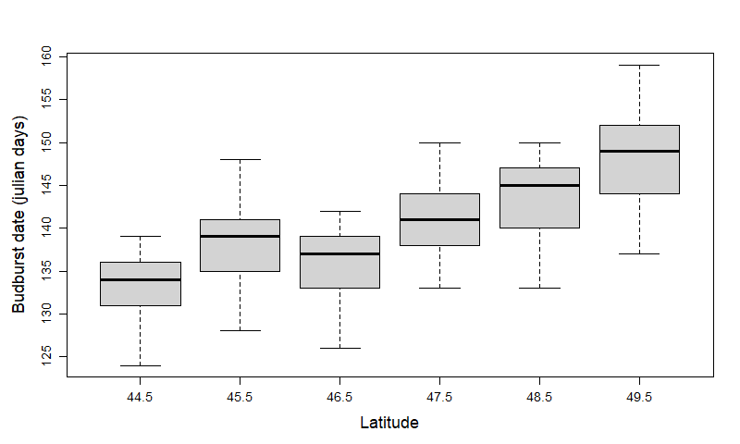

**Figure 3**: predicted date of budburst across latitude (44.5° to 49.5° N) on the Canadian East coast over a twenty years period of time (1996-2016). Budburst is expected to occur about 10 days later in Northern sites compared to Southern sites.

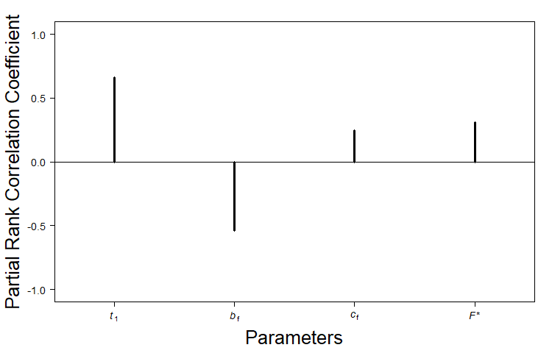

**Figure A2**: Sensitivity analysis of the tree model. The model is mostly sensitive to parameters *t1* and *bf*.