Potential impacts of climate change on the phenological synchrony between a consumer and its resource: the example of the spruce budworm and its tree host.
Portalier S.M.J., Candau J.N., Lutscher F.

Abstract
Anthropogenic climate change is increasingly affecting species phenology. Because trophic interactions often occur at specific phenological stages, changes in one species' phenology may affect others through phenological mismatch. In the case of a consumer and a resource that both exhibit a seasonal resting period, the synchrony of the end of their respective resting period is fundamental for the persistence of their interaction. Since the consumer and its resource may react differently to a change in temperature regime, the synchrony between them will likely be altered. In this study, we propose a general theoretical model that determines the duration of the resting period according to temperature, and its effects on synchrony or mismatch between phenological stages of two interacting species. We found that an increase in temperature would usually advance the end of the resting period. However, the effects of a warm or cold spell during the resting period would strongly vary according to the time and the duration of the spell. Depending on the way each species reacts to the same temperature shift, the mismatch between the consumer and its resource may increase or decrease. We then illustrate our approach using the spruce budworm – balsam fir system in eastern Canada as a case study. Our model predicts that an increase in temperature may increase the mismatch between the insect and the tree in southern sites, but may increase the synchrony in northern sites. This type of modelling approach is of prime importance to investigate potential effects of climate change on consumer – resource systems as the study of synchrony between interacting species is fundamental to predict future species distribution.
Keywords:
Balsam fir, consumer, climate change, phenology, resource, spruce budworm

1. Introduction
Anthropogenic climate change has increasingly disrupted ecological interactions for the past century (IPCC 2014 and references within). It is expected that this trend will continue and amplify as interacting species are likely to respond differently to similar environmental changes and selective pressures (Parmesan, 2006). Trophic interactions between consumers and resources, which are fundamental to the functioning of ecosystems, may be affected by climate change through: (1) direct changes in life history traits (e.g., fecundity, mortality) of the consumer and/or the resource (Bale et al., 2002), (2) changes in the abundance of the consumer and/or the resource due to cascading effects from higher or lower trophic levels (e.g., changes in the consumer’s predators or competitors) (Both, van Asch, Bijlsma, Van Den Burg, & Visser, 2009), and (3) differential shifts in the phenology of the consumer and/or the resource leading to phenological mismatch (Kharouba et al., 2018).
The concept of phenological mismatch has evolved since its inception in the early 1990s and is still debated today (e.g., Singer & Parmesan, 2020’s response to Kharouba & Wolkovich, 2020). In its stricter, original form, it states that the recruitment of a consumer is high if the most energy expensive part of its life cycle is in synchrony with the peak availability of its resource (Cushing, 1990). It was later extended to the case where both the phenologies of the consumer and resource varied (Visser & Holleman, 2001). The concept also assumed that maximum fitness of the consumer is achieved at phenological synchrony, i.e., when the most energetically demanding period of the consumer perfectly overlaps the peak resource availability. However, recent observations suggest that this might not be the case in some systems for which phenological mismatch is the historical baseline (Singer & Parmesan, 2010). Historical mismatch can result from trade-offs between fecundity and mortality (Singer & Parmesan, 2010), mutualistic interactions (Forrest & Thomson, 2012) or intraspecific competition (Iwasa, Odendaal, Murphy, Ehrlich, & Launer, 1983). Relaxing the assumption of baseline synchrony complicates predictions of potential climate change impacts. Indeed, if synchrony is the baseline, any differential change will be detrimental to the consumer’s fitness. If the baseline is a mismatch, a change that decreases asynchrony will likely be beneficial to the consumer while the opposite might exacerbate the detrimental effect of asynchrony to the point of extinction of the consumer (Singer & Parmesan, 2010).
Many organisms have advanced their phenology in recent decades (Post, et al., 2001; Parmesan & Yohe, 2003), particularly the timing of spring events at mid-high latitudes (Parmesan, 2006 ; Thackeray et al., 2016; Cohen et al., 2018). In a meta-analysis of 27 pairs of interacting species, Kharouba et al. (2018) found that phenology advanced by an average of 4 days/decade across species since the early 1980s. Interacting species were found to have advanced their phenology by similar magnitudes, resulting in relatively small (6.1 days/decade) but significant increases in mismatch. The observed mismatch had no consistent direction as 31 interactions shifted closer while 23 shifted further apart. The clearest examples of climate-driven mismatch have been reported for insect herbivores at high altitudes or latitudes (Renner & Zohner, 2018), where many organisms rely on a seasonal resting period because temperatures affecting physiological processes tend to be below species optima for most of the year. After a seasonal arrest in development that can last for several months, synchrony in springtime phenology, particularly between the emergence of phytophagous insects from diapause and the end of their host plants dormancy, is critical to the consumer’s fitness (Van Asch & Visser, 2007). Spring defoliators have evolved to exploit foliage at its annual optimal nutritional qualities, i.e., high concentration in nutrient and water and low concentrations in fibre and secondary metabolites (Hunter & Lechowicz, 1992; Mattson & Scriber, 1987). This strategy requires a precise phenological match between the consumer and its resource because the quality of foliage declines quickly with foliar expansion. If the consumer emerges too early, it may encounter a long initial period with no food or poor food quality. If it emerges too late, the speed at which the nutritional quality of the foliage degrades may outpace the consumer’s capacity to adjust physiologically, thus negatively impacting its fitness.
The seasonal resting phase of many organisms can be divided into two successive stages called endodormancy and ecodormancy in perennial woody plants, and diapause and quiescence in insects (Chuine & Régnière, 2017). Development and metabolism are generally inhibited by internal factors (e.g., depletion of energy reserves, hormones) in the first stage and by external factors (e.g., temperature, photoperiod) in the second one. Our study focuses on a system where the consumer and its resource show a seasonal resting period during part of the year (e.g., during winter). For both, we assume that the first stage of the seasonal resting period is accomplished early in the winter before the return of favourable conditions, a common case in temperate and colder climates, and that temperature is the main driver that triggers the end of the second stage and therefore the resting period. In the remainder of this paper, the expression “resting period” will refer to the second stage of the seasonal resting period.
We are currently unable to predict the direction or the magnitude of phenological mismatch between consumer and resource induced by climate change and the associated risks that it poses to species (Samplonius et al., 2021). In particular, while patterns of change in phenological synchrony as a result of climate change are observed at an increasing rate (Kharouba et al. 2018), they have been difficult to explain mechanistically. Indeed, different mechanisms can lead to a phenological mismatch between a consumer and its resource. Different species can respond to different climatic factors or to the same factor but in a different way. Species can also face different constraints in phenological plasticity (Both & Visser, 2001) or have different costs associated with phenological response (Gienapp & Visser, 2006).
The aim of this study is to investigate potential effects of climate change on the phenological synchrony between a consumer and its resource when both species respond to the same climatic factor (i.e., temperature). The interaction occurs at the end of both species’ resting periods, which is often the case for insect herbivores in mid-high latitudes. We begin with the general theoretical aspects that determine the duration of the resting period according to temperature, and their effects on synchrony / mismatch between phenological stages of the two species. Then we use a major insect pest of the Canadian boreal forest, the spruce budworm (SBW), and its main host, balsam fir, as a case study. We investigate the phenological synchrony between budworm’s emergence from winter diapause and balsam fir’s budburst across a gradient of latitudes and a number of different future climates.

2. Methods
We begin with a unified description of the mechanisms that determine the duration of the resting period of a consumer and its resource in terms of accumulation of ambient temperature. Then we list our data sources and explain the fitting methods for the spruce budworm - balsam fir system.

2.1 Theoretical development
Throughout the resting period, an organism accumulates units of some quantity. The instantaneous rate of accumulation depends on the ambient temperature. The resting period ends when a certain level of the quantity has accumulated. For trees, this quantity can be heat, for example in degree-day models (Colombo, 1998) or more recent nonlinear models (Chuine, 2000; Desbiens, 2007). For insects, the quantity can be the proportion of the corresponding life-cycle stage that they have completed (Cobbold & Powell, 2011; Régnière, St-Amant, & Duval, 2012). Since the development rate is temperature dependent, this quantity ultimately measures accumulated heat. This concept of an accumulating quantity is “still the most important assumption in plant and animal phenology modelling” (Chuine & Régnière, 2017).
We denote time by t in days and temperature by x = x(t) in degrees Celsius. The instantaneous rate of accumulation is some nonnegative increasing function of temperature, denoted by R = R(x). While developmental rates may decrease when temperatures exceed an upper threshold (Deutsch et al., 2008; Amarasekare & Coutinho, 2014), such temperatures do not generally arise during the winter resting period in mid-high latitudes. The resting period begins at time t₀ and ends at time t* when the accumulated quantity reaches the threshold level F. The fundamental equation that connects all these quantities and determines the end of the resting period is
 | 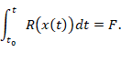 | Eq.
A typical example for the accumulation rate function is the sigmoidal function
 | 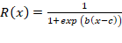, | Eq.
with parameters b < 0 and c (Chuine, 2000; Rebaudo & Rabhi, 2018). When the quantity of interest is the proportion of the life-cycle completed, the threshold level is F = 1. We illustrate the rate function in Eq. 2 as well as the condition in Eq. 1 for two different species and two simplistic temperature time series in Figure 1. As temperature patterns during the resting period change because of climate change, the end time of the resting period of a species may shift. In particular, when temperatures increase, accumulation occurs faster and the phenology advances, i.e., the end time is earlier (Fig. 1D).
The rate accumulation function of a consumer and its resource will generally differ even in the same temperature regime (compare solid and dashed curves in Fig. 1C), which typically leads to different end times of the resting period (bottom right panel). We denote these by t_{e}* (emergence time) for the insect (consumer) and by t_{b}* (budburst time) for the host tree (resource). We call the difference in end times the mismatch between the two species (i.e., mismatch = t_{e}*-t_{b}*). When the end times of the resting period of two species respond differently to climate change, then the mismatch between the two species will change. This is the fundamental quantity that we study here (Fig. 1D).
We use our theoretical model to predict general patterns of climate-change induced shifts in species phenologies and changes in the mismatch between interacting species. We use the spruce budworm and balsam fir system in eastern Canada to illustrate how estimated rate accumulation functions can be applied to different temperature scenarios to investigate how climate change may affect the phenological between these two species.

2.2 The spruce budworm – balsam fir system

2.2.1 Study system
The spruce budworm (SBW) (Choristoneura fumiferana) is the most destructive defoliator of North American boreal forests (Fleming, 2000). It feeds primarily on balsam fir (Abies balsamea), black spruce (Picea mariana), white spruce (Picea glauca), and red spruce (Picea rubens). This univoltine insect has a 8-9 months winter resting period (i.e., diapause). The first stage ends in late winter and is followed by a quiescent period during which development resumes at a rate dependent on outside temperatures. Diapause ends when second instar larvae emerge from their hibernacula (cocoon-like structure) in late April to late May. Larvae feed on expanding buds and developing needles as soon as they become available. Old needles are nutrient poor (Mattson & Scriber, 1987); expanding needles from swelling buds are nutrient rich with a maximum concentration of nitrogen and mineral elements. Hence, the success of SBW populations in establishing feeding sites in the spring depends on the synchrony of their development with that of their host trees (Régnière & Nealis, 2008; Volney & Fleming, 2007). Consequences for late-emerging SBW are severe: larval survival is depressed (from about 60% normal survival down to 10%), development is delayed, and average pupal mass decreases by about 50% for both sexes (Lawrence, Mattson, & Haack, 1997). In the boreal forests of Eastern Canada, the higher vulnerability of balsam fir to SBW defoliation compared to other host species has been attributed to its early budburst phenology (Blais, 1957). The emergence of SBW second instar larvae from their hibernacula generally precedes balsam fir budburst by several days. Balsam fir budburst phenology appears to be related to forcing temperatures but not photoperiod (Osawa, Shoemaker, & Stedinger, 1983).
We assessed historical patterns and climate change predictions of synchrony between SBW’s emergence from diapause and balsam fir’s budburst using an existing model of budworm phenology and a general budburst model fitted to observations of budburst phenology in Canada. Each species has its specific accumulation function. They were used to illustrate the general theoretical case (see section 2.1.2 and Fig. 2).

2.2.2 Phenological model of spruce budworm’s spring emergence
The physiological processes and /or environmental factors that control the termination of the first stage of SBW’s diapause are still unknown. The end of this stage is assumed to occur in late winter (Bean, 1961). For modelling purposes, authors have generally taken March 1st as the start of the quiescent stage (Régnière et al., 2012). Taking an earlier starting date would not affect the predicted date of emergence since temperatures are generally well below the 2.5ºC development threshold prior to March 1st across the vast majority of SBW’s geographical range. The heat accumulation rate during the quiescent stage is defined as (Régnière et al., 2012)
 | 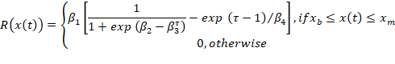 | Eq.
where
 | 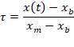 | Eq.
Accumulation occurs only when the temperature lies between a minimal (x_{b}) and a maximal value (x_{m}). Parameter values for SBW, estimated from laboratory experiments, are , , , , x_{b} = 2.5 °C, x_{m} = 35 °C and F=1 (Régnière et al., 2012). The accumulation rate function is increasing for temperatures up to ??? degrees C, which is well within the temperatures observed during the quiescent stage.

2.2.3 Phenological model of balsam fir’s budburst
Processed-based tree phenology models describe the individual or interactive effects of environmental conditions (e.g., temperature or photoperiod) on bud development (Chuine & Régnière, 2017). We use the Uniforc model of Chuine (2000) to model balsam fir’s budburst phenology. Uniforc predicts bud development as a function of temperature in the second stage of seasonal resting (i.e., ecodormancy). The heat accumulation rate is the same as in the theoretical example (see Eq. 2). Accumulation starts some time after January 1st (Desbiens, 2007), when trees have accumulated enough cold to end bud dormancy. Budburst occurs when accumulation reaches a threshold F*.
We fitted the Uniforc model to budburst phenology data collected in the 1980s and 1990s in Quebec and New Brunswick (Desbiens, 2007; Régnière pers. comm. 2020). Each year, bud development was observed in different sites during the growing season at time intervals ranging from two days to two weeks. Budburst occurs when buds develop from class I to II according to the class scheme developed by Dorais & Kettela (1982). The budburst date was defined as the date when 50% of the buds in the site have reached stage II.
We perform sensitivity analysis on both models using partial rank correlation coefficients (Wu, Dhingra, Gambhir, & Remais, 2013).

2.3 Historical and future temperature regimes in eastern Canada
We selected six locations on a latitudinal gradient across eastern Canada (Fig. 3) to explore the effects of various historical and future temperature regimes on the synchrony between SBW and balsam fir phenology. The temperature data for these locations were calculated using BioSIM (Régnière, Saint-Amant, Béchard, & Moutaoufik, 2014). BioSIM interpolates weather station historical data and climate change scenarios across North America. We used data from 1996 to 2016 to explore the latitudinal trends of past insect emergence, tree budburst and their mismatch across years.
Last, we used predicted temperatures under different warming scenarios at the same locations to gain insights in expected trends for emergence, budburst and mismatch in the future. We selected three different scenarios, known as RCP2.6, RCP4.5 and RCP8.5 (van Vuuren et al., 2011). For each scenario, we generated 1200 stochastic temperature time series over the 2001-2100 period.
Both models used temperature data with a four-hour time interval, which allows for the capture of warm events within a day (i.e., a few hours of warm temperatures, while the average daily temperature stays low).

3. Results

3.1 Theoretical results
Model equation Eq. 1 can in general not be solved explicitly for the end time, t*, at least not for realistic temperature time series x(t). Instead, we derive a general approximation formula for how t* changes when future temperature (x₂(t)) time series deviate from historical expectation (x₁(t)) by a small amount (see Supplementary Material). We use this formula to evaluate and discuss the impact of climate change on the phenology of a single species and the phenological mismatch between two species in two particular cases: a constant temperature difference throughout the resting period or a warm or cold spell during a short time period.

3.1.1 Phenology shift of a single species
In the case of a constant temperature difference, we write 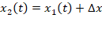 where is the difference. Then the corresponding end times t₂* and t₁* are related by
 | 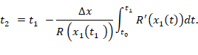 | Eq.
In the second case, if the difference in temperature between two years is a warm or cold spell of short duration at time t_{s} of temperature difference (positive for a warm spell, negative for a cold spell), then the corresponding ends of the seasonal resting phases are related by
 | 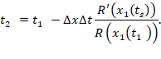 | Eq.
Both formulas show the expected qualitative pattern that if time series x₂ is warmer than x₁, i.e., 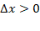, then the phenology advances, i.e., end of the seasonal resting period t₂* is before the corresponding t₁* (since all the terms after the “” sign are positive). More importantly, the formulas allow us to quantify the expected shift of the end time of the resting period. We observe that the shift depends on the derivative of the rate accumulation function. In particular, the impact of a short temperature spell is proportional to the derivative, R'(x(t_{s})), at the time of the spell (t_{s}). Hence, the phenology is most sensitive to warm or cold spells where has its maximal slope. For the rate function in Eq. 2, this occurs at temperature x=c.

3.1.2 Effects on the mismatch between two species
When heat accumulation occurs independently in each species, the mismatch between the two changes, they respond differently to changes in temperature. It is obvious that the mismatch between two species increases if the phenology of the earlier emerging species advances more quickly and decreases if it advances more slowly. Equations 5 and 6 indicate that information about the current phenology (R(x(t*))) and the sensitivity (R’(x(t))) are required to quantify the change in phenology in each species and therefore the change in mismatch.
For a theoretical example, let us consider the scenario that the resource emerges before the consumer and is more sensitive at lower temperatures. Then, if temperatures are higher than historical averages early in the season, the phenology of the resource is likely to advance more than that of the consumer, so that the mismatch would increase. Vice versa, if temperatures exceed historical averages only late in the season, when the consumer is more sensitive, the phenology of the consumer is expected to advance more, so that the mismatch would decrease. Hence, a change in mismatch is most likely if the two species are most sensitive at different temperatures, i.e., when the maximal slopes of their respective rate accumulation functions occur at very different temperatures.
In reality, the periods of high sensitivity of the two species may overlap and the rate functions at emergence time (the terms in the denominators in Eqs 5 and 6) could differ significantly. As a result, the effect of temperature increases depends on details of each scenario. We illustrate this dependence using the rate function 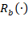 for balsam fir (Eq. 2) and 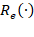 for SBW (Eq. 3) together with a simplified time series of daily mean temperatures as modelled by
 | 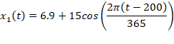 | Eq.
where the mean, amplitude and offset have been chosen to match historical averages in the city of Fredericton (NB, Canada). We denote the end times of the consumer for the time series x_{i}(t) by t_{e,i}* (emergence time) and of the resource by t_{b,i}* (budburst time).
When the future temperature differs from historical expectation by a constant, we use Eq 5 to approximate the advance in phenology. In this simplified model, the end of the seasonal resting period for the resource (consumer) occurs on day 127 (131), the rate curve has its highest slope at 7.14 degrees (19.2 degrees), and the end of the resting period advances by about 3.75 (3.88) days per degree increase in mean temperature. The linear approximation in Eq. 5 captures the actual end of the resting period very well (Fig. 2A). Since the resting period of the resource at historical temperature regimes ends earlier, but advances more slowly with increasing mean temperature than that for the consumer, the mismatch decreases over time. However, the difference is small (0.13 days per degree increase). With this simplified temperature time series, the tree emerges before the insect, whereas in reality the budworm usually emerges earlier. More realistic time series give us the empirically observed pattern (see Section 3.2).
When future time series differ from historical expectation by a short spell of duration and temperature difference , we apply the corresponding formula (Eq. 6) to each species. Then the mismatch changes according to
 | 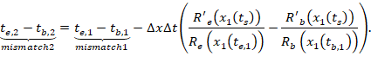 | Eq.
Since the resource emerges roughly four days prior to the consumer under historical expectations in our simplified time series (see preceding scenario), mismatch 1 is positive. The sensitivity of the resource is a relatively narrow peak around the maximum at x=c_{1,} while the sensitivity of the consumer is much broader and peaks at much higher temperatures (higher, in fact, than usually arise before emergence) (Fig 2B). Hence, the phenology of the consumer will advance noticeably no matter when a warm spell occurs, whereas the phenology of the resource will advance noticeably only when it occurs near the temperature x=c1. In addition, the rate function at emergence (the denominators in Eq. 8) differs vastly between the two species. For our particular time series, the values are R_{b}(x(t_{1,b}*)) = 0.041 and R_{e}(x(t_{1,e}*)) = 0.00198, respectively. Consequently, even if the resource is more sensitive than the consumer at the time of the spell (R’_{e}>R’_{b}), the difference in parentheses in Eq. 8 can still be negative because the denominator in the first term is much larger than in the second. Indeed, this is what happens with the simplified time series: the phenology of both species advances, and that of the consumer advances more, so that the mismatch decreases, no matter when a warm spell happens. The situation with realistic time series that vary across latitude is more nuanced (see below).
Despite their simplicity, these scenarios give us some important insights into the evolution of the mismatch. The advance of the phenology of each species is a nonlinear function of temperature increase and each species has a temperature regime during which its phenology is most sensitive to change, namely when the slope of the rate function is large.

3.2 Case study: spruce budworm - balsam fir system

3.2.1 Fitting and sensitivity
Fitting the Uniforc model to phenological data from Quebec and New Brunswick resulted in the parameter values: b = -1.32, c = 7.14 °C, t₀ = 87 (March 28th), and F* = 18.6 (RMSE = 12.6).
We analyzed the residuals of the fitting of the balsam fir model in order to check its quality. The residuals follow a Normal distribution centred on 0 (Fig. 4A). There is no obvious pattern for the residuals across latitude in the range of our study (Fig. 4B).
In order to test the accuracy of both insect and tree models, we compared predicted budburst and emergence date with available data for budburst and emergence dates for two years (2013, 2014) in two sites in Quebec (Pureswaran et al., 2019). Measured budburst occurred between day 136 (May 16th) and day 168 (June 17th), in 2013, and between day 149 (May 29th) and day 166 (June 15th), in 2014. The model predicts a median budburst on day 147 (May 27th) in 2013, and day 148 (May 28th) in 2014. For the insect, the emergence peak occurred on day 129 (May 9th) in 2013, and on day 143 (May 23th) in 2014. The model predicts a median emergence on day 140 (May 20th) in 2013, and day 141 (May 21th) in 2014. Hence, the accuracy of both models is satisfactory.
Our analysis shows that the budworm model is sensitive to most parameters (Fig. 4C). The only exception is x_{m} (the maximal temperature) since very high temperatures are rare during late winter and spring, and to a certain extent . Increasing parameters , , and x_{b} (minimal temperature) delays emergence, while increasing strongly advances phenology. The tree model is most sensitive to parameters t₀ (when the tree starts accumulating heat) and b (which drives the speed of accumulation). An increase in t₀ postpones phenology, while an increase in b advances it (Fig. 4D).

3.2.2 Spruce budworm – balsam fir system across latitude
Both emergence (Fig. 5A) and budburst (Fig. 5B) occur later at higher latitudes, although some discrepancies may occur due to altitude. However, insects and trees are not affected by temperatures in the same way. Hence, the mismatch between both events varies across latitude (Fig. 5C). At lower latitudes, emergence is expected to occur 5 to 10 days before budburst. Hence, the whole larval population may have time to emerge before budburst occurs, which allows larvae to benefit from an important source of nutrients. At higher latitudes, emergence may sometimes occur before budburst and sometimes after. In brief, insects should be more adapted to their host phenology at lower latitude than at higher latitudes, where larvae may experience some years with harsher conditions than others.

3.2.3 Predicted trends according to warming scenarios
Across all scenarios, emergence and budburst are expected to occur earlier when temperatures increase, although both events should still occur later in northern sites. Warmer scenarios lead to an increase of variance, more than a real shift in date compared to less warm scenarios. Insects and trees react differently to temperature increase. Balsam fir shows a difference between northern and southern sites of 10 days on average. This difference stays approximately the same in case of warmer temperatures (i.e., budburst date is shifted similarly across latitude, see Fig. 5A). On the other hand, emergence of SBW is expected to shift differently across latitude (about 15 days compared to 10 nowadays, see Fig. 5B).
Therefore, the mismatch is affected. Southern sites are expected to show emergence occurring before budburst most of the time. In case of a moderate warming scenario (RCP2.6), the waiting time is expected to be short, which would allow the larvae to have access to the nutrient-rich swelling buds and developing needles. Thus, a moderate warming would be beneficial for the insect at low latitudes. In case of greater warming (RCP4.5, RCP8.5), variance may lead to emergence occurring too early some years, leading to larvae dying from starvation. to. Thus, a greater temperature increase may lead to stronger population variances among years.
In northern sites, all warming scenarios lead to an increased synchrony between the insect and its host. The overall pattern appears similar to what is currently expected in southern sites. However, the variance is expected to be greater with warmer scenarios, which may increase insect mortality from time to time, when emergence occurs too late.

4. Discussion
We propose a temperature-driven mechanistic model to determine the end of the seasonal resting period of species. We investigate the effects of temperature on species phenology, and its consequences on consumer-resource synchrony, across latitude and under future climate scenarios.

4.1 Expected impacts of climate change on phenological mismatch between consumer and resource
A growing body of literature shows phenological shifts of species due to climate change with different species shifting at different rates (Visser & Both, 2005; Donnelly et al., 2011; Kharouba et al., 2018). By linking development with temperature, our modelling approach predicts the expected phenological shift under various future climate scenarios for a species whose resting period is determined by temperature. More specifically, the change in phenology is determined by the interaction of the new temperature pattern and the slope of the rate accumulation function (R’); see Eq. 8 and Supplementary Material. For example, a warm spell occurring when the slope of development rate is very low may have little effect compared to the same warm spell occurring when development is more sensitive to temperature (i.e., when R’ is high); see Fig. 2B. Consecutive spells will have additive effects: several warm spells will advance phenology several times, while a cold spell may cancel effects of a warm spell.
For a consumer to efficiently exploit a resource, some form of temporal synchrony is required. Observations of consumer-resource systems show that, as an effect of climate change, their degree of synchrony can increase or decrease, but the mechanisms behind this difference are unclear (Kharouba et al., 2018). We focused on the duration of the seasonal resting period, which constitutes a significant stage in many species’ life cycle. As different species react differently to temperature changes, we applied our model to each species separately to predict whether their degree of synchrony will increase or decrease as temperature patterns change.
A phenological shift of the consumer and its resource may affect their population dynamics and subsequently the larger food web in which they are embedded. For example, an increase of the phenological mismatch may limit the consumer’s food intake, which affects its biomass, its life cycle, and potentially even its ability to persist in the considered geographic zone (Simmonds et al., 2020). If a subsidiary resource is available, the consumer may switch resources (Stålhandske et al., 2016). A decrease of the phenological mismatch may lead to a stronger depletion of the resource. Both of these outcomes may cause ripple effects through the food web. Thus, a shift in relative phenology between the consumer and its resource can affect species demography in many ways (Miller-Rushing et al., 2010), and also their geographic distribution. Our work, which is based on heat accumulation, improves our ability to predict the direction and the magnitude of the change in phenological synchrony, a research challenge identified by earlier studies (Kharouba et al. 2018).

4.2 The spruce budworm - balsam fir system and its general implications
We apply our general theory to predict the future mismatch between spruce budworm and balsam fir across latitude under different warming scenarios. According to the general theory, a warm spell occurring at any time during the heat accumulation period is likely to affect the insect because its R’(.) has a wide profile (see Fig. 2B, and section 3.1.2). The tree will react only if the warm spell occurs within its narrow sensitivity period. Therefore, under a change in temperature regime that would lead to several warm spells, the insect will advance its phenology more than the tree. Simulations with realistic temperature time series (showing several warm spells) confirm the theoretical results. Under an increase of temperatures, insect phenology would advance by 15 days on average, depending on latitude, while the tree phenology would advance by 7 days on average. The expected overall mismatch increases by approximately 7 days on average (see Fig. 5 and section 3.2.3).
Budworms have to emerge within two weeks of budburst to have access to a rich source of nutrients (see introduction). A shift in phenology increasing the likelihood of this pattern would in turn increase larval survival and population persistence in previously non-favourable regions. Under historical temperature regimes, budworm emergence date in northern sites is close to budburst date, which causes the budworm to emerge too late in some years, while emergence in southern sites occurs within 15 days before budburst. An increase of the mismatch benefits the insect in northern sites since it would emerge before budburst most of the time, while in southern sites, the budworm would emerge too early some years. A shift in phenology that leads to emergence occurring too early (or too late) would cause severe budworm mortality and prevent its persistence in the considered region. This has consequences on the tree host, since an increase in the persistence of the insect will increase damages for the tree, which in turn may affect persistence of the tree in the considered region. Since insect pests (especially SBW), along with fire cycles and soil composition are the main drivers of forest composition in the black spruce, white spruce and balsam fir zones (Harper et al., 2003), a change in phenological synchrony between these species may affect their future geographic distribution.
A change in phenology and mismatch between budworm and balsam fir would also affect other potential host species. It is known that black spruce is a suitable host, but its phenological mismatch with budworm protects the tree from a long term budworm establishment (Pureswaran et al., 2015). Moreover, in northern sites, black spruce seems to be somehow protected because the budworm cannot establish for a long period due to a high frequency of cold years (Pureswaran et al., 2015). However, our model predicts that warming should lead to a better synchrony between the insect and balsam fir in these sites, which means that the budworm might be able to establish and generate outbreaks, which in turn would affect black spruce populations. To test this hypothesis, we require in situ phenological data for a parameterization of the tree model (Eq. 2) for white spruce and black spruce.
Our model assumes that neither the consumer nor the resource affects the phenology of the other species. The resulting synchrony is indirect: only temperature drives phenology. Recent observations of interactions between defoliation and host phenology suggest that severe defoliation by budworm may advance budburst phenology (Deslauriers, Fournier, Cartenì, & Mackay, 2019). According to our model, an increase in temperature should increase the mismatch by advancing the budworm phenology more than that of the tree. If defoliation leads to an advance in phenology for the tree, then the resulting mismatch would stay close to the historical mismatch, which would reduce the benefit of this physiological response for the tree.

4.3 Future extensions
The present study provides novel insights towards a better understanding of the effects of an increase of temperatures on species phenology. Further studies may consider specific features that we do not include in the model. First, our study is limited to cases where the phenology is directly constrained by environmental variables (more specifically temperature). It is well known that organisms can use temperature (or any other environmental variables) indirectly as cues for predicting an optimal time window to have access to resources or convenient environmental conditions (e.g., photoperiod, rainfall) (McNamara et al., 2011).
Second, we measure mismatch as the time lag between peaks of consumer demand and resource availability. Some authors have argued that more precise measurements should take into account the shape and location of the phenological distributions around these peaks (e.g., Lindén, 2018) while others showed that, in some cases, time lag between phenological peak dates was a better predictor of resource availability than the overlap between phenological distributions (Ramakers et al., 2020).
The theoretical framework presented here can be applied to other consumer - resource systems. The concrete example of the spruce budworm - balsam fir system informs the required methodology. To estimate the mismatch between two interacting species, the two rate accumulation functions must be calibrated accurately. It appears that the model is sensitive to the temporal resolution of the temperature time series. There are two timescales at which temperatures affect the outcome of the model. The first one occurs at the daily scale. Average daily temperatures lead to different results than a four-hour time interval for temperatures (used throughout the present study) since variations within a day may allow for development during a few hours, even when the average temperature over the whole day may not.
The second one occurs at a broader timescale (e.g., weekly). For the study system, we used temperature data from BioSim (Régnière et al., 2014) that lead to realistic emergence and budburst dates when compared to real data (see section 3.2). Especially, budworm usually emerges before budburst, which is the observed pattern in the field (Pureswaran et al., 2019). More simplistic distributions that do not contain any warm spell can lead to the opposite pattern (i.e., budburst occurs first). Realistic temperatures show warm periods (of a few days) during days with low average temperatures (i.e., late winter - early spring), which advance the insect phenology compared to theoretical (cosine) distributions. The tree is less sensitive to these short warm events. (Thornton et al., 2020)
The modelling approach presented here allows for investigation of potential effects of climate change on consumer-resource systems. Synchrony / mismatch between a consumer and its resource is fundamental to predict future species distribution. Future studies may go further by including more complex mechanistic approaches (e.g., energy budget models) in order to model the whole life cycle of the consumer, which would lead to new insights on the dynamics of the systems. Our model could be linked to models that explore the consequences of phenological mismatch on the population dynamics of a consumer and its resource (e.g., Bewick, Cantrell, Cosner, & Fagan, 2016).

Acknowledgement
The authors thank Remi Saint-Amant for his helpful guidance to obtain temperature data from BioSIM, and Dr. Jacques Régnière for sharing data on balsam fir phenology. This study was funded by the Healthy Forest Partnership.

References
Amarasekare, P., & Coutinho, R. M. (2014). Effects of temperature on intraspecific competition in ectotherms. The American Naturalist, 184(3), E50-65. doi: 10.1086/677386
Bale, J. S., Masters, G. J., Hodkinson, I. D., Awmack, C., Bezemer, T. M., Brown, V. K., … Whittaker, J. B. (2002). Herbivory in global climate change research: direct effects of rising temperature on insect herbivores. Global Change Biology, 8(1), 1–16. doi: 10.1046/j.1365-2486.2002.00451.x
Bean, J. L. (1961). Predicting emergence of second-instar spruce budworm larvae from hibernation under field conditions in minnesota. Annals of the Entomological Society of America, 54(2), 175–177. doi: 10.1093/aesa/54.2.175
Bewick, S., Cantrell, R. S., Cosner, C., & Fagan, W. F. (2016). How resource phenology affects consumer population dynamics. The American Naturalist, 187(2), 151–166.
Blais, J. R. (1957). Some relationships of the spruce budworm, Choristoneura fumiferana (Clem.) to black spruce, Picea mariana (Moench) Voss. The Forestry Chronicle, 33(4), 364–372. doi: 10.5558/tfc33364-4
Both, C., van Asch, M., Bijlsma, R. G., Van Den Burg, A. B., & Visser, M. E. (2009). Climate change and unequal phenological changes across four trophic levels: constraints or adaptations? Journal of Animal Ecology, 78(1), 73–83. doi: 10.1111/j.1365-2656.2008.01458.x
Both, C., & Visser, M. E. (2001). Adjustment to climate change is constrained by arrival date in a long-distance migrant bird. Nature, 411(6835), 296–298. doi: 10.1038/35077063
Chuine, I. (2000). A united model for budburst of trees. Journal of Theoretical Biology, 207, 337–347. doi: 10.1006/jtbi.2000.2178
Chuine, I., & Régnière, J. (2017). Process-based models of phenology for plants and animals. Annual Review of Ecology, Evolution, and Systematics, 48(1), 159–182. doi: 10.1146/annurev-ecolsys-110316-022706
Cobbold, C. A., & Powell, J. A. (2011). Evolution stabilises the synchronising dynamics of poikilotherm life cycles. Bulletin of Mathematical Biology, 73(5), 1052–1081. doi: 10.1007/s11538-010-9552-1
Cohen, J. M., Lajeunesse, M. J., & Rohr, J. R. (2018). A global synthesis of animal phenological responses to climate change. Nature Climate Change, 8(3), 224–228. doi: 10.1038/s41558-018-0067-3
Colombo, S. J. (1998). Climatic warming and its effect on bud burst and risk of frost damage to white spruce in Canada. The Forestry Chronicle, 74(4), 567–577. doi: 10.5558/tfc74567-4
Cushing, D. H. (1990). Plankton production and year-class strength in fish populations: An update of the match/mismatch hypothesis. Advances in Marine Biology, 26(C), 249–293. doi: 10.1016/S0065-2881(08)60202-3
Desbiens, M. (2007). Relation phénologique entre le débourrement des bourgeons chez le sapin baumier et l’émergence des larves de deuxième stade de la tordeuse des bourgeons de l’épinette, Choristoneura fumiferana (Lepidoptera: Tortricidae). ProQuest.
Deslauriers, A., Fournier, M.-P., Cartenì, F., & Mackay, J. (2019). Phenological shifts in conifer species stressed by spruce budworm defoliation. Tree Physiology, 39(4), 590–605. doi: 10.1093/treephys/tpy135
Deutsch, C. A., Tewksbury, J. J., Huey, R. B., Sheldon, K. S., Ghalambor, C. K., Haak, D. C., & Martin, P. R. (2008). Impacts of climate warming on terrestrial ectotherms across latitude. Proceedings of the National Academy of Sciences of the United States of America, 105(18), 6668–6672. doi: 10.1073/pnas.0709472105
Donnelly, A., Caffarra, A., & O’Neill, B. F. (2011). A review of climate-driven mismatches between interdependent phenophases in terrestrial and aquatic ecosystems. International Journal of Biometeorology, 55(6), 805–817. doi: 10.1007/s00484-011-0426-5
Dorais, L., & Kettela, E. G. (1982). A review of entomological survey and assessment techniques used in regional spruce budworm. Choristoneura Fumiferana.
Fleming, R. A. (2000). Climate change and insect disturbance regimes in Canada’s boreal forests. World Resource Review, 12(3), 521–548.
Forrest, J., & Thomson, J. D. (2012). Pollinator experience, neophobia and the evolution of flowering time. Proceedings of the Royal Society B: Biological Sciences, 276(1658), 935–943. doi: 10.1098/rspb.2008.1434
Gienapp, P., & Visser, M. E. (2006). Possible fitness consequences of experimentally advanced laying dates in Great Tits: differences between populations in different habitats. Functional Ecology, 20(1), 180–185. doi: 10.1111/j.1365-2435.2006.01079.x
Harper, K., Boudreault, C., DeGrandpré, L., Drapeau, P., Gauthier, S., & Bergeron, Y. (2003). Structure, composition, and diversity of old-growth black spruce boreal forest of the Clay Belt region in Quebec and Ontario. Environmental Reviews, 11(1 SUPPL.), 2003. doi: 10.1139/a03-013
Hunter, A. F., & Lechowicz, M. J. (1992). Foliage quality changes during canopy development of some northern hardwood trees. Oecologia, 89(3), 316–323.
Iwasa, Y., Odendaal, F. J., Murphy, D. D., Ehrlich, P. R., & Launer, A. E. (1983). Emergence patterns in male butterflies: A hypothesis and a test. Theoretical Population Biology, 23(3), 363–379. doi: 10.1016/0040-5809(83)90024-2
Kharouba, H. M., Ehrlén, J., Gelman, A., Bolmgren, K., Allen, J. M., Travers, S. E., & Wolkovich, E. M. (2018). Global shifts in the phenological synchrony of species interactions over recent decades. Proceedings of the National Academy of Sciences, 115(20), 5211–5216. doi: 10.1073/pnas.1714511115
Kharouba, H. M., & Wolkovich, E. M. (2020). Disconnects between ecological theory and data in phenological mismatch research. Nature Climate Change, 10(5), 406–415. doi: 10.1038/s41558-020-0752-x
Lawrence, R. K., Mattson, W. J., & Haack, R. A. (1997). White spruce and the spruce budworm: Defining the phenological window of susceptibility. Canadian Entomologist, 129(2), 291–318. doi: 10.4039/Ent129291-2
Lindén, A. (2018). Adaptive and nonadaptive changes in phenological synchrony. Proceedings of the National Academy of Sciences of the United States of America, 115(20), 5057–5059. doi: 10.1073/pnas.1805698115
Mattson, W., & Scriber, M. (1987). Feeding ecology of insect folivores of woody plants: nitrogen, water, fiber, and mineral considerations. In F. Slansky & J. Rodriguez (Eds.), The Nutritional Ecology of Insects, Mites, and Spiders (pp. 105–146). John Wiley & Sons, New York.
McNamara, J. M., Barta, Z., Klaassen, M., & Bauer, S. (2011). Cues and the optimal timing of activities under environmental changes. Ecology Letters, 14(12), 1183–1190. doi: 10.1111/j.1461-0248.2011.01686.x
Miller-Rushing, A. J., Høye, T. T., Inouye, D. W., & Post, E. (2010). The effects of phenological mismatches on demography. Philosophical Transactions of the Royal Society B: Biological Sciences, 365(1555), 3177–3186. doi: 10.1098/rstb.2010.0148
Osawa, A., Shoemaker, C. A., & Stedinger, J. R. (1983). A stochastic model of balsam fir bud phenology utilizing maximum likelihood parameter estimation (Abies balsamea, Quebec). Forest Science, 29(3), 478–490. doi: 10.1093/forestscience/29.3.478
Parmesan, C. (2006). Ecological and evolutionary responses to recent climate change. Annual Review of Ecology, Evolution, and Systematics, 37(1), 637–669. doi: 10.1146/annurev.ecolsys.37.091305.110100
Parmesan, C., & Yohe, G. (2003). A globally coherent fingerprint of climate change impacts across natural systems. Nature, 421(6918), 37–42. doi: 10.1038/nature01286
Post, E., Forchhammer, M. C., Stenseth, N. C., & Callaghan, T. V. (2001). The timing of life-history events in a changing climate. Proceedings of the Royal Society B: Biological Sciences, 268(1462), 15–23. doi: 10.1098/rspb.2000.1324
Pureswaran, D. S., De Grandpré, L., Paré, D., Taylor, A., Barrette, M., Morin, H., … Kneeshaw, D. D. (2015). Climate-induced changes in host tree–insect phenology may drive ecological state-shift in boreal forests. Ecology, 96(6), 1480–1491. doi: 10.1890/13-2366.1
Pureswaran, D. S., Neau, M., Marchand, M., De Grandpré, L., & Kneeshaw, D. (2019). Phenological synchrony between eastern spruce budworm and its host trees increases with warmer temperatures in the boreal forest. Ecology and Evolution, 9(1), 576–586. doi: 10.1002/ece3.4779
Ramakers, J. J. C., Gienapp, P., & Visser, M. E. (2020). Comparing two measures of phenological synchrony in a predator–prey interaction: Simpler works better. Journal of Animal Ecology, 89(3), 745–756. doi: 10.1111/1365-2656.13143
Rebaudo, F., & Rabhi, V.-B. (2018). Modeling temperature-dependent development rate and phenology in insects: review of major developments, challenges, and future directions. Entomologia Experimentalis et Applicata, 166(8), 607–617. doi: 10.1111/eea.12693
Régnière, J., & Nealis, V. G. (2008). The fine-scale population dynamics of spruce budworm: survival of early instars related to forest condition. Ecological Entomology, 33(3), 362–373. doi: 10.1111/j.1365-2311.2007.00977.x
Régnière, J., Saint-Amant, R., Béchard, A., & Moutaoufik, A. (2014). BioSIM 10: User’s manual, A. Nat. Resour. Can., Can. For. Serv. Laurentian Forestry Centre, Québec (Quebec). Inf. Rep. LAU-X-137E.
Régnière, J., St-Amant, R., & Duval, P. (2012). Predicting insect distributions under climate change from physiological responses: spruce budworm as an example. Biological Invasions, 14(8), 1571–1586. doi: 10.1007/s10530-010-9918-1
Renner, S. S., & Zohner, C. M. (2018). Climate change and phenological mismatch in trophic interactions among plants, insects, and vertebrates. Annual Review of Ecology, Evolution, and Systematics, 49(1), 165–182. doi: 10.1146/annurev-ecolsys-110617-062535
Samplonius, J. M., Atkinson, A., Hassall, C., Keogan, K., Thackeray, S. J., Assmann, J. J., … Phillimore, A. B. (2021). Strengthening the evidence base for temperature-mediated phenological asynchrony and its impacts. Nature Ecology and Evolution, 5(2), 155–164. doi: 10.1038/s41559-020-01357-0
Simmonds, E. G., Cole, E. F., Sheldon, B. C., & Coulson, T. (2020). Phenological asynchrony: a ticking time‐bomb for seemingly stable populations? Ecology Letters, 23(12), 1766–1775. doi: 10.1111/ele.13603
Singer, M. C., & Parmesan, C. (2010). Phenological asynchrony between herbivorous insects and their hosts: Signal of climate change or pre-existing adaptive strategy? Philosophical Transactions of the Royal Society B: Biological Sciences, 365(1555), 3161–3176. doi: 10.1098/rstb.2010.0144
Singer, M., & Parmesan, C. (2020). Misunderstanding mismatch. doi: 10.32942/osf.io/rxmct
Stålhandske, S., Olofsson, M., Gotthard, K., Ehrlén, J., Wiklund, C., & Leimar, O. (2016). Phenological matching rather than genetic variation in host preference underlies geographical variation in host plants used by orange tip butterflies. Biological Journal of the Linnean Society, 119(4), 1060–1067. doi: 10.1111/bij.12838
Thackeray, S. J., Henrys, P. A., Hemming, D., Bell, J. R., Botham, M. S., Burthe, S., … Wanless, S. (2016). Phenological sensitivity to climate across taxa and trophic levels. Nature, 535(7611), 241–245. doi: 10.1038/nature18608
Thornton, M. M., Shrestha, R., Wei, Y., Thornton, P. E., Kao, S., & Wilson, B. E. (2020). Daymet: Daily Surface Weather Data on a 1-km Grid for North America, Version 4. ORNL Distributed Active Archive Center. doi: 10.3334/ORNLDAAC/1840
Van Asch, M., & Visser, M. E. (2007). Phenology of forest caterpillars and their host trees: The importance of synchrony. Annual Review of Entomology, 52, 37–55. doi: 10.1146/annurev.ento.52.110405.091418
van Vuuren, D. P., Edmonds, J., Kainuma, M., Riahi, K., Thomson, A., Hibbard, K., … Rose, S. K. (2011). The representative concentration pathways: an overview. Climatic Change, 109(1), 5–31. doi: 10.1007/s10584-011-0148-z
Visser, M. E., & Holleman, L. J. M. (2001). Warmer springs disrupt the synchrony of oak and winter moth phenology. Proceedings of the Royal Society B: Biological Sciences, 268(1464), 289–294. doi: 10.1098/rspb.2000.1363
Visser, Marcel E., & Both, C. (2005). Shifts in phenology due to global climate change: the need for a yardstick. Proceedings of the Royal Society B: Biological Sciences, 272(1581), 2561–2569. doi: 10.1098/rspb.2005.3356
Volney, W. J. A., & Fleming, R. A. (2007). Spruce budworm (Choristoneura spp.) biotype reactions to forest and climate characteristics. Global Change Biology, 13(8), 1630–1643. doi: 10.1111/j.1365-2486.2007.01402.x
Wu, J., Dhingra, R., Gambhir, M., & Remais, J. V. (2013). Sensitivity analysis of infectious disease models: methods, advances and their application. Journal of The Royal Society Interface, 10(86), 20121018. doi: 10.1098/rsif.2012.1018

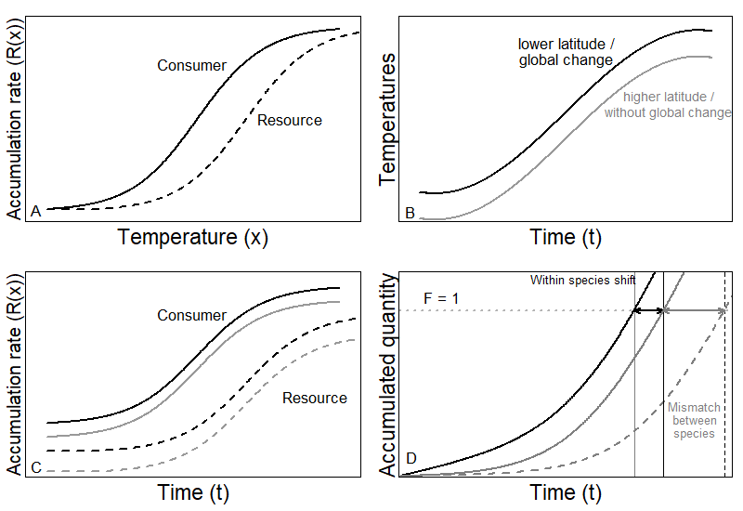
Figure 1: Illustration of theoretical development. (A) The rate accumulation function for two different species (solid line is consumer and dashed line is resource). (B) Two simplified temperature time series (black line is warmer and grey line is cooler). (C) Four combinations of rate accumulation; each species with two different temperature time series. (D) The resulting end of the resting phase for the consumer in cooler (grey solid line) and warmer (black solid line) temperatures and for the resource in cooler temperatures (black dashed line). The difference within species (grey vs. black line) indicates the shift in emergence in space (due to latitude or altitude) or time (due to global change). The difference between species (solid vs. dashed line) indicates the mismatch in the end of the seasonal resting phase for a fixed temperature regime (same location and same time).

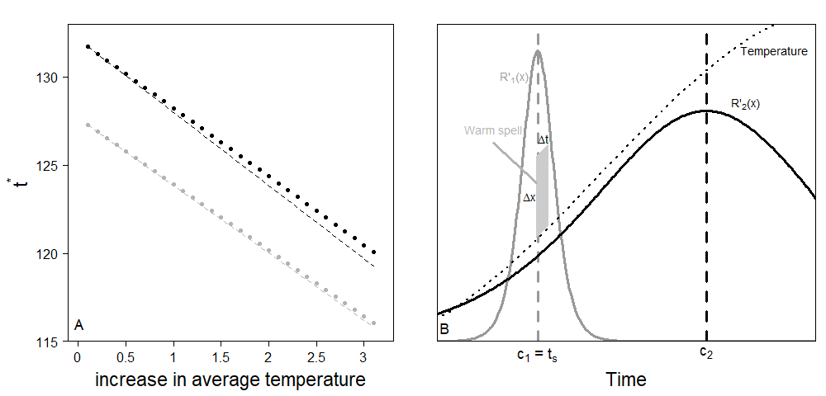
Figure 2: Effects of (A) a constant temperature difference, and (B) a short warm spell, on species phenology. For both panels, black is the consumer (SBW), and grey is the resource (balsam fir). (A) A constant temperature difference advances species phenology. Solid is the predicted value, dashed is the linear approximation from the model with simple time series. (B) The two species have their R’ that peaks at different temperatures. A short warm spell will mostly affect the species for which R’ is highest at that time (in this example, the tree is more sensitive than the insect).

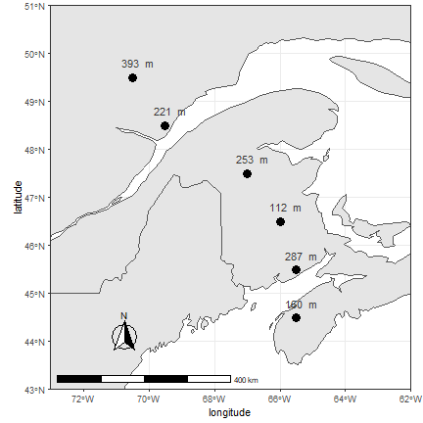
Figure 3: Location of the sample sites where temperature data were collected for past and future trends. Points are located across a gradient of latitude in Nova-Scotia, New Brunswick, and Quebec. Altitude is indicated above each point.

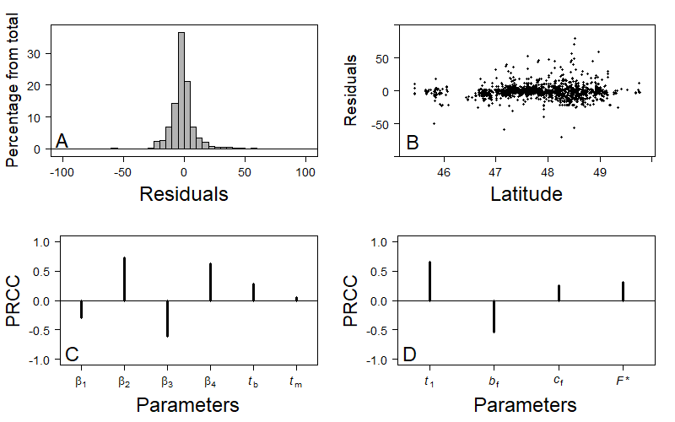
Figure 4: Fitting residuals and sensitivity analysis of the balsam fir model. (A) Residuals follow a Normal distribution centered on 0. (B) No obvious latitudinal patterns can be found on the residuals within the range of latitudes that is used throughout the rest of the study. (C) Partial Rank Correlation Coefficient (PRCC) shows that the budworm model is sensitive to most parameters especially , and x_{b} that delay emergence, and that hasten emergence. (D) The tree model is mostly sensitive to b_{f} that hastens budburst, and t₁ that delays budburst.

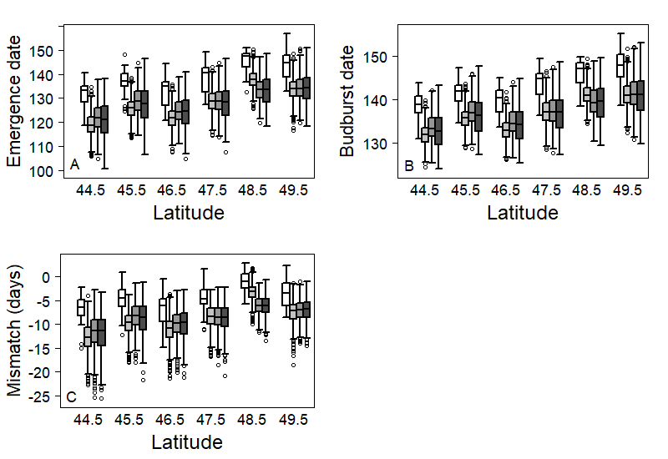
Figure 5: Latitudinal distribution of (A) emergence date of L₂ instar (Julian days), (B) budburst date (Julian days), and (C) mismatch between emergence and budburst date. For each latitude, the white box (left one) represents the 1996-2016 period. Grey boxes represent expected outcomes according to RCP 2.6 (light grey), RCP 4.5 (dark grey), and RCP 8.5 (black) scenarios over 2021 to 2100. Both emergence and budburst are expected to occur later at higher latitudes. Overall warming scenarios, both events are expected to occur earlier in the year. Among future scenarios, warmer scenarios generate more variance. Nowadays, emergence is expected to occur 5 to 10 days before budburst at low latitudes, while at higher latitudes, emergence may sometimes occur before budburst and sometimes after. For all warming scenarios, an increase in mismatch is expected. At low latitudes, emergence may occur too early some years, which may lead to low survival of L₂. At higher latitudes, emergence is expected to systematically occur a few days before budburst, which would increase survival of L₂.

