Somewhere within the introduction, we define the term seasonal resting period as a general term for dormancy in plants and diapause (possibly followed by quiescent phase) in insects. The end of the seasonal resting period is bidburst (plants) or emergence (insects). We acknowledge that there are finer subdivisions of these life-cycle phases, but we don’t consider those.

2. Methods

We begin with a unified description of the mechanism that determines the duration of the seasonal resting period in terms of accumulation of ambient temperature. Then we list our data sources and explain the fitting methods.

2.1 Theoretical development

Throughout the seasonal resting phase, an organism accumulates units of some quantity. The rate of accumulation depends on the ambient temperature, and the seasonal resting phase ends when a certain level of that quantity has been accumulated. For trees, this quantity can be heat, for example in degree-day models [REF] or more recent nonlinear models [Chuine, Desbien]. For insects, the quantity can be the proportion of the corresponding life-cycle stage that they have completed [Regniere, Cobbold and Powell].
We denote time by in days and temperature by in degrees Celsius. The rate of accumulation is some nonnegative function of temperature, denoted byFor the range of temperatures that occur during the resting phase, is an increasing function. While developmental rates typically decrease above some maximum tolerable temperature [Amarasekare or refs therein], such temperatures do no arise during the quiescent phase [REF ?]. The quiescent phase begins at some time and ends at such timewhen the accumulated quantity reaches a certain threshold level The fundamental equation that connects all these quantities and determines the end of the seasonal resting phase is

Eq. 1

A typical example for the accumulation rate function is the sigmoidal function

Eq. 2

whereandare two parameters to be estimated from data [REFS]. When the quantity of interest is the proportion of the life-cycle completed, it is natural to set the threshold level to be . If we divide Eq. 1 by and include the term into the function in Eq. 2, we can standardize notation and compare different rate functions. We illustrate the rate function in Eq. 2 as well as the condition in Eq. 1 for two different species and two simplistic temperature time series in Figure 1.

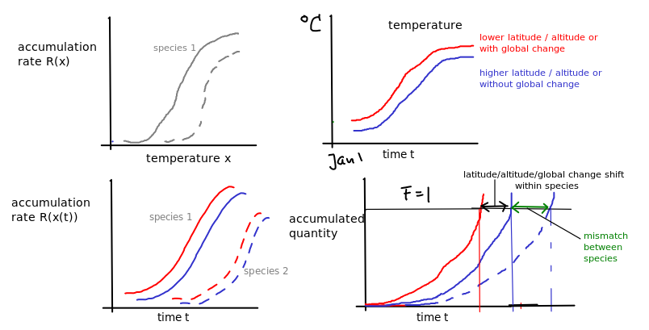
Figure 1: Illustration of theoretical development. Top left: The rate accumulation function for two different species (solid and dashed). Top right: two simplified temperature time series (warmer and cooler). Bottom left: Four combinations of rate accumulation; each species with two different temperature time series. Bottom right: The resulting end of the resting phase for species 1 in cooler (blue solid) and warmer (red solid) temperatures and for species 2 in cooler temperatures (blue dashed). The difference within species (blue vs red) indicates the shift in emergence in space (due to latitude or altitude) or time (due to global change). The difference between species (solid vs dashed) indicates the mismatch in the end of the seasonal resting phase for a fixed temperature regime (same location and same time).

When temperature patterns change over time, the end of the seasonal resting phase of a species may change. For example, when temperatures increase, the accumulation rate also increases, and therefore the threshold level is reached earlier, i.e., the seasonal resting phase ends earlier (compare the red and the blue solid curve in Figure 1, bottom right panel). The difference in these end times is the climate-change induced shift.

For two different species, e.g., a resource and its consumer, different rate curves can lead to different end times even in the same temperature regime (compare solid and dashed curves in Figure 1, bottom right panel). We call this difference in end times the mismatch between the two species. When the climate-change induced shift in end time differs between species, then the mismatch of end times between species will change over time. This is the fundamental quantity that we are interested in here.

Our formula allows us to predict how the end of the seasonal resting phase changes when the temperature time series changes by a small amount. For a first example, if the temperature difference between two years is simply a constant (), i.e., , then the corresponding end times and are related by
Eq. 3

For a second example, if the difference in temperature between two years is a short warm spell of duration at time of temperature differente , then the corresponding ends of the seasonal resting phases are related by

Eq. 4

In particular, the impact of the spell is proportional to the derivative at the time of the spell. Hence, the end time of the seasonal resting period is the most sensitive to warm or cold spells where has its maximal slope. For the rate function in Eq 2, this occurs at temperature We give the mathematical derivation of these results in the appendix.

When we have two species, a consumer and its resource, they each have their rate accumulation function R. Different combinations of parameters (e.g., b, c, and F) will typically lead to different end times of the seasonal resting period. We denote these by t_e^* (emergence time) for the insect and by t_b^* (budburst time) for the host trees. The difference between the two is the mismatch, i.e.,

This quantity is illustrated in the bottom right plot of Figure 1. One would expect that a consumer that crucially relies on a certain resource would have evolved a relatively small mismatch with that resource. However, this does not mean that its rate accumulation curve has to be the same as that of its resource. Even if the functional form is the same, many different parameter combinations in in Eq. 2 lead to the same end time of the resting period. Then the consumer might have its highest sensitivity to cold or warm spells (see Eq. 4) at different temperatures and/or might have a different sensitivity to an overall change in temperatres (see Eq. 3). Hence, the mismatch might increase or decrease with changing temperature patterns. In the following, we explain how we estimated rate accumulation functions and employed different temperature scenarios to see how this mismatch might change in the spruce budworm and balsam fir system in eastern Canada.

3 RESULTS

We begin illustrating the general principle by calculating budburst and emergence time with a much simplified time series that considers only the long-term mean monthly temperatures. We use the a standard cosine function , where is the mean annual temperature, is the amplitude, and is the offset, so that corresponds to January 1. We use the same functional form of the heat accumulation function for trees and insects, but with different parameter values according to Section METHODS (see Appendix for details). In this simplified model, the end of the seasonal resting period for the tree (insect) occurs on day 122 (129), the rate curve has its highest slope at 14.6 degrees (23 degrees), and the end of the resting period advanced by about 4.8 (4.6) days per degree increase in mean temperature. Since the rest period of the trees ends earlier and advances faster, the mismatch increases over time, but the difference is small. The linear approximation captures the actual end of resting period very well (Figure 2).

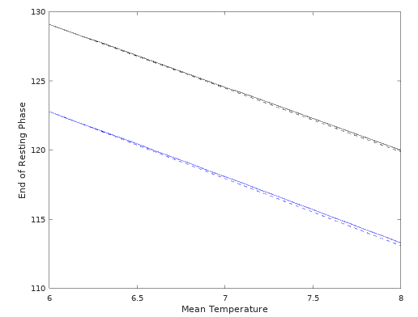

Figure 2:
End of resting phase from the model with simple time series. Black is the insect, blue is the tree. Solid is the actual value, dashed is the linear approximation.

