

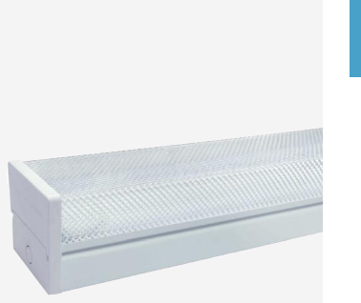 | 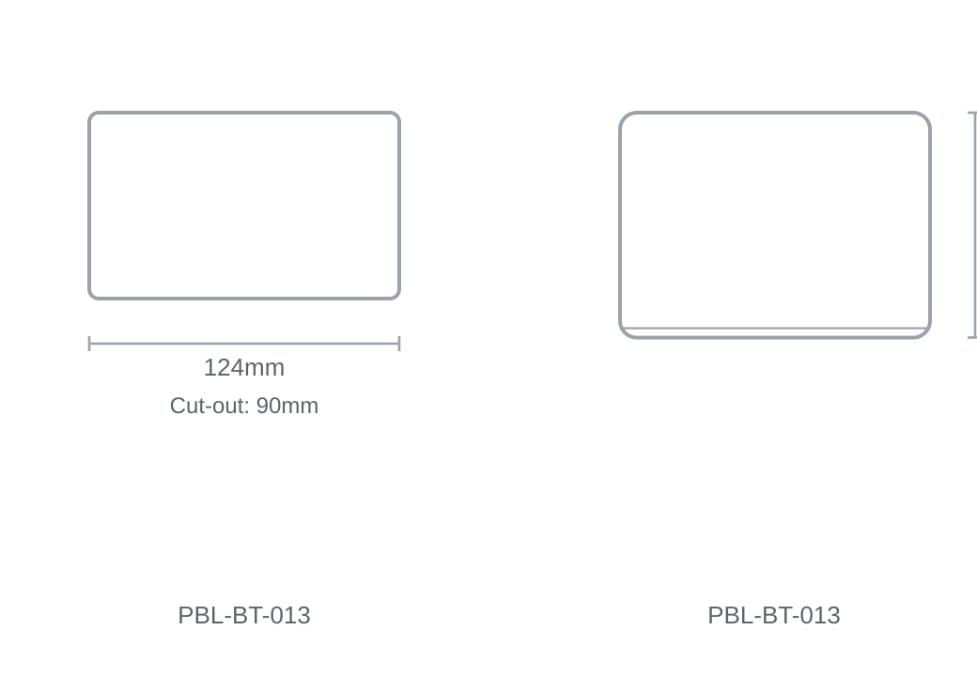

Technical Specification
Category | Batten Lights
Colour | White
Colour Temp | 6000K
Lumens Output | 3400lm
Wattage | 18W
Beam Angle | 120°
Size | 124 × 90mm
Cut-out | 90mm

