

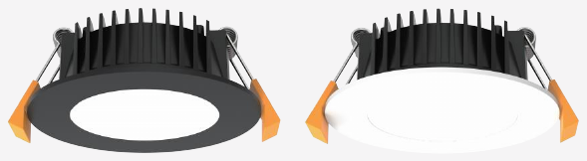 | 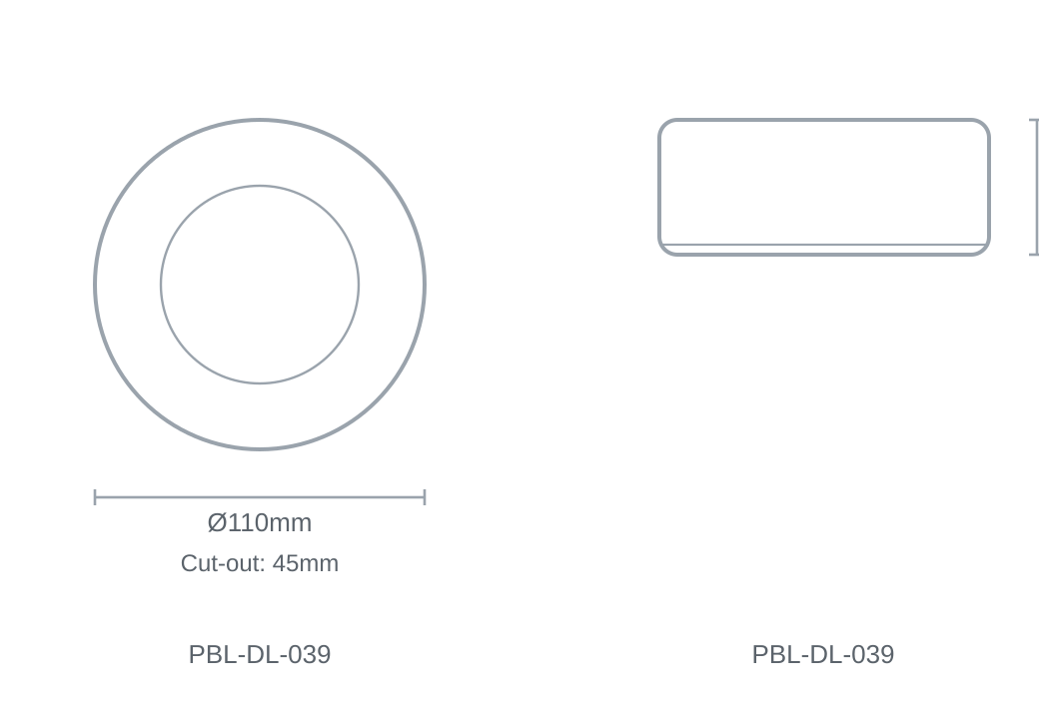

Technical Specification
Category | Downlights & Shop Lights
Colour | Black / White
Colour Temp | 3000K / 4000K / 5700K
Lumens Output | 874lm
Wattage | 13W
Beam Angle | 100°
Material | Aluminium
Size | Ø110 × H45mm
Cut-out | 45mm

