

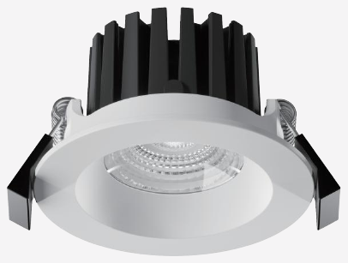 | 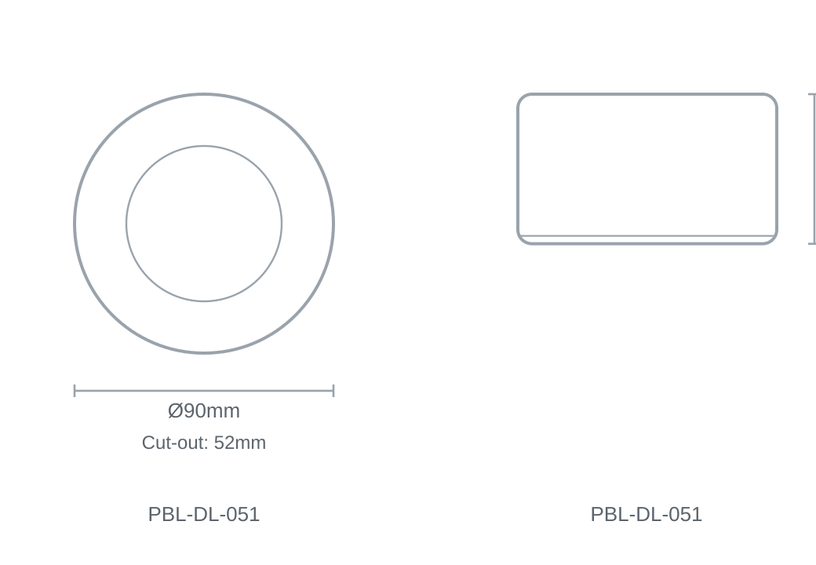

Technical Specification
Category | Downlights & Shop Lights
Colour | White
Colour Temp | 3000K
Lumens Output | 816lm
Wattage | 10W
Beam Angle | 60°
Material | Die-cast Aluminium
Size | Ø90 × H52mm
Cut-out | 52mm

