

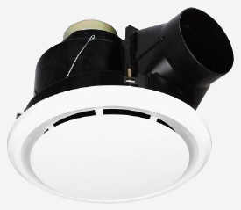 | 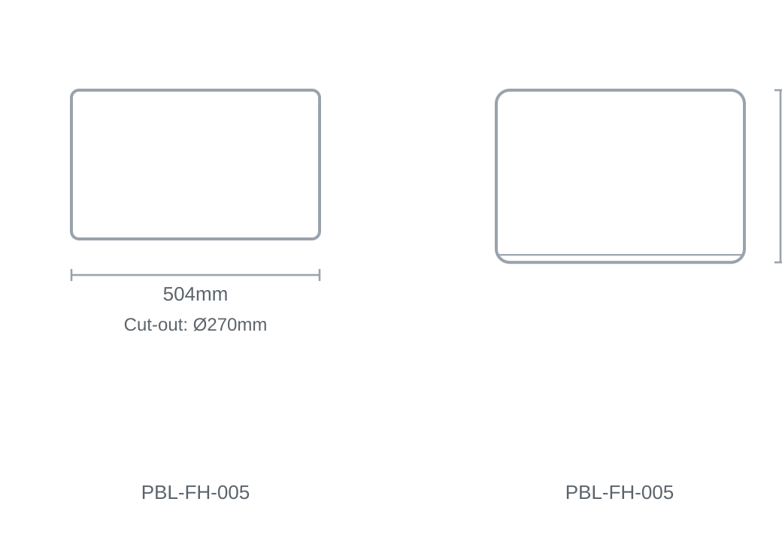

Technical Specification
Category | Fan / Bathroom Heaters
Colour | White
Lumens Output | 900lm
Wattage | 10W
Material | Aluminium
Size | 504 × 350mm
Cut-out | Ø270mm

