

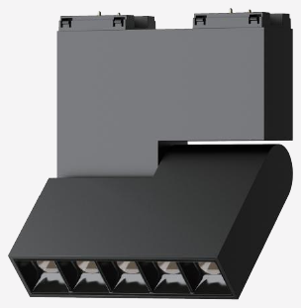 | 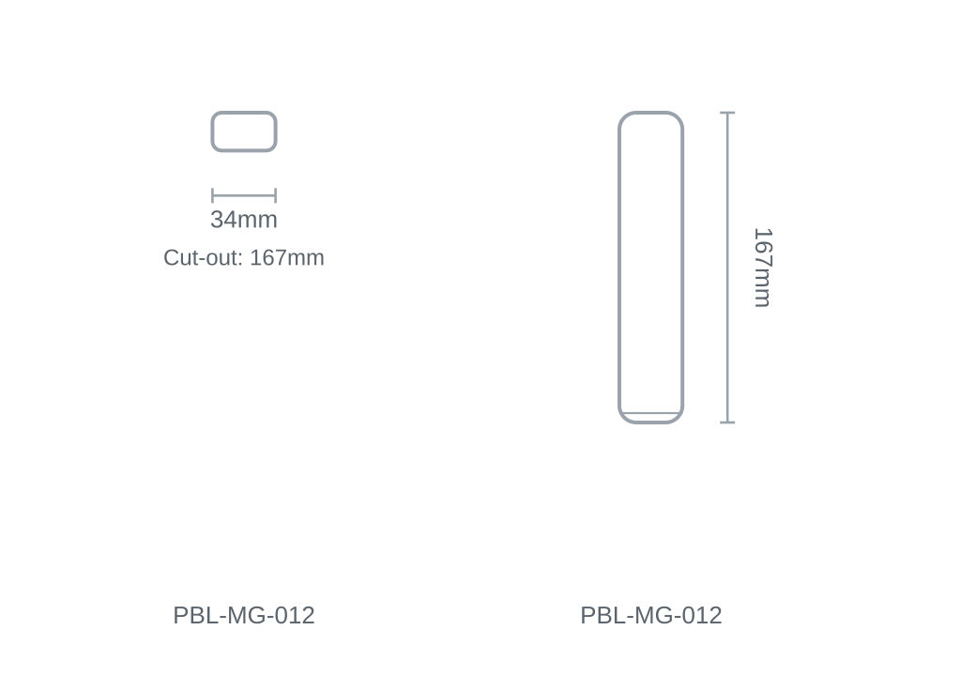

Technical Specification
Category | Magnetic Track
Colour | Black
Colour Temp | 3000K / 4000K
Lumens Output | 7lm
Wattage | 10W
Beam Angle | 45°
Material | Aluminium
Size | 34 × 167mm
Cut-out | 167mm

