

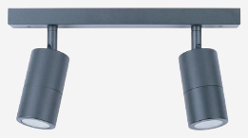 | 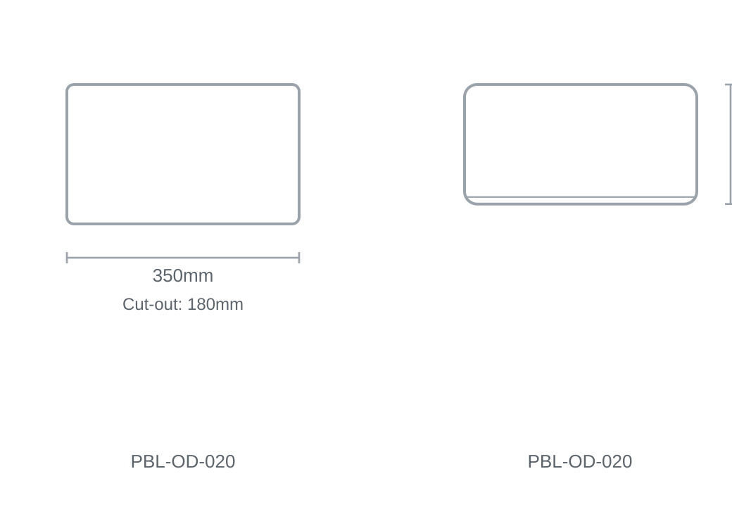

Technical Specification
Category | Outdoor Lights
Colour | Black / White
Wattage | 35W
Material | Aluminium
Size | 350 × H180mm
Cut-out | 180mm

