

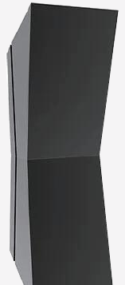 | 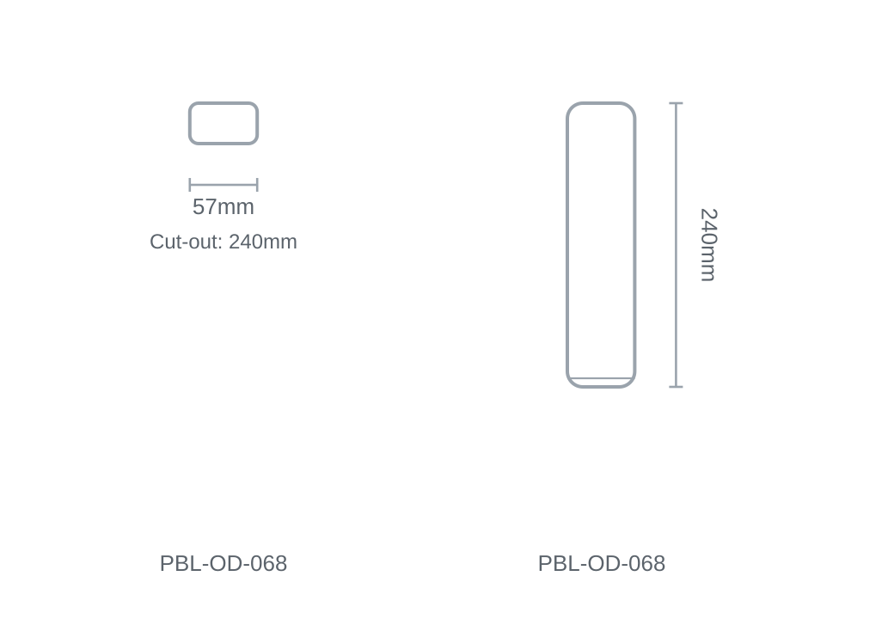

Technical Specification
Category | Outdoor Lights
Colour | Black / White
Colour Temp | 3000K / 4000K / 6500K
Lumens Output | 216lm
Wattage | 6W
Beam Angle | 228°
Material | Aluminium
Size | 57 × H240mm
Cut-out | 240mm

