

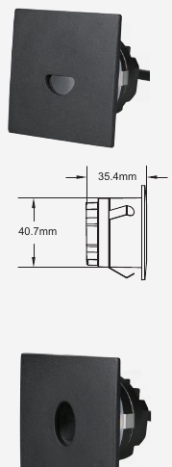 | 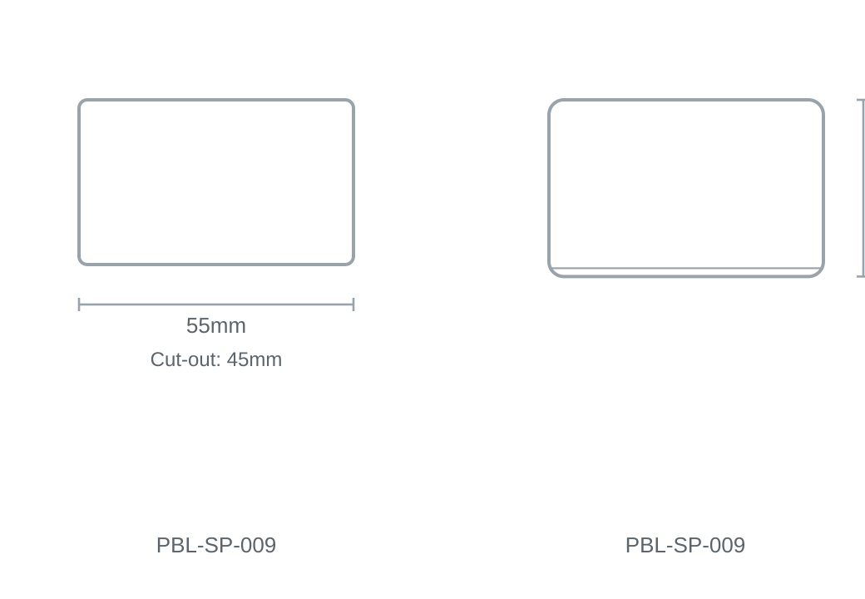

Technical Specification
Category | Step Lights
Colour | Black / White
Colour Temp | 3000K / 4000K / 5000K
Lumens Output | 62-79lm
Wattage | 3W
Beam Angle | 15°
Material | Die-cast Aluminium
Size | 55 × H35.4mm
Cut-out | 45mm

