

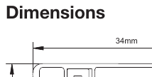 | 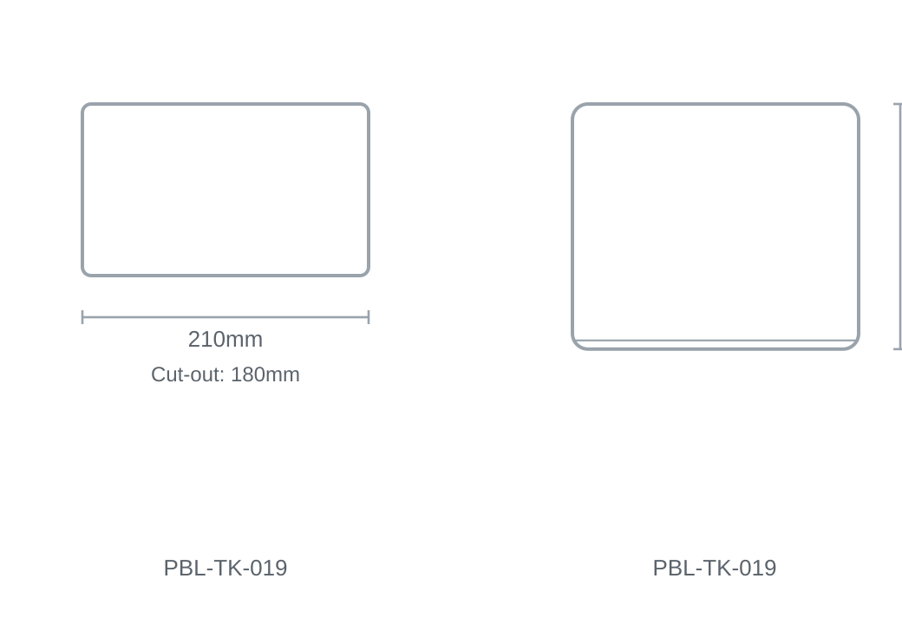

Technical Specification
Category | Track Lights
Size | 210 × 180mm
Cut-out | 180mm

