

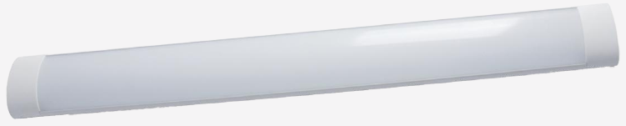 | 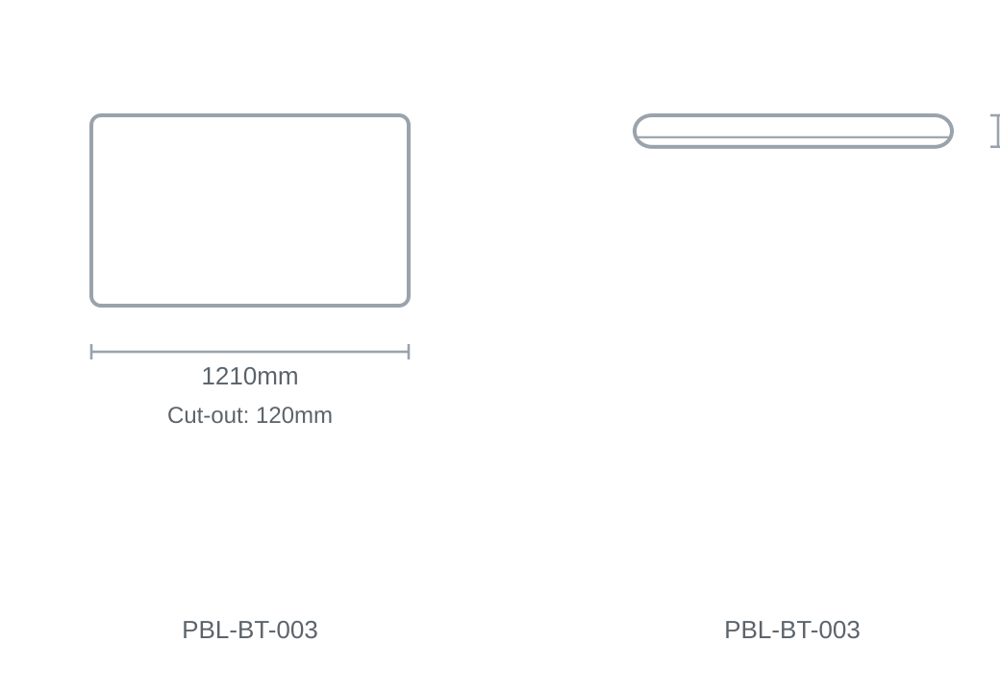

Technical Specification
Category | Batten Lights
Colour | White
Colour Temp | 3000K / 4000K / 6000K
Lumens Output | 3800lm
Wattage | 40W
Beam Angle | 120°
Size | 1210 × 120mm
Cut-out | 120mm

