

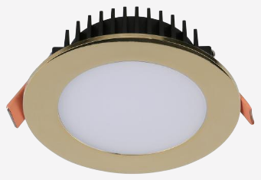 | 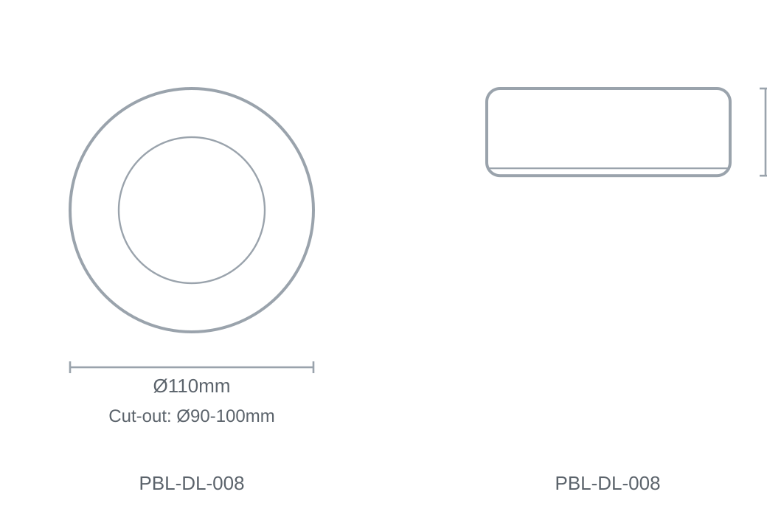

Technical Specification
Category | Downlights & Shop Lights
Colour | Black / Gold / White
Colour Temp | 3000K / 4000K / 5700K
Lumens Output | 800-900lm
Wattage | 12W
Beam Angle | 100°
Material | Die-cast Aluminium
Size | Ø110 × H39.4mm
Cut-out | Ø90-100mm

