

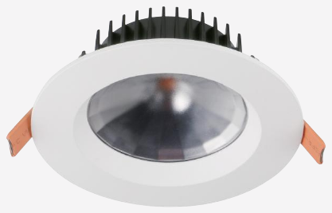 | 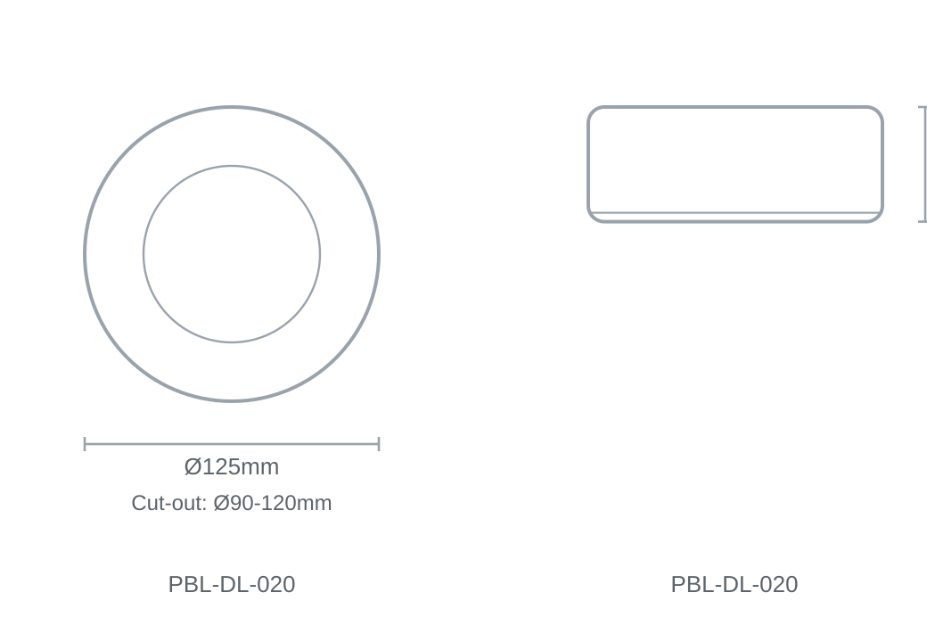

Technical Specification
Category | Downlights & Shop Lights
Colour | Black
Colour Temp | 2700K / 3000K / 4000K / 5000K / 5700K
Lumens Output | 1098-1168lm
Wattage | 15W
Beam Angle | 100°
Material | Die-cast Aluminium
Size | Ø125 × H48.7mm
Cut-out | Ø90-120mm

