

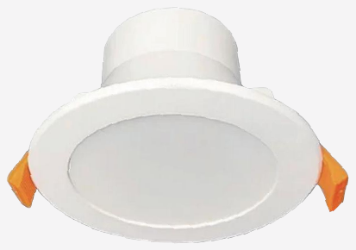 | 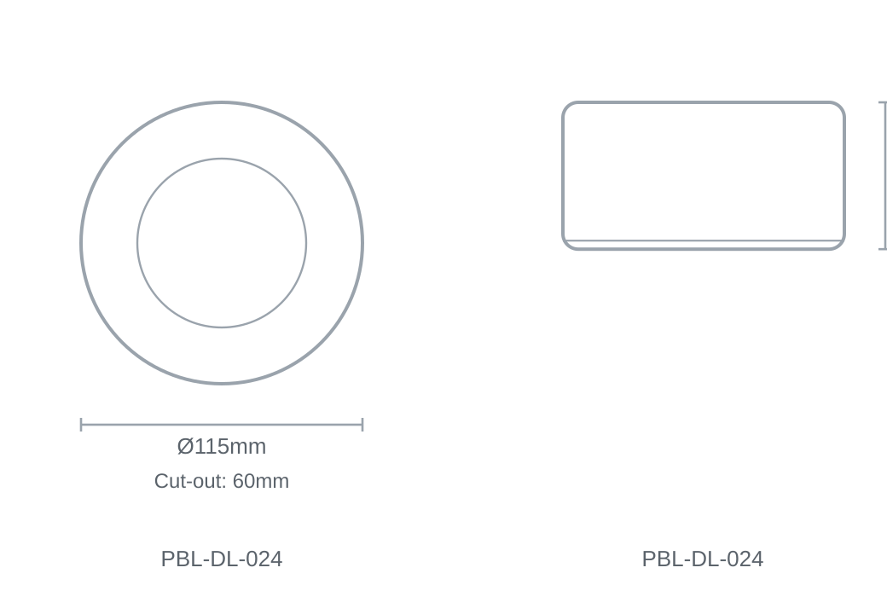

Technical Specification
Category | Downlights & Shop Lights
Colour | White
Colour Temp | 3000K / 6000K
Lumens Output | 650-750lm
Wattage | 10W
Beam Angle | 110°
Material | Die-cast Aluminium
Size | Ø115 × 60mm
Cut-out | 60mm

