

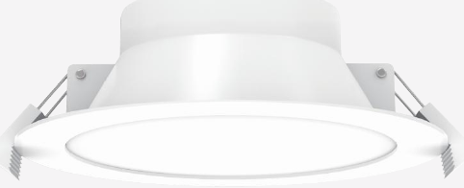 | 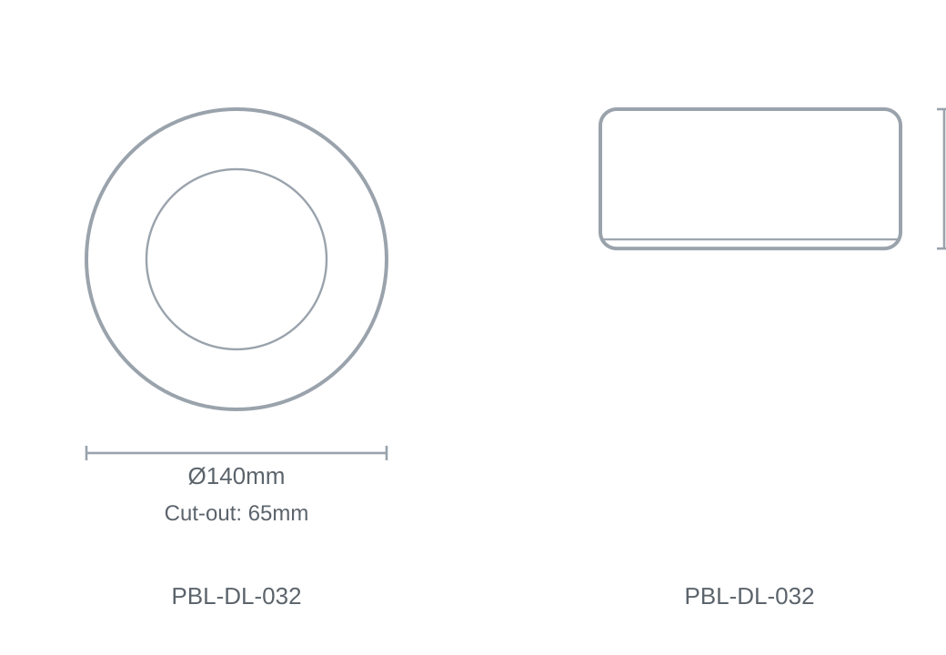

Technical Specification
Category | Downlights & Shop Lights
Colour | White
Colour Temp | 3000K / 4000K / 6000K
Lumens Output | 1020-1200lm
Wattage | 15W
Beam Angle | 110°
Material | Die-cast Aluminium
Size | Ø140 × 65mm
Cut-out | 65mm

