

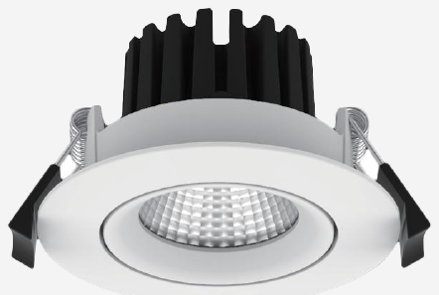 | 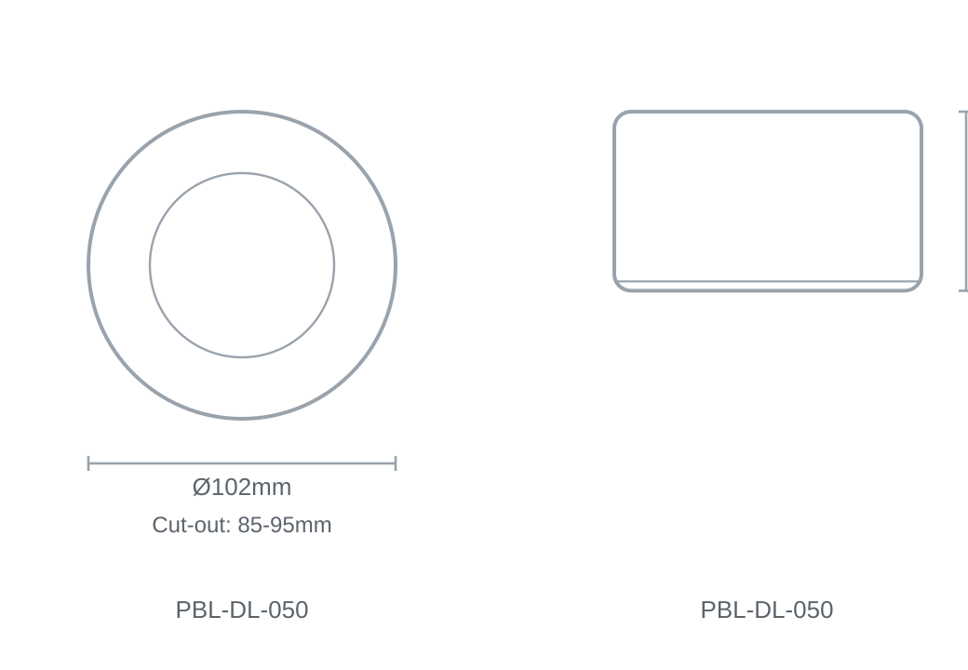

Technical Specification
Category | Downlights & Shop Lights
Colour | Black / White
Colour Temp | 3000K / 4000K
Lumens Output | 816lm
Wattage | 10W
Beam Angle | 38°
Material | Aluminium
Size | Ø102 × 59.5mm
Cut-out | 85-95mm

