

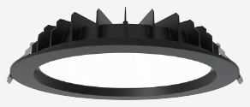 | 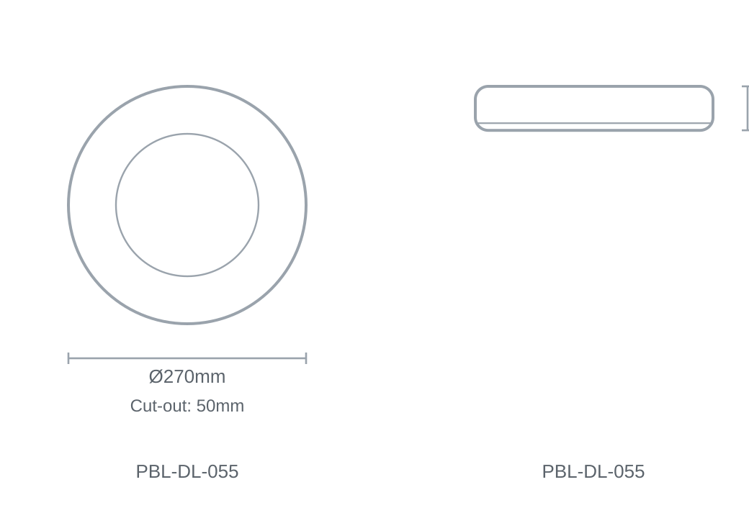

Technical Specification
Category | Downlights & Shop Lights
Colour | White
Colour Temp | 3000K / 4000K / 5700K
Lumens Output | 5978lm
Wattage | 60W
Beam Angle | 100°
Material | Aluminium
Size | Ø270 × H50mm
Cut-out | 50mm

