

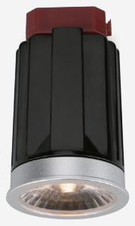 | 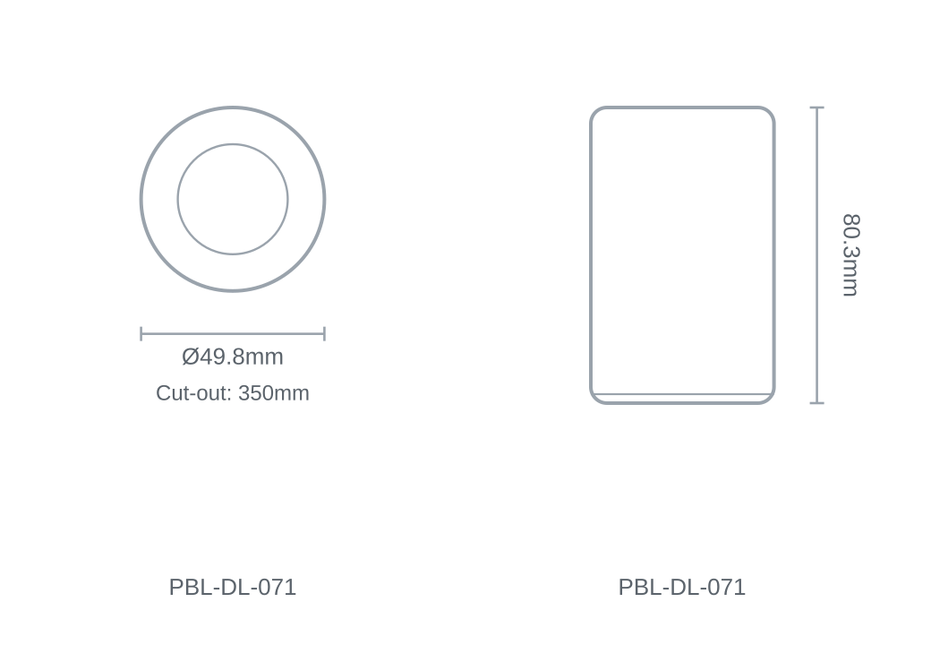

Technical Specification
Category | Downlights & Shop Lights
Colour | Black
Colour Temp | 2700K / 3000K / 4000K / 5000K / 5700K
Lumens Output | 520-625lm
Wattage | 10W
Beam Angle | 60°
Material | Die-cast Aluminium
Size | Ø49.8 × H80.3mm
Cut-out | 350mm

