

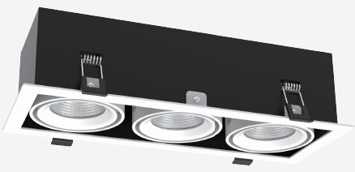 | 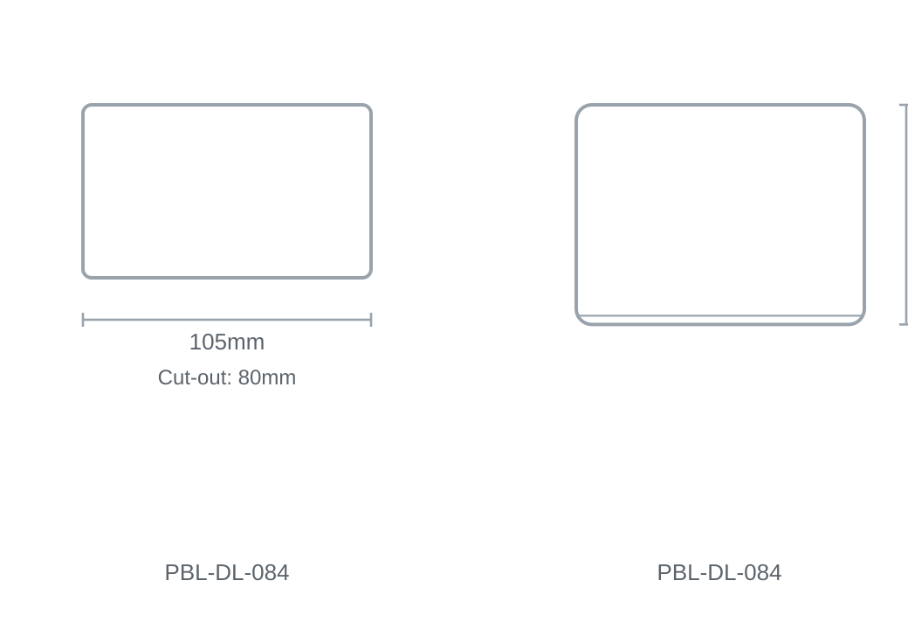

Technical Specification
Category | Downlights & Shop Lights
Colour | Black / White
Colour Temp | 3000K / 4000K / 5700K
Lumens Output | 2751lm
Wattage | 30W
Beam Angle | 60°
Material | Aluminium
Size | 105 × H80mm
Cut-out | 80mm

