

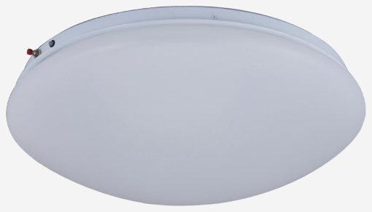

Technical Specification
Category | Emergency Lights
Colour | White

