

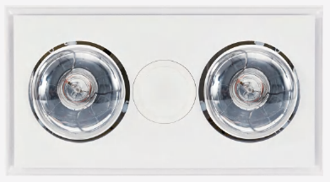 | 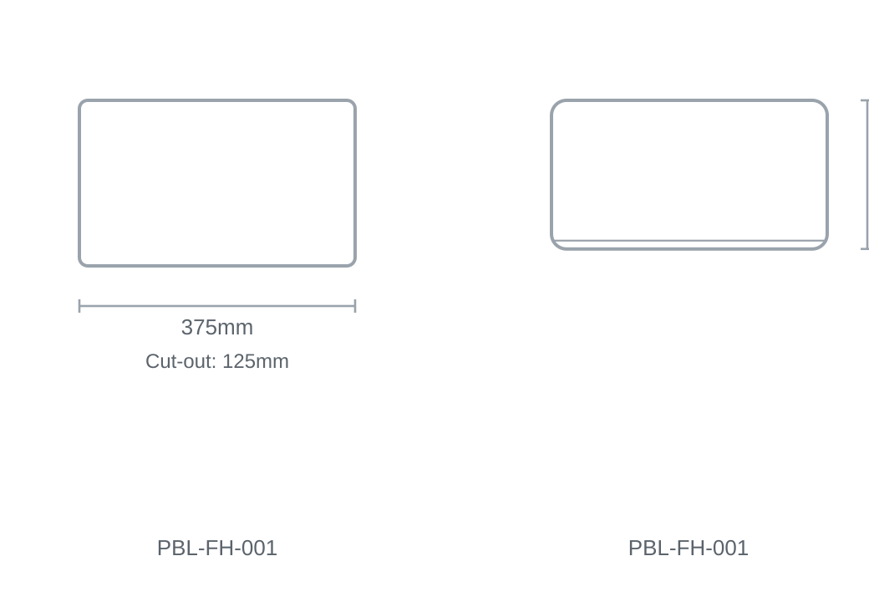

Technical Specification
Category | Fan / Bathroom Heaters
Colour | White
Colour Temp | 4000K
Lumens Output | 900lm
Wattage | 605W
Material | Aluminium
Size | 375 × 202mm
Cut-out | 125mm

