

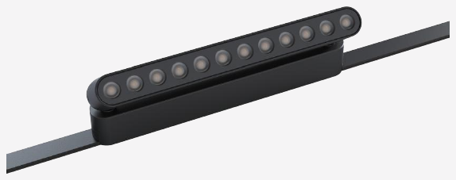 | 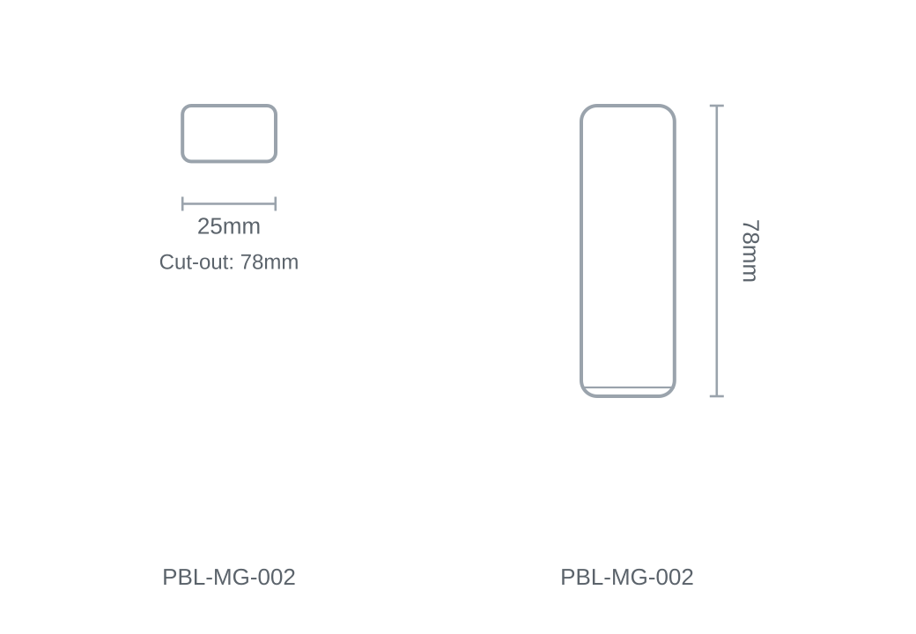

Technical Specification
Category | Magnetic Track
Colour | Black
Colour Temp | 3000K / 4000K / 6000K
Lumens Output | 534lm
Wattage | 12W
Beam Angle | 24°
Material | Aluminium
Size | 25 × 78mm
Cut-out | 78mm

