

 | 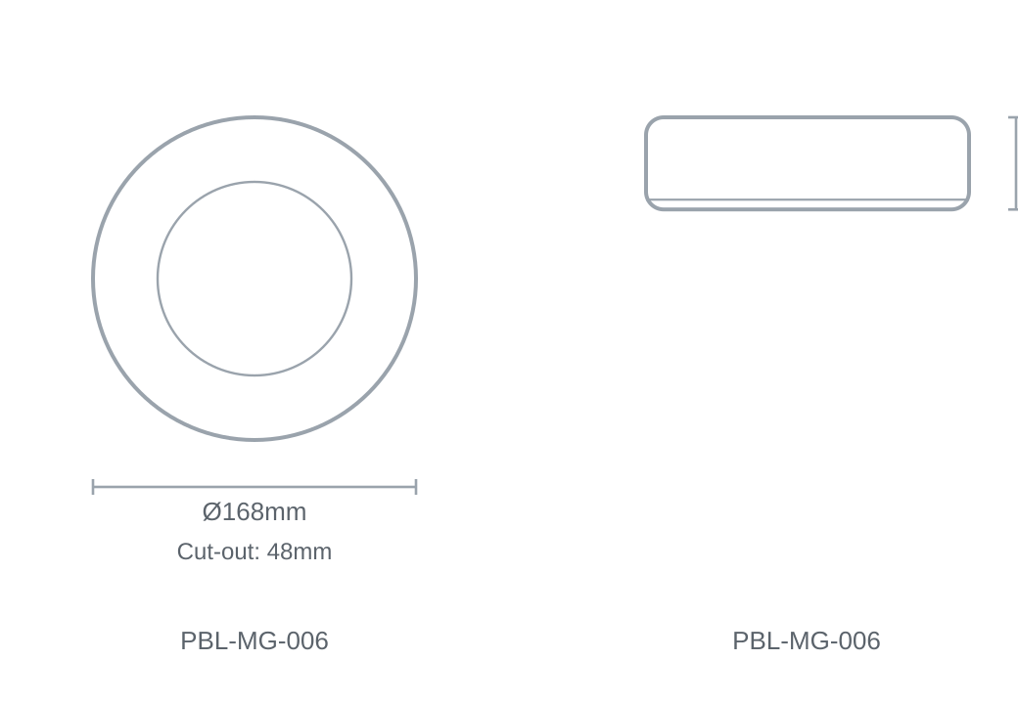

Technical Specification
Category | Magnetic Track
Colour | Black
Colour Temp | 3000K / 4000K / 6000K
Lumens Output | 28lm
Wattage | 6W
Beam Angle | 120°
Material | Aluminium
Size | Ø168 × 48mm
Cut-out | 48mm

