

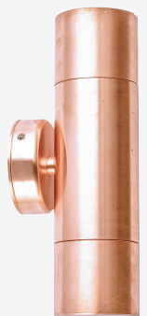 | 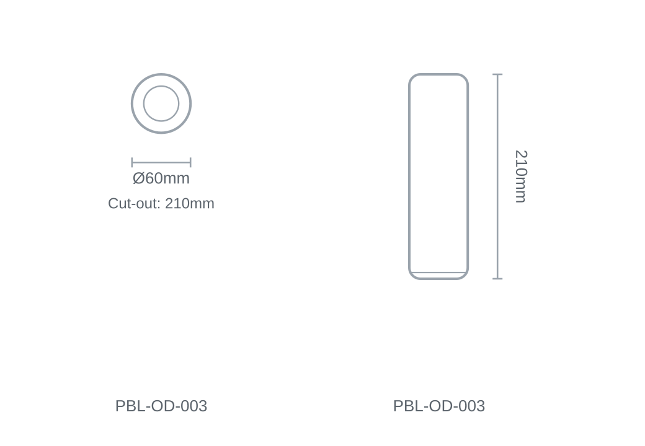

Technical Specification
Category | Outdoor Lights
Wattage | 35W
Size | Ø60 × H210mm
Cut-out | 210mm

