

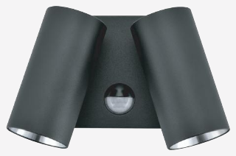 | 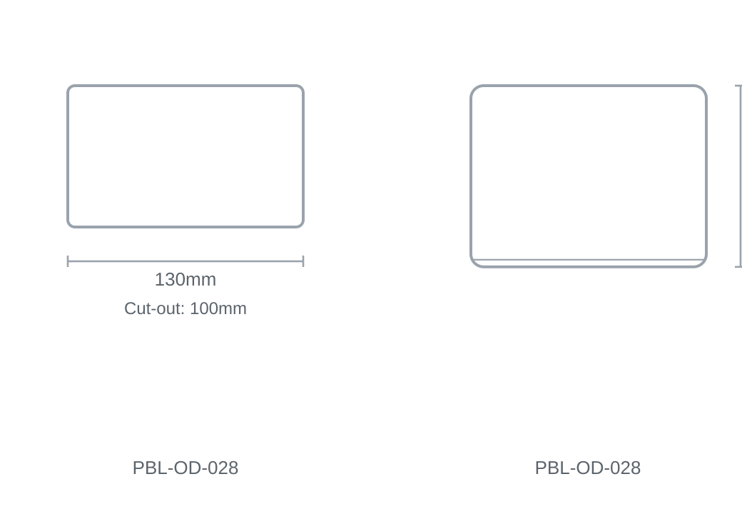

Technical Specification
Category | Outdoor Lights
Colour | Black / White
Colour Temp | 3000K / 4000K / 5000K
Wattage | 8W
Material | Aluminium
Size | 130 × H100mm
Cut-out | 100mm

