

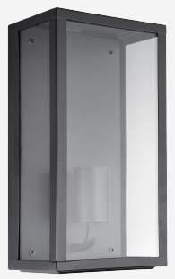 | 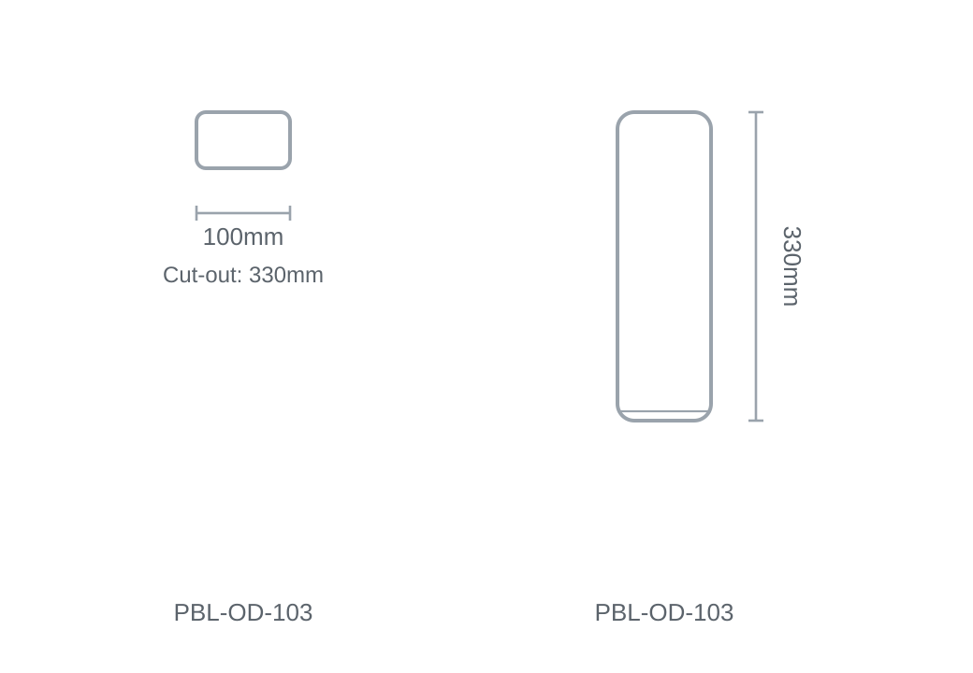

Technical Specification
Category | Outdoor Lights
Colour | Black / White
Wattage | 15W
Material | Die-cast Aluminium
Size | 100 × H330mm
Cut-out | 330mm

