

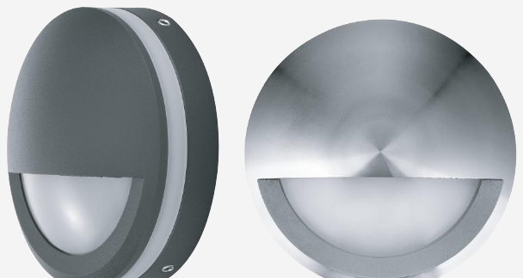 | 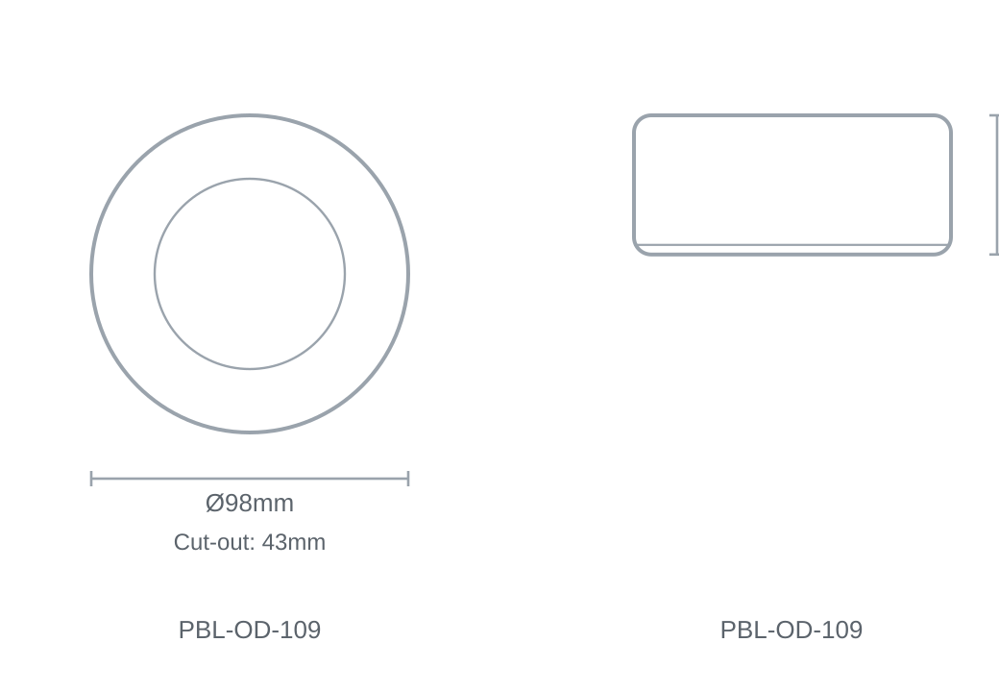

Technical Specification
Category | Outdoor Lights
Colour | Black
Colour Temp | 6000K / 3000K
Lumens Output | 400lm
Wattage | 6W
Beam Angle | 120°
Material | Aluminium
Size | Ø98 × 43mm
Cut-out | 43mm

