

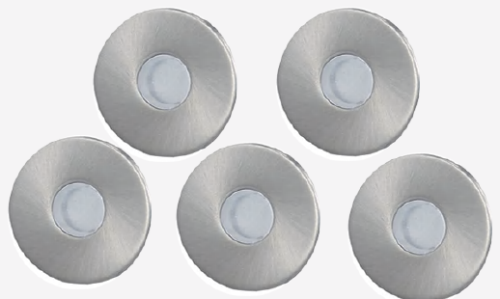 | 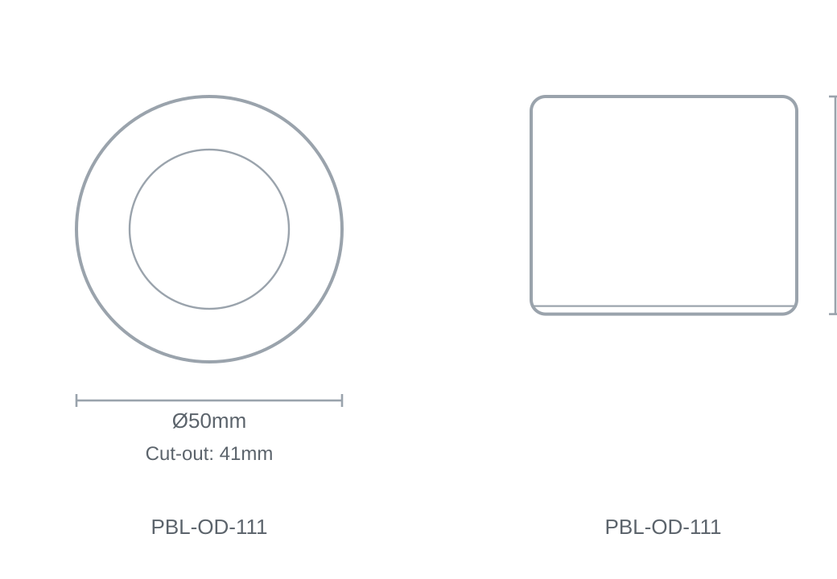

Technical Specification
Category | Outdoor Lights
Colour | White
Colour Temp | 6000K
Lumens Output | 520lm
Material | Stainless Steel
Size | Ø50 × 41mm
Cut-out | 41mm

