

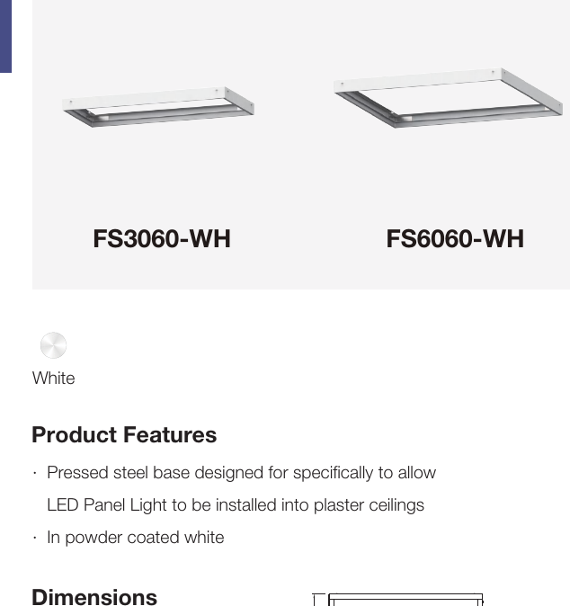 | 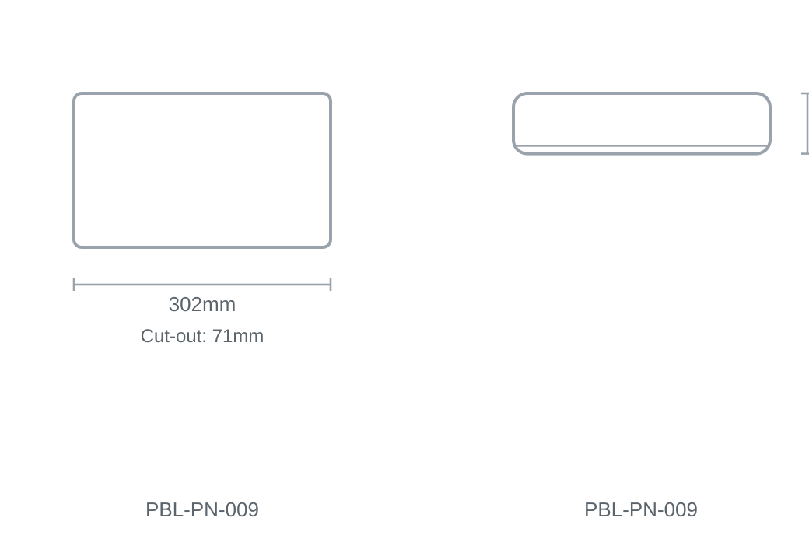

Technical Specification
Category | Panels
Colour | White
Size | 302 × 71mm
Cut-out | 71mm

