

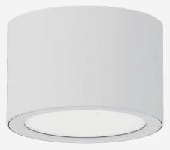 | 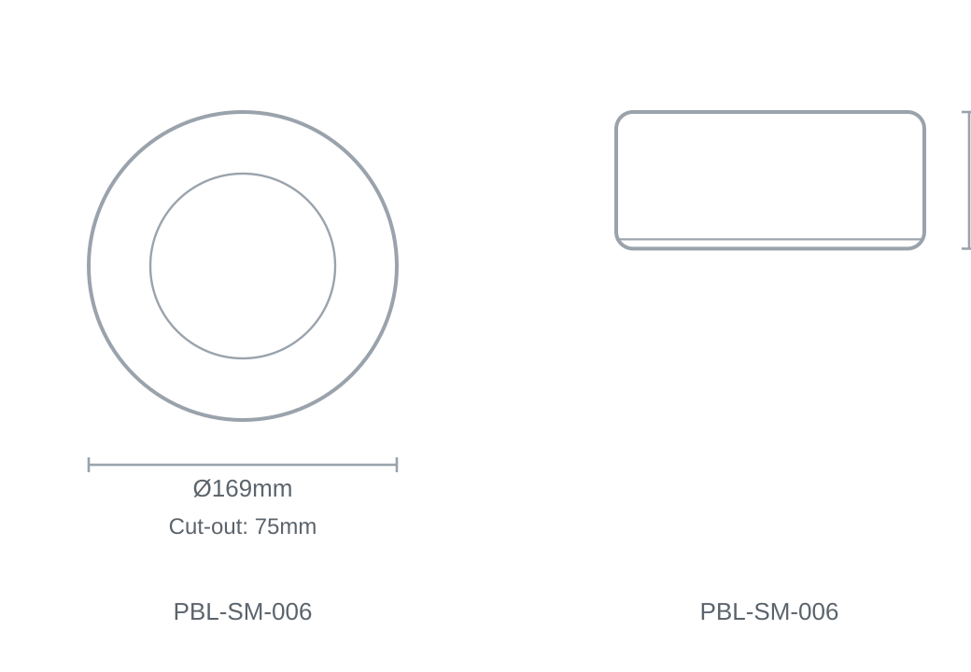

Technical Specification
Category | Surface Mount Downlights
Colour | Black / White
Colour Temp | 3000K / 4000K / 5700K
Lumens Output | 2400lm
Wattage | 20W
Beam Angle | 100°
Material | Aluminium
Size | Ø169 × H75mm
Cut-out | 75mm

