

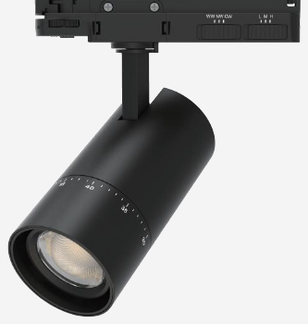 | 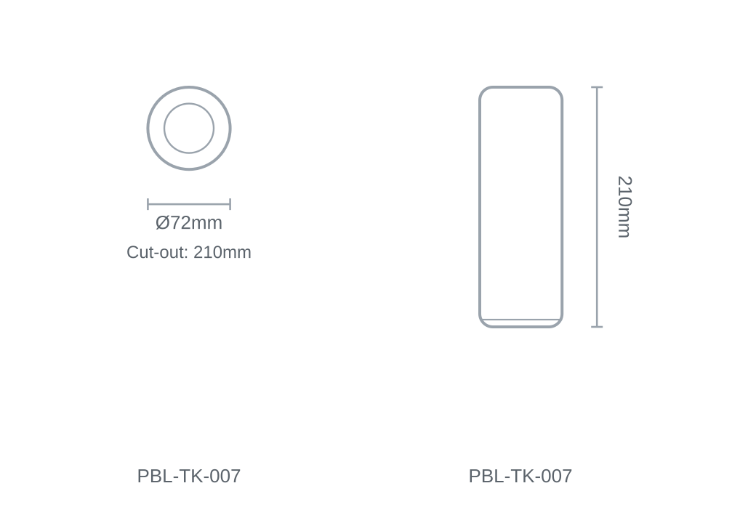

Technical Specification
Category | Track Lights
Colour | Black / White
Colour Temp | 3000K / 4000K / 5700K
Lumens Output | 1823lm
Wattage | 20W
Beam Angle | 24°
Material | Aluminium
Size | Ø72 × 210mm
Cut-out | 210mm

