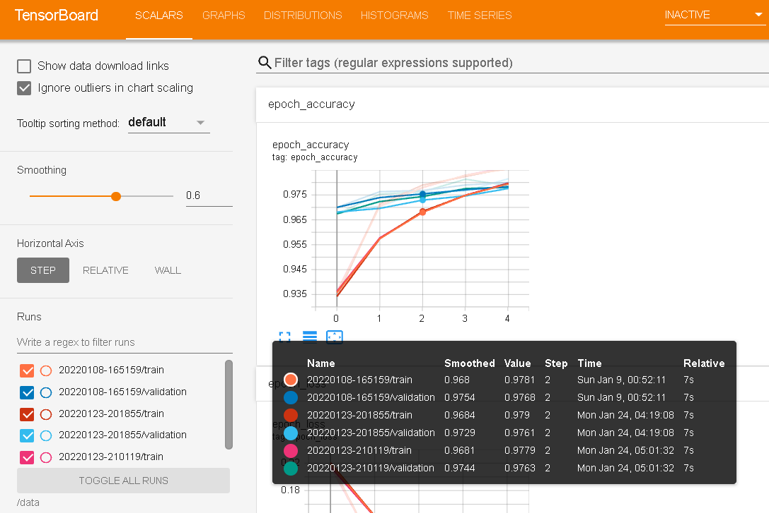Use the pipeline to package the transferlearning model, use the vgg16 model, use the python package kfp.components to package the model into yaml, design the pipeline, and then visualize the output results into tensorborad, and then observe the results of the model training, the packaging is complete In the future, the model can be deployed to the required environment and kits more conveniently, which can save more time. This model throws images into four categories for training, and the result is 97% accuracy. The pipeline packaged by katib has been used to analyze which optimization function this model is suitable for to achieve the highest accuracy. The test results ADAM can optimize the model to the best, and the model I packaged also uses ADAM to optimize the parameters. The first node of the pipeline graph that runs out is the training process, and the second node is the tensorborad visualization model.