Tools and Technologies

The main technology for building this project is ReactJS [42]. It is utilized for building front-end components, including the sounds control panel, header, Pomodoro section, etc. Having worked as a web developer for over one year, only Linh has lots of experience with ReactJS, his role is to gather other team members’ code and managing the code’s repository.

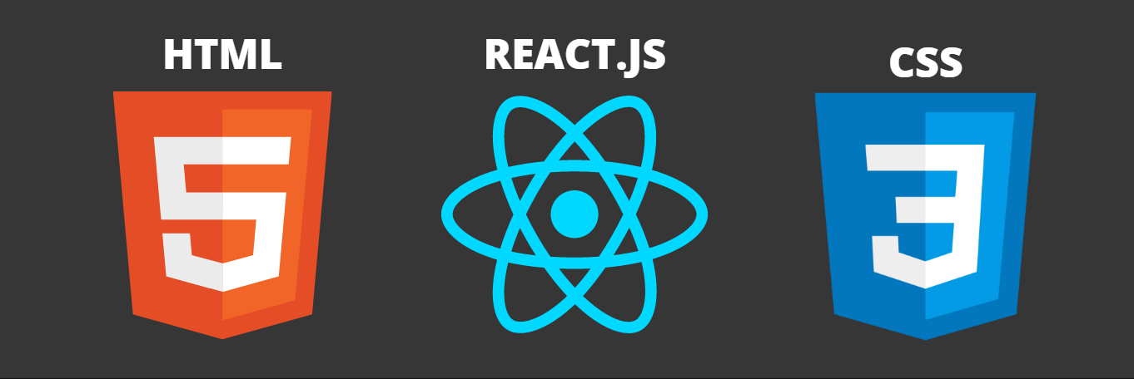

HTML and CSS will also be used for structuring and styling the project. All of the team members are familiar with these technologies since we have done some online courses and tutorial before (W3School, freecodecamp, etc).

In addition, Spotify API [43] will be integrated into the website for playing songs and providing users' logins feature. Using API is still something new to our team and we have to do research about applying it into our code.

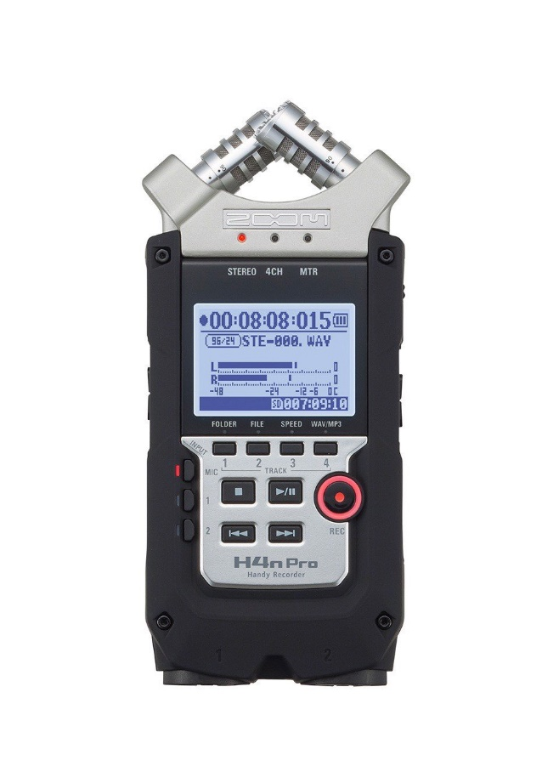With the help of Canva [44], we can build a demo interface of the website and different components. Hoang who was responsible for the UI-UX position had done several projects with Canva before because of its convenient and promptitude.

For the soundtracks, if possible, we would like to invest in the Zoom H4n Pro - an exceptional microphone/digital audio recording device [45]. It is an easy-to-use technology and works best for ambience recording. In addition, we also need an earphone to check the quality of the sound while it is being recorded.

To have high resolution and nice-exposure pictures, we can use images from Unsplash [46] – a photo discovery platform for free to use, high-definition photos.

While Firebase [47] will be used to store the database, different sound packages, and high-quality pictures, Git and Github help us with handling version controls and remote repositories. Spotifour members are familiar with these technologies since we had used them before in other projects, like assignment 2, or in other courses.

All of the software that we use in this project are free of charge, our team can use them for commercial purposes and no licenses are needed.

[42] React. “React - A javascript library for building user interfaces.” reactjs.org. https://reactjs.org/ (accessed Dec. 9, 2021).

[43] Spotify for Developer. “Web API.” developer.spotify.com. <https://developer.spotify.com/documentation/web-api/> (accessed Dec. 9, 2021).

[44] Canva. “What will you design?.” Canva.com. <https://www.canva.com/> (accessed Dec. 9, 2021).

[45] Mynewmicrophone. “Best Microphones For Recording Ambience.” mynewmicrophone.com. <https://mynewmicrophone.com/ambience/> (accessed Dec. 9, 2021)

[46] Unsplash. “The internet’s source of freely-usable images.” unsplash.com. https://unsplash.com/ (accessed Dec. 9, 2021).

[47] Firebase. “Firebase helps you build and run successful apps.” firebase.google.com. https://firebase.google.com/ (accessed Dec. 9, 2021).