COP 3502 – Summer 2002 – Assignment #3
Due in class: Wednesday July 10th
You will write programs in C to solve the following problems. Each program is a stand-alone program, so the disk you submit will contain three separate programs.

Problem #1
Write a C program that reads n integers into an array, then prints on a separate line the value of each distinct element in the array along with the number of times it occurs in the array. The values must be printed in descending order. Your program must use different functions for the following tasks:
- A function to read in the n integers and place them in the array.
- A function which determines the distinct values and the number of times each occurs in the array.
- A function which prints the distinct values and the number of occurrences for each in descending order.

Assumptions:
- Prompt the user to enter the value of n, assume that the maximum value of n is 20 for this program. Your program must check to be sure the user has entered a proper value for n.
- User can enter both positive and negative values into the array.

Example execution:

Enter the number of elements in your array (1-20): 7
Enter number 1: -45
Enter number 2: -29
Enter number 3: 56
Enter number 4: -45
Enter number 5: -45
Enter number 6: 0
Enter number 7: 56

Number 56 appeared 2 times
Number 0 appeared 1 time
Number –29 appeared 1 time
Number –45 appeared 3 times

Problem #2
Write a C program that will read in a string of n characters (1 character at a time) then use a recursive function to reverse the string of characters and place them in to a second array in the reverse order from the original input order, and finally use another function to determine if the original string was a palindrome (a word or string that reads the same forward and backward). Your program should prompt the user for the original string, print out this string as well as the reverse of the string, and finally should print a message indicating if the string is a palindrome.

Assumptions:
- Prompt the user to enter the value of n, assume that the maximum value of n is 20 for this program. Your program must check to be sure the user has entered a proper value for n.
- Don’t actually deal with strings, just use an array of characters for both the original and the reversed “string”.

Example Execution:
Enter the number characters in your string (1-20): 11
You entered the string: hello world
Your string reversed is: dlrow olleh
Your string is not a palidrome.

Enter the number characters in your string (1-20): 5
You entered the string: radar
Your string reversed is: radar
Your string is a palidrome:

Problem #3
Write a C program that will perform the following operations on three matrices A, B, and C where matrices A and B will be randomly filled with integer values between 1 and 20. Matrix C will be used as a result matrix.
- Randomly fill both A and B and print both after filling.
- Adds two compatible matrices and prints the sum matrix.
- Multiplies two compatible matrices and prints the product matrix.
- Transposes and prints the transpose of each matrix A, B, and C.

Assumptions:
- The definition for each matrix A, B, and C will be a square matrix which means that the number of rows and the number of columns is the same in each matrix. However, the user may elect to fill only a portion of each matrix. For example the user might set matrix A[4, 5] and matrix B[3, 4]. C will be used as a result matrix so its usable dimensions will be determined by the operation which produces the result in C. For this program use the following to define the matrices:

#define maxrows 8
#define maxcols 8

int A[maxrows][maxcols];
int B[maxrows][maxcols];
int C[maxrows][maxcols];

- Each matrix will be randomly filled using the built-in C function rand( ) which is part of the standard C library so you will need to include the following statement at the top of your program:

#include <stdlib.h>
- Each matrix will contain values between 1 and 20 which can be accomplished with the following:
value = rand( ) %20 + 1;

- The output of the addition, multiplication, and inverse operations are matrices and must be printed so that the output looks like a matrix. Print the matrices in row-major order. The following shows an acceptable format for the printing of a 4x5 matrix:

18 20 5 6 9
3 7 7 3 5
2 10 11 2 10
14 4 1 13 4

Definitions:
- Matrix addition is defined as: C[ i, j ] = A[ i, j ] + B[ i, j ] where 0 ≤ i ≤ maxrows and 0 ≤ j ≤ maxcols. Matrix addition is defined only if the row dimension of A and B are the same and the column dimension of A and B are also the same.

for (i = 0; i < rows; i++)
for (j = 0; j < columns; j++)
C[i][j] = A[i][j] + B[i][j];

- Matrix multiplication is defined as:
C[ i, j ] = A[ i,1] × B [1,j] + A[ i, 2] × B[2, j] + … + A[i, columns] × B[rows, j].

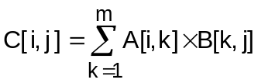 where m = the number of columns of A
Matrix multiplication is only defined if the number of columns in A is the same as the number of rows in B. Result C has number of rows = number of columns of A and number of columns = number of rows of B. Thus if, A is 2x3 and B is 3x2 the result C is 2x2.

for (i = 0; i < columns; i++)
for (j = 0; j < rows; j++)
for (k = C[i][j] = 0; k < n; k++) //n = rows or columns
C[i][j] += A[i][k] * B[k][j];
- The transpose of a matrix is defined as: an interchange of the rows and columns of the matrix. Thus a matrix A defined as a 3x4 matrix will have a transpose which is 4x3.

for (i = 0; i < rows-1; i++)
for (j = i+1; j < columns; j++){
temp = A[i][j];
A[i][j] = A[j][i];
A[j][i] = temp;
}

Example Execution:
Enter the row dimension of matrix A: 3
Enter the column dimension of matrix A: 3
Enter the row dimension of matrix B: 3
Enter the column dimension of matrix B: 3

Matrix A is:
2 4 5
3 1 4
2 6 8

Matrix B is:
3 4 1
2 5 1
2 6 2

Sum of A + B is:
5 8 6
5 6 5
4 12 10

Product of A × B is:
24 58 16
19 41 12
34 86 24

Transpose of Matrix A is:
2 3 2
4 1 6
5 4 8

Transpose of Matrix B is:
3 2 2
4 5 6
1 1 2

Transpose of Matrix C is:
24 19 34
58 41 86
16 12 24

Matrix Operations Explained

Matrix Addition

for (i = 0; i < n; i++)
for (j = 0; j < n; j++)
A[i][j] = B[i][j] + C[i][j];

In general, matrix addition is defined only for two matrices of the same size (although they do not need to be square). Thus A[n,m] = B[n,m] + C[n,m] with addition defined as:

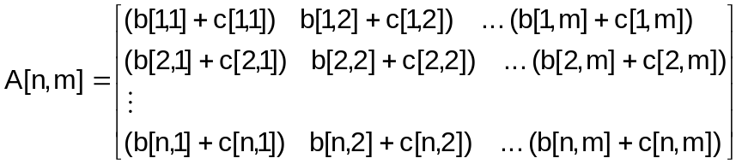

Example:

Martix B
2 | 3 | 2
1 | 4 | 6
3 | 2 | 2

Matrix C
4 | 3 | 2
1 | 3 | 3
2 | 2 | 4

Matrix C = A[n,m] + B[n,m]
2 + 4 = 6 | 3 + 3 = 6 | 2 + 2 = 4
1 + 1 = 2 | 4 + 3 = 7 | 6 + 3 = 9
3 + 2 = 5 | 2 + 2 = 4 | 2 + 4 = 6

Matrix Multiplication

for (i = 0; i < n; i++)
for (j = 0; j < n; j++)
for (k = A[i][j] = 0; k < n; k++)
A[i][j] += B[i][k] * C[k][j];

In general: matrix multiplication of two matrices B[n,m] and C[m,r] is defined as:

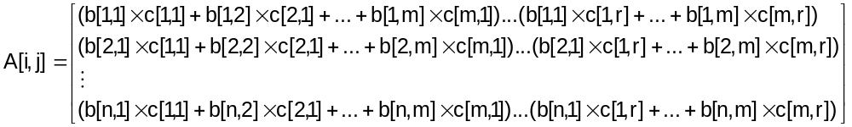
(Note that the dimensions of A are n × r, in the general case, since m = m)
Since we are dealing with only square matrices n = r.

Example:
Matrix B
2 | 3 | 2
1 | 4 | 6
3 | 2 | 2

Matrix C
4 | 3 | 2
1 | 3 | 3
2 | 2 | 4

Matrix A = B × C
(2*4 + 3*1 + 2*2) | (2*3 + 3*3 + 2*2) | (2*2 + 3*3 + 2*4)
(1*4 + 4*1 + 6*2) | (1*3 + 4*3 + 6*2) | (1*2 + 4*3 + 6*4)
(3*4 + 2*1 + 2*2) | (3*3 + 2*3 + 2*2) | (3*2 + 2*3 + 2*4)

Thus Matrix A is:
15 | 19 | 21
20 | 27 | 38
18 | 19 | 20

Matrix Transposition

for (i = 0; i < n-1; i++)
for (j = i+1; j < n; j++){
temp = A[i][j];
A[i][j] = A[j][i];
A[j][i] = temp;
}

In general, the transpose of a matrix is the matrix that results from the interchanging of its rows and columns. Given a matrix B, its transpose is generally denoted as B^{T}.

Example:

Matrix B
2 | 3 | 2
1 | 4 | 6
3 | 2 | 2

Matrix B^{T}
2 | 1 | 3
3 | 4 | 2
2 | 6 | 2

Matrix A = B × C
(2*4 + 3*1 + 2*2) | (2*3 + 3*3 + 2*2) | (2*2 + 3*3 + 2*4)
(1*4 + 4*1 + 6*2) | (1*3 + 4*3 + 6*2) | (1*2 + 4*3 + 6*4)
(3*4 + 2*1 + 2*2) | (3*3 + 2*3 + 2*2) | (3*2 + 2*3 + 2*4)

Thus Matrix A is:
15 | 19 | 21
20 | 27 | 38
18 | 19 | 20

Matrix Transposition

for (i = 0; i < n-1; i++)
for (j = i+1; j < n; j++){
temp = A[i][j];
A[i][j] = A[j][i];
A[j][i] = temp;
}

In general, the transpose of a matrix is the matrix that results from the interchanging of its rows and columns. Given a matrix B, its transpose is generally denoted as B^{T}.

Example:

Matrix B
2 | 3 | 2
1 | 4 | 6
3 | 2 | 2

Matrix B^{T}
2 | 1 | 3
3 | 4 | 2
2 | 6 | 2

