COP 3502 – Lab Notes

Continuation of Order Analysis

Last week’s lab introduced you to the concept of order analysis. This week we will use this information to estimate the running time of algorithms based on their order.

Estimating Run-Time

We know that we can't accurately compare run times measured on different machines, or with different operating systems or languages or compilers. But, what if we have measured the run time of a specific algorithm, on a specific combination of hardware, OS, language and compiler? How do we estimate the new run time just for a change in data size?

If the algorithm is linear, i.e., O(n), it should be easy. If we know the ratio of old data size to new data size, we know the increase or decrease in time. For example: if it took 10 seconds for n = 50, then if we double the data size to n = 100, it should take twice as long.

Since increases in data size are not always going to be by integer multipliers,
we should generalize this calculation to a simple formula that can be used for
any values:

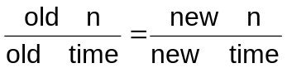

This formula is based on the fact that the ratio of data size (n) over time is the same for both the old and new data sizes, i.e., the time to perform each step is the same. The increase or decrease in time comes from the change in the size of the data, which means more or fewer steps are needed.

For example: if we know that a certain O(n) algorithm takes 30 seconds when n = 75, we can calculate the estimated time for n = 100 as follows:

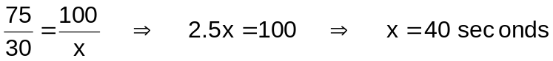

But, what if the algorithm is O(n²)? We must modify our formula a little. Since the formula puts n over time, it is really calculating how much time each step takes, i.e., 75steps/30seconds = 2.5 steps/second or 2/5 seconds per step.

So, what does that mean for our formula for O(n²)?

We know that an O(n) algorithm takes (by our definition of Order) roughly 1 step for each item in the data set, thus it takes n steps for n items. But, an O(n²) algorithm takes n² steps for n items. Thus, we should use that number of steps on top of the formula:

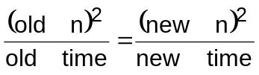

So, for a given O(n²) algorithm with n = 10, that takes 50 seconds, if we increase n to 20, how much longer will it take?

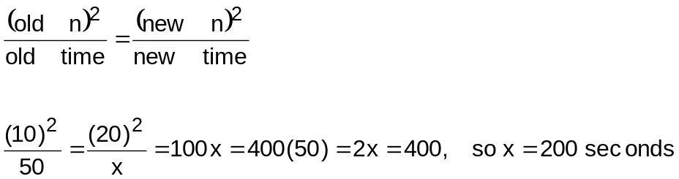

The same would be true for O(n³), O(n⁴) , O(n⁵), and O(n^{m}) algorithms. We must calculate the number of steps needed for a certain data size and divide by the time required to complete the task.

So, what about O(2^{n}) algorithms? Again, we must find the number of steps and divide by the time:

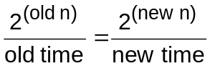

So, for a given O(2^{n}) algorithm with n = 4 that takes 48 seconds, if we increase n to 6, how much longer will it take?

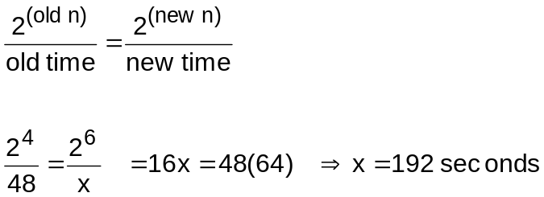

The same general method can be used for estimating run times for algorithms that are O(log₂ n), O(n³), O(n!), etc.

We can also use this method when we know the change in time and want to find the change in data size that has occurred. As long as we have three out of the four values (sizes and/or times), we can find the fourth by simple algebra.

Remember, these are only estimates and are only useful when the only thing that
varied was the data size (same machine, compiler, OS, etc.).

Practice Problems

- For an O(n!) algorithm, one data set with n=4 takes 72 seconds. How long will it take for a data set with n=5?

360 seconds

- For an O(2^{n} ) algorithm, one data set with n=7 takes 96 seconds. If you used a different sized data set and it took 12 seconds to run, how large must that data set be?

n=4

- For an O(n/lgn) algorithm, and instance with n=32 runs takes 96 ms. How long would it take to run the algorithm with n=64?

160ms.

- For an O(nlog₂ n) algorithm, one data set with n=16 takes 32 seconds. How long would it take for a data set with n=8?

12 seconds

- Question: Find the value of x in terms of n after the following code segment below has executed. You may assume that n is a positive even integer.

x = 0;
for (i = 1; i <= n*(8*n+8); i++) {
for (j = n/2; j <=n; j++) {
x = x + (n – j);
}
}

First notice that all we are doing is repeatedly adding numbers into x. Furthermore, since the inner loop is NOT dependant on the value of i, we are adding the same value into x for each iteration of the outer loop.

0+1+2+...+n/2 = n/2*(n/2+1)/2 = (n² + 2n)/8

Now, we see that we add this value into x exactly n(8n+8) number of times. Repeated addition is multiplication, so the value of x after the loops are done will be

(n² + 2n)/8*n(8n+8) = n(n+2)/8*n*8*(n+1)

= n²(n+1)(n+2)

- 6. Given the following pseudocode segment, answer the questions below for an arbitrary n:
x = 0
for(i=1 ; i<=2n; i++)
for(j=1; j<=i, j++)
x=x + 3;

- What is the Order of this segment? (3 pts) O(n²)

b) What will be the value of x when the for loops end? (3 pts)

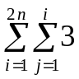 = 3 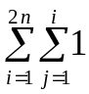 = 3 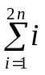 = 3 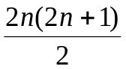 = 3 (n(2n+1)) = 6n² + 3n

