Computer Science Foundation Exam
December 14, 2001
Section I B
No Calculators!

KEY
Name:

SSN:

In this section of the exam, there are three (3) problems

You must do all of them.

The weight of each problem in this section is indicated with the problem. The algorithms in this exam are written in a combination of pseudocode and programming language notation. Any algorithms that you are asked to produce should use a syntax that is clear and unambiguous. Partial credit cannot be given unless all work is shown.

As always, be complete, yet concise, and above all be neat. Credit cannot be given when your results are unreadable.
(4, 10%) You are given two global arrays A and B, each including a range of locations from 1 to n. Arrays A and B are already populated with arbitrary integer values, while array C has been initialized to zero at each location. Write a recursive subroutine called prob4 that will compute the sum of A[I] and B[I] and store it in C[I], for each value of I ranging from 1 to m. Your subroutine should require a single parameter to accomplish its task.

Example: A = [1, 2, 4, 5] and B = [6, 3, 2, 4] the call prob4(2) would produce C = [7, 5, 0, 0]

Either form is acceptable

(5, 18%) Find the closed form expression in terms of the parameter N (and M where indicated) for each of the following summations:
a)
Give the value of this expression for N = 38.

b) 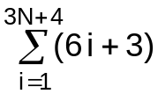 = 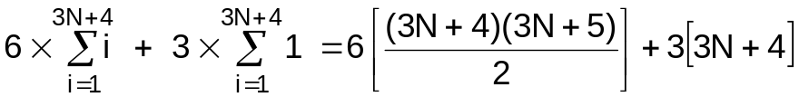

c) 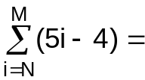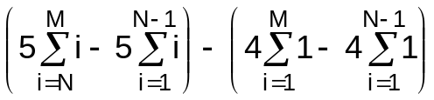

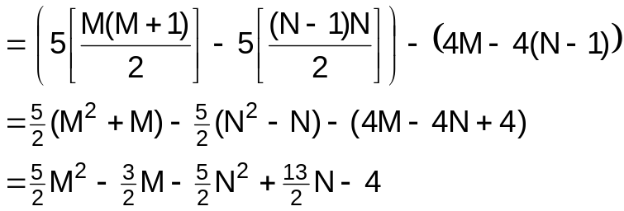
Give the value of this expression for N=40 and M = 68.

c) 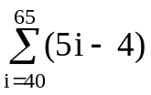= 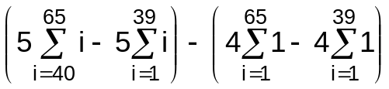

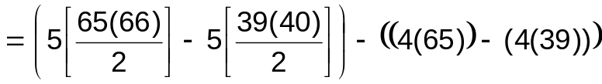

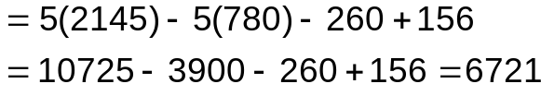
(6, 18%) Given the following Binary Tree, answer the questions below :
50

20
60

80
558
26
10

75
22

18
25
70
77

a) Is this a valid Binary Search Tree? (circle one) YES NO

b) List the nodes of this tree in the order that they are visited in a preorder traversal:

first node last node
visited visited

c) Perform the following procedure on the tree above, listing the output in the spaces below and leaving any unused spaces blank. Assume that the procedure is initially called with: P6(root, 20) and that the tree nodes and pointers are defined as:

tree_node definesa record
data isoftype Num
left, right isoftype ptr toa tree_node
endrecord
tree_ptr isoftype ptr toa tree_node

procedure P6 (node_ptr isoftype in tree_ptr, key isoftype in Num)
if (node_ptr <> NULL) then
P6(node_ptr^.left, (node_ptr^.data - key))
P6(node_ptr^.right, (node_ptr^.data + key))
if (node_ptr^.data > key) then
print(node_ptr^.data)
endif
endif
endprocedure

