COP 3503 Summer 2002
Computer Science II
Exam #1 Solutions
June 17, 2002
Name : __________________
1) (10 pts) Using the definition of Ω, prove that n² - 4n + 8 = Ω(n²). (Note: In order to get credit for this question, you must state which values of c and n₀ you are picking.)

Pick c = 1/2 and n₀ = 5. It will be shown that n² - 4n + 8 > (1/2)n², for all n > 5.
We can show this by showing that the difference of the two functions is greater than 0 for the specified domain (all n > 5):

n² - 4n + 8 - (1/2)n² = (1/2)n² - 4n + 8
= (1/2)[n² - 8n + 16]
= (1/2)(n-4)²
> 0, since all squares of real numbers are non-negative and n≠4.

2) (10 pts) Consider executing the O(n²) and the O(n) MCSS algorithms on the list of numbers below:

9, -3, 7, -12, 3, -2, 5, -8, 8, 13, -20, 6, -4, 3, -5, 3, -2, 18, 9, -4, 5

In both algorithms, we keep track of the "best sum seen so far." Let the variable that stores this value be sum. Every time we see a better sum, we CHANGE the value stored in sum. For both algorithms, sum is initialized to 0. For each algorithm, how many times is sum changed? Also, list each value of sum during the algorithm. (Hint: Do not take too much time tracing through the O(n²) algorithm. Instead consider how it works to answer the question.)

The O(n) algorithm computes the following sums: 9, 6, 13, 1, 4, 2, 7, -1

at this point, the sum variable gets reset to 0 and then these sums are computed:

8, 21, 1, 7, 3, 6, 1, 4, 2, 20, 29, 25, 30

Of these, the variable sum takes on the values 9, 13, 21, 29, and 30

The O(n²) algorithm calculates all possible sums. But, you must consider what order they will be calculated. The only difference is that it WON'T reset sum to 0 in that first iteration. So, its sequence of sums in the first iteration is:

9, 6, 13, 1, 4, 2, 7, -1, 7, 20, 0, 6, 2, 5, 0, 3, 1, 19, 28, 24, 29
After this iteration, sum will be 29 and will only be replaced once by the actual MCSS, 30. So sum will take on the values 9, 13, 20, 28, 29, and 30 in the O(n²) algorithm.

O(n) algorithm : 5 , List of values of sum: 9, 13, 21, 29, 30
O(n²) algorithm: 6 , List of values of sum: 9, 13, 20, 28, 29, 30
3) (10 pts) Use induction to prove that the following summation is true for all positive integers n:

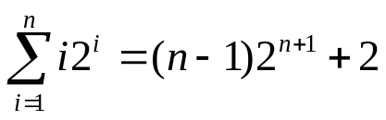

Base case. n=1 LHS = 1(2)¹ = 2, and RHS = (1-1)2¹⁺¹+2 = 2. Thus for n=1, the equation is true.

Assume for an arbitrary positive integer n=k that
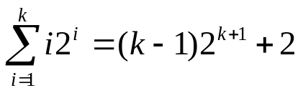
Under that assumption, prove for n=k+1 that
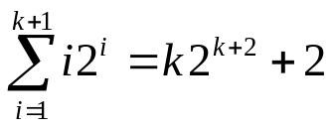

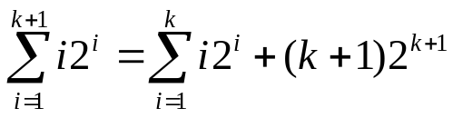
= 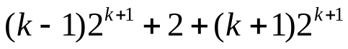, using the I.H.
= 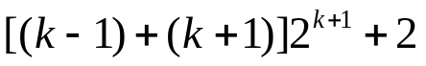
= 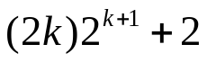
= 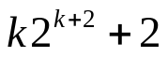,
which proves the inductive step, assuming the inductive hypothesis. Thus, the formula given above is true for all positive integers n.

8) (9 pts) Solve the following recurrence relations using the formula given in the textbook:

a) T(n) = 5T(n/2) + O(n²)

A = 5, B = 2, k = 2, since 5 > 2², this is the first case and T(n) = O(n^(log₂5)).

T(n) = O(n^(log₂5))

b) T(n) = 8T(n/3) + O(n²)

A = 8, B = 3, k = 2, since 8 < 3², this is the third case and T(n) = O(n²).

T(n) = O(n²).

c) T(n) =32T(n/4) + O(n^{2.5})

A = 32, B = 4, k = 2.5, since 32 = 4^{2.5}, (to see this note that 4 = 2² so 4^{2.5} = 2^{2(2.5)} = 2⁵=32), this is the second case and T(n) = O(n^{2.5}log₂n).

T(n) = T(n) = O(n^{2.5}log₂n).

9) (3 pts) Tiger Woods, who just captured golf's U.S. Open is named after this Indian land mammal.

Tiger

