Main Memory Management

Project #1

- The input file (Allocate_deallocate1.txt)

Example of an input file:
Best-fit
Allocate Process 1 200
Allocate Process 2 100
Allocate Process 1 50
Allocate Process 3 150
Deallocate Process 1
Allocate Process 2 75
Deallocate Process 2
Allocate Process 1 200
Deallocate Process 3
Deallocate Process 1

2) Data structures

- #define MEMSIZE 1024

- char MEM[MEMSIZE];

- seg_list is used for maintaining list of free memory segments

- struct seg_list {
unsigned long segptr; /* index in MEM */
unsigned long segsize; /* could be all of MEM */
struct seg_list *next;
};

- struct seg_list *FreeMem = NULL;

- The FreeMem list is maintained in order by base address of each free segment on the list
  - FreeMem = calloc(1, sizeof(struct seg_list));
  - FreeMem->segsize = MEMSIZE;
  - FreeMem->segptr = 0;
  - FreeMem->next = NULL;

- struct segment_type{
long membase; /* memory address of segment */
unsigned int seglen; /* segment length */
};

- struct pcb_type {
struct segment_type *segtable; /* segment table pointer */
unsigned int segtab_len; /* segment table length */
}

- struct pcb_type **PCB_Table = NULL;
  - PCB_Table = calloc(MAX_NUMBER_OF_PROCESSES, sizeof(struct pcb_type *));

3) int Search_FreeMem( unsigned int len )
- This function searches the list of free memory segments for a segment of at least length (len) and returns the address of this free segment.
- If the request cannot be satisfied, return( -1 )
- If MEM[i] denotes the beginning of a free segment, then "return i“; DO NOT RETURN "&MEM[i]".
- Update the FreeMem list element from which the space was taken and the variable (available_memory)

4) Dynamic Storage-Allocation
- First-fit
  - Allocate the first hole that is big enough.
- Best-fit
  - Allocate the smallest hole that is big enough
- Worst-fit
  - Allocate the largest hole

5) int Alloc_seg( unsigned int len )
{
- Check if there is sufficient free space (available_memory)
- If the request cannot be satisfied, return( -1 ).
while(1) {
Segment_base_address =Search_FreeMem(len );
if(Segment_base_address>=0)
return Segment_base_address;
Compact_mem();
}
}

6) main( ) {
Test_Mem();
}

Test_Mem( ){

for (i=0;i< MAX_NUMBER_OF_PROCESSES;i++)
{
PCB_Table[i] = calloc( 1, sizeof( struct pcb_type ));
allocate memory for the PCB_Table[i]->segtable ( Assume that the maximum length of the segment table is MAX_NUMBER_OF_SEGMENTS); // MAX_NUMBER_OF_SEGMENTS = 10
}

// get input from Allocate_deallocate1.txt
while (condition1) {
get operation, process_no, and seglen from Allocate_deallocate1.txt
if operation = “Allocate”
if MAX_NUMBER_OF_SEGMENTS > PCB_Table[process_no]-> segtab_len
Membas=Alloc_seg(seglen)
if Membas!= -1
increment PCB_Table[process_no]-> segtab_len
PCB_Table[process_no].Membase=Membas;
PCB_Table[process_no].seglen=seglen;
if operation = “Deallocate”
Dealloc_memory(PCB_Table[process_no]);
…
}
…
}

8) Compact_mem()

(1)


(2)
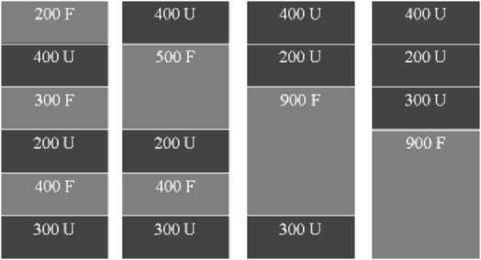

(3)
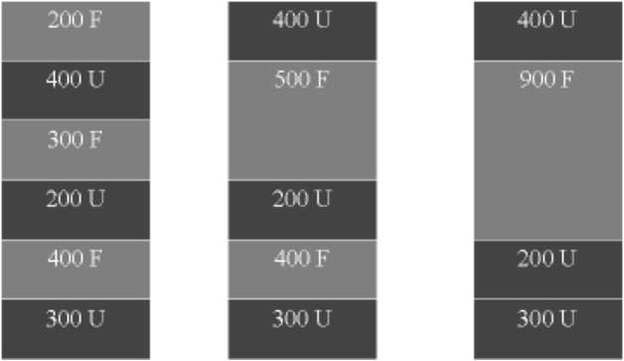

(4)
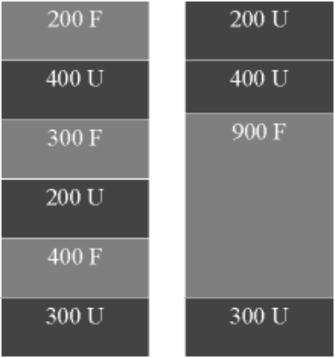

- You must use 1 or 4

9) Dump_mem_seg()

- Call Dump_mem_seg() for any change in memory segments
- Log.out

Example
Allocate/Deallocate/Move/Merge
Free memory = 674
100 Used
50 Used
150 Free
200 Used
124 Free
400 Free

10) Dealloc_memory( struct pcb_type *pcb)
- Search for the first pair of elements satisfying the relation: b[i] < base < b[i+1]. Create a new free list element with [base, len] and insert it at the appropriate place between b[i] and b[i+1].

- Update the variable (available_memory)

- Call Merge_seg() to scan the FreeMem list looking for adjacent pairs of elements E[i] = { b[i], len[i] } and E[i+1] = { b[i+1], len[i+1] } where b[i+1] = b[i]+len[i].

11) Example

Allocate_deallocate1.txt
First-fit
Allocate Process 1 200
Allocate Process 2 100
Allocate Process 1 300
Deallocate Process 1
Allocate Process 2 300
Allocate Process 3 200
Allocate Process 3 400
Allocate Process 3 24
Deallocate Process 2
Allocate Process 1 200
Deallocate Process 3
Deallocate Process 1

- available_memory=1024;
- FreeMem list = {(0,1024)}

Allocate Process 1 200
PCB_Table [0] ->segtab_len = 1;
PCB_Table[0] -> segtable = {(0, 200)}
FreeMem list = {(200,824)}

Allocate Process 2 100
PCB_Table [1] ->segtab_len = 1;
PCB_Table[1] -> segtable = {(200, 100)}
FreeMem list = {(300,724)}

Allocate Process 1 300
PCB_Table [0] ->segtab_len = 2;
PCB_Table[0] -> segtable = {(0, 200), (300, 300)}
FreeMem list = {(600,424)}

Deallocate Process 1
PCB_Table [0] ->segtab_len = 0
PCB_Table[0] -> segtable = {}
FreeMem list = {(0,200), (300, 300), (600, 424)}

Merge_seg()
FreeMem list = {(0,200), (300, 724)}

Allocate Process 2 300
PCB_Table [1] ->segtab_len = 2;
PCB_Table[1] -> segtable = {(200, 100), (300, 300)}
FreeMem list = {(0,200), (600, 424)}

Allocate Process 3 200
PCB_Table [2] ->segtab_len = 1;
PCB_Table[2] -> segtable = {(600, 200)}
FreeMem list = {(0,200), (800, 224)}

Allocate Process 3 400

PCB_Table[0] -> segtable = {}
PCB_Table[1] -> segtable = {(200, 100), (300, 300)}
PCB_Table[2] -> segtable = {(600, 200)}
FreeMem list = {(0,200), (800, 224)}

Compact_mem()
PCB_Table[0] -> segtable = {}
PCB_Table[1] -> segtable = {(200, 100), (300, 300)}
PCB_Table[2] -> segtable = {(824, 200)}
FreeMem list = {(0,200), (600, 224)}

Compact_mem()
PCB_Table[0] -> segtable = {}
PCB_Table[1] -> segtable = {(200, 100), (524, 300)}
PCB_Table[2] -> segtable = {(824, 200)}
FreeMem list = {(0,200), (300, 224)}

Compact_mem()
PCB_Table[0] -> segtable = {}
PCB_Table[1] -> segtable = {(424, 100), (524, 300)}
PCB_Table[2] -> segtable = {(824, 200)}
FreeMem list = {(0,200), (200, 224)}

Merge_seg()
FreeMem list = {(0, 424)}

PCB_Table[2] -> segtable = {(824, 200),(0, 400)}
FreeMem list = {(0, 24)}

Allocate Process 3 24
PCB_Table[2] -> segtable = {(824, 200),(0, 400), (400,24)}
FreeMem list = {}

...
…

Due Date: Sept. 17, at 6:00pm
- Hardcopy.
- Softcopy with executable file on a 3.5” disk (you must check that the disk doesn’t contain any virus).
- Do not forget to put your name, your email, and your pid on everything
- Write what OS you used.
- Write if your program works or not.
- Make an example; print the input and the output of that example.

