VLSI
Vary Large Scale Integration
Chapter 56

Michael DePouw
10-2-03
Vary Large Scale Integration (VLSI) is a term used to describe the level of integration in which current computers are designed in. VLSI is the culmination of 100 years of computer refinement. It allows for computing devices to achieve smaller and smaller sizes. To understand what VLSI is an understanding of what a transistor and an integrated circuit are is extremely important. And understanding why and how they were invented helps to tie all the pieces together.
In 1906 the Venerable Vacuum Tube computer was invented. This allowed for number crunching that was not fathomable a few years before that. As the computer was adapted for more and more uses certain limitations were experienced. For instance, they were incredibly unreliable. A vacuum tube computer composed of 1000 tubes might malfunction once an hour. They were also extremely large and consumed tremendous amounts of electricity which produced enormous amounts of heat.
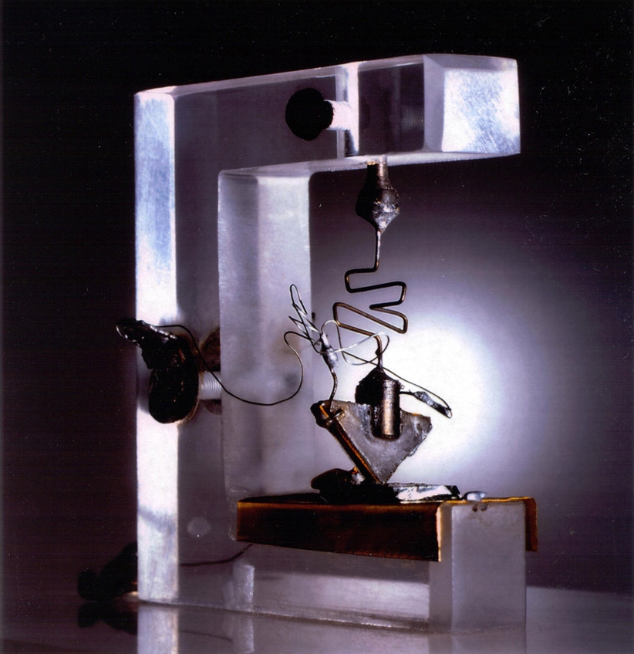
In 1947 at Bell Labs, Shockley, Bardeen, and Brattain invented the transistor. This was the answer to the problems of the vacuum tube computer. The transistor was small which meant is consumed a lot less power and therefore gave off a lot less heat. This made it enormously more reliable. A transistor has two basic functions: switching and modulation/amplification. For example a dimmer is analogous to a transistor. The dimmer can act like a switch by turning the light on or off. It can also act as a modulator by dimming or illuminating the light.
A few years after the introduction of the transistor a junction transistor was created at Bell Labs by Shockley. A junction transistor is composed of 3 layers of semiconductors. Semiconductors are in between conductors and insulators. Semiconductors don’t readily allow for the passage of electricity until they are doped. Once a semiconductor is doped it will contain an unequal amount of electrons and protons and thus allow for the transportation of current. To achieve this doped effect an additional element is added to the semiconductor. Semiconductors with an addtional number of electrons are called n-type semiconductors. Semiconductors with a shortage of electrons are called p-type semiconductors. The junction transistor is composed of a layer of p-type semiconductor called the base sandwiched between two n-type semiconductors called the emitter and collector. The base controls the current flowing between the emitter and collector creating a transistor. Instead of Bell Labs keeping this information in-house they shared it with virtually any interested company.

Emitter | N-Type
Base | P-Type

Collector | N-Type

The transistor allowed for more complex machines to be created. In fact so complex that a major problem with the transistor was soon discovered, wiring. As complexity increased so did the number of soldering connections. A machine composed of a 1000 transistors might have 3000 soldering joints. So the race was on to find a solution.
In 1952 a British scientist named Dummer developed the idea of a wireless electrical circuit. His idea was really an extension of the junction transistor. In 1958 at Texas Instruments Kilby created the first wireless electrical circuit also known as an integrated circuit or chip. During the same period, Hoerni at Fairchild Semiconductor created the first planar transistor. Planar transistors are like junction transistors except n-type and p-type layers are only a few atoms thick and multiple layers are nested on top of each other. In 1959 at Fairchild Semiconductor, Noyce applied the planar fabrication technique to other electronic components created on a silicon slab. Noyce also purposed narrow conducting channels to remove wires. So finally the solution to the discrete transistors was born with the creation of the integrated circuit.
The problem with the first integrated circuits was that they were extremely expensive. For example a flip-flop, which holds one bit, was $450! Luckily in 1961 President Kennedy decided that our nation should send a man to the moon and back him back safely. Because price became no object the integrated circuit market flourished and prices continuously fell.
Researchers at Motorola found a compelling reason to reduce chip size. The smaller the chip the more likely the chip is going to work. The reason why some chips run afoul during manufacturing is dust. If a particle of dust gets on the chip during manufacturing it becomes garbage. For example is a wafer contains 6 chips and a dust of particle gets on the wafer it might ruin 2 chips. If the wafer contains 42 chips, 2 chips will still get ruined but the remaining 40 wouldn’t. This yields a 10 fold increase in quantity with a 7 fold increase in integration. As integration increased the new problem became that it was harder and harder to integrated planar transistors.
In the early 1970’s Metal-Oxide-Semiconductors (MOS) were introduced. MOS allowed for greater integration to occur. This became the era of Large Scale Integration (LSI). The problem with LSI was that it became a black art. Very few people understood the technology, so the only place to get an education in the subject was on the job from senior level employees.
This all changed with the introduction of a book in 1979. The book was Introduction to VLSI Systems by Mead and Conway. This book was revolutionary for a few reasons. One it provided a central location for acquiring information on chip design. Two it spawned a course on VLSI at almost every engineering school. This drastically increased the number of trained people in the field of VLSI and reduced the cost of hiring such people. This allowed for all types of companies who never designed chips before to suddenly be able to have a chip design department. Third the book introduced the idea of logical networks. These are the and, or, not … gates used by the designers today.
VLSI circuits are fabricated from a three layer substrate with an insulating layer between them. In VLSI circuits the gate controls the flow of electricity between the source and the drain to create a transistor.
Source | Metal

Silicon Dioxide
Gate | Polysilicon
Silicon Dioxide
Drain | Diffusion

For example: This illustration is an example or a not gate. If X is high (gate is high) then X’ will be low because X’ will be grounded out. If X is low then X’ will be high because the Supply will supply a current for X’.
Gate (Polysilicon)
Drain (Diffusion)
X'
Ground
Supply
X

VLSI circuits are created in five major steps. The first step is to cut a silicon crystal into individual wafers. Each wafer contains hundreds of copies of a circuit. The second step is to cover the wafer with silicon dioxide. Then the unwanted silicon dioxide is removed by placing a mask over it and emitting intense radiation on it. A mask is just a cut out of the areas were the circuit needs to be for a specific layer. The third major step is to cover the silicon dioxide layer with a polycrystalline silicon layer. Then use another mask to remove unwanted areas. At this point the polycrystalline is doped. The fourth major step is to cover the polycrystalline with another layer of silicon dioxide and again removing unwanted areas with a mask. The last major step involves covering the circuit with a metal, typically aluminum and then applying a final mask. At this point the wafer is ready to be cut into individual chips and cemented into plastic.
References
Dewdney, A. K. The New Turing Omnibus. Henry Holt and Company, New York, New York, 1993

Glasser, Lance and Daniel W. Dobberpuhl. The Design and Analysis of VLSI Circuits. Addison-Wesley, Reading, Massachusetts, 1985

Mead, Carver and Lynn Conway. Introduction to VLSI Systems. Addison-Wesley, Reading, Massachusetts, 1980

Time Life Books. The Chipmakers. Addison-Wesley, Reading, Massachusetts, 1987

http://www.lucent.com/minds/transistor/pdf/tech.pdf

