COP 4232
Software Systems Development

Lab1 Requirements Documents

© Dr. David A. Workman
School of Computer Science
University of Central Florida
Orlando, Florida

May 19, 2004
May 20, 2004
May 25,26 2004
June 2, 2004
Lab1: Implement Classes of the IOMgmt Namespace

Objectives: To introduce features of C++ key to developing large software systems. To develop reusable components for the term simulation project. To introduce software specification concepts using UML.
C++ Features:
(1) File IO using fstream and its subclasses ifstream and ofstream.
(2) Exception classes and exception handling.
(3) Design principles for ASCII IO of class instances (OO Data Design)
(4) Namespaces for organizing and sharing reusable components or packages.
(5) Overloaded extraction (>>) and insertion( << ) operators as friend functions.
General Requirements:

All labs associated with this project shall include, as a minimum, the following deliverables: all source files necessary to successfully compile, link and execute the delivered application program using g++ on Unix (Olympus or eola); all input and output data files used to test the program prior to delivery; a Readme file giving your name (or team members), submission date, Lab number, and any comments about the submission that will help in fairly evaluating your work.

All delivered files shall be submitted electronically via email in the form of a (.zip) file with a prefix having the form: Lab <number> - <last name> - <month><day>. For example, the file name for Dr. Workman submitting Lab 2 on May 21 would be: Lab2-Workman-May21.zip. Note that only the first letter of each hyphenated phrase should begin with an upper case character; <number> is a single digit, <month> is three letter, <day> is two digits.

Any resubmission of the same Lab shall be submitted using the same file format – only the date portion would need to change. If you have more than one submission of a given Lab on the same day, then only the latest one will be evaluated for a grade.
1. Lab Introduction

You have already read the document entitled, A Specification For the Classroom Simulation System (CSS), published on the course web site (Assignments page). As a convenient reference, we have reproduced the part of that reference introducing the generic architecture for discrete event simulation systems. Figure 1 illustrates the four major system components of this architecture.

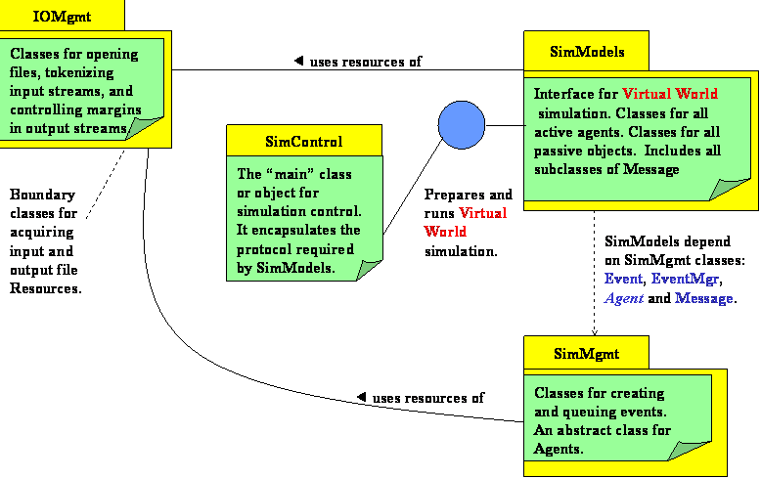

Figure 1. Component Architecture for Discrete Event Simulation

As mentioned in lecture, each programming assignment in this course will be structured around developing part or all of these components. Lab1 will focus on developing namespace IOMgmt, the set of utility classes designed to help the developer manage simulation input and output files.

The remainder of this section describes the member classes in detail. Lab1 will then consist of implement some of these classes. Some of these classes will be given to you as is. The Assignment page on the course web site will contain a link giving you access to the set of reusable class files you can download for this assignment.

1.1 Namespace IOMgmt

The namespace iomgmt provides reusable classes for identifying and opening existing ASCII input and output files. Figure 2 illustrates a UML class diagram describing the relationships among these classes.

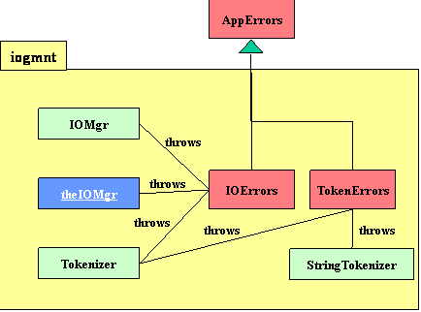

Figure 2. Class Diagram Namespace IOMgmt

Observe that there are two exception classes, IOErrors and TokenErrors, both derived subclasses of AppErrors. AppErrors and IOErrors will be given to you as reusable classes. A Lab1 requirement is that you implement TokenErrors following the style of IOErrors. TokenErrors should be used by client code to report syntax errors encountered when parsing class instances from some input stream. IOErrors are reserved for errors relating to external file disposition, availability, or violations to the host file naming convention.

Class IOMgr provides a method, getFileName(), taking a prompt message as a parameter and conducts a dialog with the user via the standard input (cin) and output (cout) boundary objects to obtain the name of an external file from the user. IOMgr also provides overloaded methods, openFile(), for opening files as input or output and throws an instance of exception, IOError, if the open operation does not succeed for the identified file. To facilitate formatting output streams, IOMgr offers a set of related methods for setting line margins in an output stream and forcing output to specified margins. Finally, as a convenience to clients, IOMgmt provides a pre-defined instance of class IOMgr called, theIOMgr. This single instance is visible everywhere iogmt is visible an obviates the need for the developer having to define such an instance.

Iomgmt provides a boundary class, Tokenizer, to provide a logical view of ASCII input files as streams of tokens as opposed to streams of characters or lines. In this view, the input file is an alternating sequence of delimiter strings and token strings, optionally beginning and ending with a delimiter string. Delimiter strings and token strings are composed from disjoint alphabets. The user can change the alphabet for delimiter strings at any time by a call to SetDelims(), the default alphabet is {blank, tab, EOL}. The token alphabet is always the complement of the delimiter alphabet. To obtain the next pair (delimiter, token) from the input stream, the client calls method Scan(). If no token exists in the input stream, Scan() returns the null string. If the client wishes to examine the delimiter string discarded by Scan(), it may do so by calling the method Discard() before the next call to Scan(). The delimiter string could be null on the first call to Scan(). The method More() is a boolean function that returns false once the end-of-file has been sensed.

Tokenizer interacts with the user to define the name of the input file using a pre-defined instance of IOMgr, theIOMgr, defined by the namespace, iomgmt. If the input file is not found or the open is unsuccessful for some reason, Tokenizer throws an instance of exception IOError.

Iomgmt also provides class, StringTokenizer. This class offers the same logical functionality as class Tokenizer except that it operates on string objects instead of an input streams. StringTokenizer is frequently useful for further tokenizing the discard and token strings returned by a Tokenizer.

AppErrors is an exception class defined in the global namespace. This is the root exception class. Every instance of this class contains two data members that define the origin of an exception (in what method and class?) and a message string that diagnoses the cause of the exception in the originating method. The values of these data members can be obtained by methods: getMsg() and getOrigin(). As the exception travels up the call chain, each exception handler (catch block ) has an opportunity to append additional information to the origin and message data members. After updating the exception content, the handler re-throws the exception to continue its propagation upward along the call chain to some point where the exception can be properly dealt with, or where the program must be terminated. Appending information to an exception is accomplished using the methods: appendOrigin() and appendMsg(). If the exception is handled ( caught ) at the highest level of control before the program terminates, the origin and message members of the exception can be output to provide a trace of the call chain and a diagnosis at each method that handled (caught ) the exception along this chain. Derived subclasses of AppErrors should be defined by an application to identify the general reason and origin of exceptions.

1.2. Class Specifications

Table 1.2.1a Attribute Table for TokenError
Data Member | Type | Purpose
-TOKENERROR | static const string | Provides a default exception origin of  ”TokenError{}”.
-msg | inherited from AppError | A message string diagnosing the exception cause.
-origin | inherited from AppError | A message string identifying the exception origin (class::method())

Table 1.2.1b Method Table for TokenError
Method | Profile | Purpose and Functional Requiremenst
+TokenError | () | Default constructor. Null body – automatic call to superclass default constructor.
+TokenError | (string Msg) | Appends parameter string (Msg) to inherited msg data member (msg) and defines inherited data member (origin) using the default origin  TOKENERROR.
+TokenError | (string Msg,  string Origin) | Appends parameter string (Msg) to inherited msg data member (msg) and appends inherited data member (origin) with the parameter (Origin).

Table 1.2.2a Attribute Table for IOMgr
Data Member | Type | Purpose
-fileName | string | The encapsulated file name input by the user as a result of a call to getFileName().  Default value = “”.
-prompt | string | The encapsulated prompt string passes as a parameter to getFileName(). The prompt is saved for possible use in constructing error messages when exceptions occur. Default value = “”.
-lineorg | long | This member is used to record the output stream file position immediately after a newLine() has called. All margin control methods will use this as the base file position. Default value = “0”.
-curpos | long | This member is used to record the current output stream file position immediately before or after an operation on the stream. Margin control methods use this member to compute the margin relative to the beginning of the current line of an output stream. Default value = “0”.
-margin | long[] | This member implements a stack of margin values relative to the beginning of the current line (lineorg). By pushing and popping this stack, the application program can record the position of output text on one line and return to that same relative position on subsequent lines. Size of the margin stack is a #define value: MARGINSIZE. Initial value of all elements is “0”.
-idx | int | Indexes the margin[] stack. Initial value = -1.

Table 1.2.2b Method Table for IOMgr
Method | Profile | Purpose and Functional Requiremenst
+IOMgr | () | Default constructor. Sets all data members to their default value.
+getFileName | (string Prompt)  return void  throw IOError | Writes the (Prompt) to (cout) and reads the user’s response from (cin), saving it in data member (filename). The (Prompt) is saved in data member (prompt). If the user enters a null string, this method writes an error message to (cout) and queries the user as to whether to “repeat” or “terminate”. If the user wishes to “repeat”, then the dialog is repeated. If the user wishes to “terminate”, an appropriate IOError exception is thrown and exit() is called to terminate the program.
+openFile | (ofstream& fout)  return void  throw (IOError) | Attempts to open (fout) as an output file (ios::out) using data member (filename). If the open operation fails, then an appropriate IOError exception is thrown.
+openFile | (ifstream& fin)  return void  throw (IOError) | Attempts to open (fin) as an input file (ios::in) using data member (filename). If the open operation fails, then an appropriate IOError exception is thrown.
+getName | () return string | An inspector method returning the value of data member (filename).
+pushMargin | (ofstream& fout)  return void  throw (IOError) | This method sets (curpos) to the current stream position on (fout) and then pushes the difference between (curpos) and (lineorg) onto the (margin[]) stack. It throws and IOError if there is a stack overflow. Hint: use library method tellp().
+popMargin | () return void  throw (IOError) | This method updates (curpos) from the top of the (margin[]) stack and pops the stack. If there is a stack underflow, an IOError exception is thrown.
+newLine | (ofstream& fout)  return void | Outputs a newline character (endl) to (fout) and resets (curpos) and (lineorg) to the current file position on (fout). Hint: use library method tellp().
+deltaMargin | (ifstream& fin,  int delta )  Return void | The purpose of this method is to skip forward or backward in the input stream (fin) by an amount (delta). If (delta) is negative, then this method allows the client to re-read part of the input stream. If (delta) is positive, then it allows the client to skip forward. Care must be taken in both cases not to skip backward or forward beyond the stream boundaries (BOF, EOF). An IOError exception should be thrown if an attempt is made to do so. Hint: use tellg(), seekg(0,ios::beg) and seekg(0,ios::end) to obtain file position values corresponding to the beginning and end of the file, respectively. Then, seekg( delta, ios:cur) should be between these limits.
+deltaMargin | (ofstream& fout,  int delta)  return void  throw IOError | The purpose of this method is to advance the output file position on (fout) by an increment (delta). If (delta) is zero, (curpos) is updated to the current file position. If (delta) is positive, (curpos) and the file position on (fout) is advanced by (delta) blank characters. If (delta) is negative, a call to newLine() is made to start a new line. The file position on (fout) and (curpos) are updated so that they define a margin on the new line that is less than the old margin (old curpos) on the previous line by amount (delta). The value of (delta) produces a negative offset on the new line, then an IOError exception is thrown. Hint: use library method seekp() and tellp().
+advToMargin | (ofstream& fout)  return void | This method issues a newLine() on (fout) and sets the current file position and (curpos) relative to the margin value on top of the stack. The stack is not changed. Hint: use library method seekp(). Remember that stack values are relative to (lineorg). Note: this method is somewhat similar to deltaMargin() except that it obtains the margin value from the stack, rather than from a parameter. A difference is that it always forces a new line for positioning to the new margin.
+toMargin | (ofstream& fout)  return void | This method sets the current file position on (fout) and (curpos) relative to the margin value on top of the stack. The stack is not changed. Hint: use library method seekp(). Remember that stack values are relative to (lineorg). Note: this method is somewhat similar to, but more dangerous than, deltaMargin() in that a new line is not forced if the file position is to the left of its previous position relative to (lineorg). Thus, this method could be used to overwrite earlier text if so desired. Use this method with care!
+pushToMargin | (ofstream& fout,  int delta )  return void  throw IOError | This method combines the function of pushMargin(fout) and deltaMargin(fout, delta).
+popToMargin | (ofstream& fout)  return void  throw IOError | A call is first made to popMargin() – this updates (curpos) from the top stack value and pops the stack. An IOError may be thrown on stack underflow. If no exception is thrown, the file position on (fout) is advanced to the new (curpos)
+pushAdvMargin | (ofstream& fout)  return void  throw IOError | Equivalent to pushMargin() followed by advToMargin().
+popAdvMargin | (ofstream& fout)  return void  throw IOError | Equivalent to popMargin() followed by advToMargin();
+clearMargins | () return void | Re-initializes the margin stack.

Table 1.2.3a Attribute Table for StringTokenizer
Data Member | Type | Purpose
-strbuff | string | Buffer used to hold the string to be tokenized.  Default = “”.
-DELIMS | static const string | Default delimiter string = { blank, tab }
-delimiters | string | Current active set of delimiter symbols. Default value = DELIMS
-discard | string | Contents of the discard string – the string of delimiter symbols read before reading the first non-delimiter (or token symbol).

Table 1.2.3b Method Table for StringTokenizer
Method | Profile | Purpose and Functional Requiremenst
+StringTokenizer | () | Default constructor.
+StringTokenizer | ( string astr ) | Constructor that initializes (strbuff) with (astr).
+CatBuff | ( string astr ) | Appends (astr) to the right end of (strbuff).
+More | () return bool | Returns true if there are more tokens in (strbuff). That is, at least one non-delimiter symbol remains.
+Scan | () return string | Returns the next token string, if there is one. Returns the null string (“”), otherwise. As a side effect the (discard) string is constructed from leading delimiter symbols before the first token symbol is encountered. Symbols are read from (strbuff) until it is empty (null).  The end of a token is the last non-delimiter read from (strbuff) before a delimiter symbol is encountered, or the end of (strbuff), which ever occurs first. If the token is terminated by a delimiter symbol, that symbol is put back on the left of (strbuff).
+SetDelims | ( string newDelims ) | Updates (delimiters) with a new set of delimiter symbols. If (newDelims) is null, a TokenError exception is thrown.
+GetDelims | () return string. | Returns the current (delimiter) string.
+GetDiscard | () return string. | Returns the current (discard) string.
+Reset | () return void. | Resets the (delimiter) string to DELIMS
+Putback | ( string back ) | Concatenates (back) to the left end of (strbuff).

1.3 Assignment Requirements

The general requirements for this assignment are the following:
- Implement classes TokenError, IOMgr, and StringTokenizer according to the class specifications given in section 1.2.
- Implement classes Agent, Instructor, and Student according to the specifications given in this section. (See #6.) In summary, this involves implementing the IO methods for reading ( writing ) instances of these classes from (to) ASCII files following the design and implementation principles for OO Data described in an earlier document. The output methods for these classes shall use the margin control methods of IOMgr.
- Test all the above classes by writing a simple main() that reads instances of Agent, Instructor, and Student from an input file designated at runtime by the interactive user. There will be exactly one instance of each class in the input file, but the order is random.
The logic of your main() should handle any order by: (a) checking the opening token of a class instance to identify the class responsible for parsing the input image, (b) pushing the opening token back to the input stream, (c) calling the extraction operator (>>) for an object of the relevant class to parse the image.
After all instances have been read, they are written to an output file designated at runtime by the interactive user. The instances shall be written in the order and format described below using the stream insertion operator (<<) and theIOMgr for margin control.
- Input Format. The input format shall be free-form with regard to margins. A class instance must have an ASCII image as prescribed in the guidelines on OO Data Design (i.e., open token, data member sequence, close token). The image of an input instance may begin on one line and end on another line. Line boundaries are permitted anywhere in an input image that a whitespace delimiter can legally occur; i.e.; line breaks cannot occur in the middle of a token that is part of the image syntax – only between complete tokens of the image.
Input Example.
Line1= Agent{ name: smith
Line2= age: 25 }Agent Student{ name: jones age: 19 PID: d555555 course:
Line3= COP4232 }Student
Line4= Instructor{ name: workman age: xxx officeHrs: MW(12pm-2:45pm)
Line5= }Instructor
Input Errors: If a violation occurs to the instance syntax, a TokenError exception shall be thrown by the input method identifying the originating method (and class) and the cause or type of error – as best it can be determined - and the offending token. The input method shall pushback the offending token for subsequent reading before throwing the exception. TokenError exceptions shall be caught and handled by main() by scanning tokens until the next closing (or opening ) token is found – if one exists. Input is allowed to continue until the end-of-file is reached, or until all valid instances of each type have been read.

- Output Format. The output image of each instance must have the format shown below.
Current Margin →Class{ member1: value1
→ member2: value2
→ …
→ memberk: valuek
→}Class
The opening token of a given instance shall begin on the same line as the closing token of the previous instance (if there is one), and there shall be 5 blanks separating these tokens. The first of the three instances shall begin at margin 10 on the first line of output. Note: The spacing between instances (and whether or not they can begin and end on the same line) is under control of the main(), the controlling method, but format of the instance image itself is defined by the class output methods.
The Agent instance shall be followed by the Instructor instance, and finally by the Student instance.
Output Example:
……….Agent{ name: smith
………. age: 25
……….}Agent…..Instructor{ name: workman
…………………... age: xxx
………………….. officeHrs: MW(12pm-2:45pm)
…………………..}Instructor…..Student{ name: jones
………………………………… age: 19
………………………………… PID: d555555
………………………………… course: COP4232
…………………………………}Student
- The Agent, Instructor and Student classes are specified by the UML Class Diagram shown below.

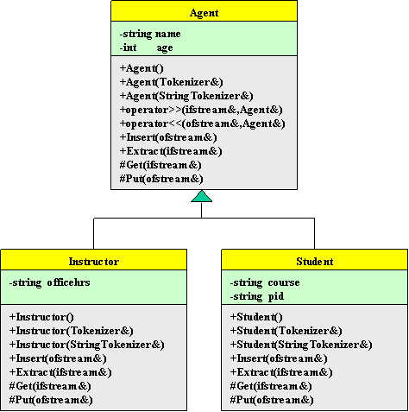
Figure 3. Class Diagram for Agent, Instructor, and Student

Note: The insertion (<<) and extraction (>>) operators must be implemented as friends in C++. They need only be declared in the base class – they will be inherited by any subclasses. The implementation of these operators will exploit polymorphism to call the appropriate Extract() or Insert() method that shall defined in every subclass. The methods Extract(), Insert(), Get(), and Put() shall be declared virtual in every class. This ensures that polymorphism will be invoked wherever and whenever these methods are re-defined in subclasses. A (-) prefix for a class member implies (private), a (+) implies (public), and a (#) implies (protected). Your source code shall be composed of the following files:
lab1.cpp //main file
IOMgmt.h //header file for iomgmt namespace
IOMgmt.cpp //implementation file for iomgmt namespace
agent.h //header file for class Agent
agent.cpp //implementation file for class Agent
instructor.h //header file for class Agent
instructor.cpp //implementation file for class Agent
student.h //header file for class Agent
student.cpp //implementation file for class Agent
makefile //program make file

