COP 4232
Software Systems Development

Lab2 Requirements Documents

© Dr. David A. Workman
School of Computer Science
University of Central Florida
Orlando, Florida

May 28, 2004
Lab2: Develop a Use Case Model for a Automobile Refueling System

Objectives: To apply the concepts and principles of Use Case Modeling to a real world system. To learn and apply the UML notation for Use Case Modeling.
USP Concepts and UML Features:
(1) Use Cases.
(2) Use Case Diagrams.
(3) Actors.
(4) Use Case relationships: include, generalize, specialize, association

Introduction: Auto Refueling System

Management of Jiffy Stop Convenience Store has been receiving a persistent stream of consistent complaints from customers about the inconveniences they suffer when purchasing gasoline. To help identify the potential problems with their gasoline service, Jiffy Stop management has commissioned a study to model this part of their business operations. (Start theme from “Mission Impossible”) Your task (should you choose to accept it) is to conduct this study and write a Use Case Model as the primary deliverable of the study. If you choose not to accept this assignment, “your grade will destruct in five seconds.”

Unless management can identify the cause of these complaints, customers will slowly migrate to the competition (DinoServ on the other side of the intersection with Alafaya) and Jiffy Stop will have to declare Chapter 11. This project is management’s only hope to stay in business (aren’t you convinced, now?)

The modeled scenario begins when the customer exits his/her car and walks to the gas pump to start the refueling process. It ends when the customer returns to his/her car after refueling is complete and leaves the premises of Jiffy Stop. Your modeling should answer the following questions at a minimum.

- What is the structure of the pump interface? How can it be improved?
- What payment options are available?
- What functions or use cases does the pump support?
- What is the interaction sequence or scenario for each use case?
- How many fuel grades are supported?
- What external systems support the pump’s capabilities.

The “Jiffy Store” in the above scenario is any convenience store of your choosing. Your model shall reflect the reality of refueling at this convenience store and shall be accurate in the interaction details required to execute a refueling task. The Use Case Model you prepare shall identify the actual convenience store modeled in this study. The outline for this document is given below.

Title Page and Format
- Document type, System Title, Author, Publication Date, Course, Assignment
- Table of Contents (TOC)
- Table of Figures
- The document must be page numbered!

System Summary
  - Scope and purpose of document ( Document content, Intended audience )
State the purpose of a Use Case Model and its intended audience.
  - Business case: motivation for building the system; how it meets needs of users and organization.
State why you are doing this study. Justify the need for this study.
  - Concept of Operation
    - Use Case Diagram – your model of Jiffy Stop as a car refueling system from the custormer’s perspective. (Example UCD shown below for the CoffeeMaker II System)
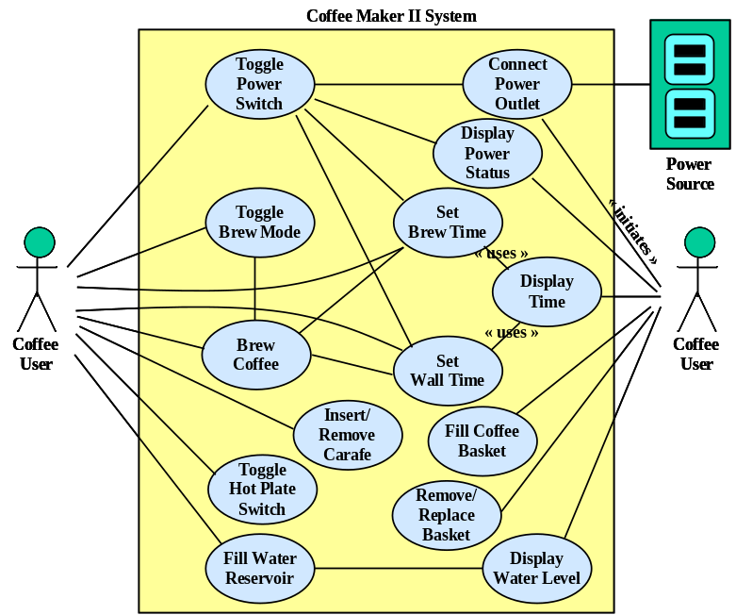
    - Narrative identifying and describing each use case in logical sequential (the order in which the user would execute them) and the relationships among the use cases. The description of each use case should identifies all actors involved in that use case (and perhaps key internal agents) and describe their roles with respect to the use case they engage in. The narrative should also identify all problem domain data consumed, manipulated, or produced by the system; this is information that actors must provide to the system or the system produces for actors.
  - System Architecture and Interfaces
Each use case defines an interface with actors. Information (data) flows across that interface (system boundary). This subsection describes the physical appearance of each use case interface with its actors and identifies what interface features are exercised to capture data supplied by an actor or delivered to an actor participating in the use case. This section should include the following:
    - Diagrams showing physical view of the system use case interfaces and a narrative describing the purpose of interface features for entering or displaying data. One figure can be used for several use cases. (Example below from CoffeeMaker II System)
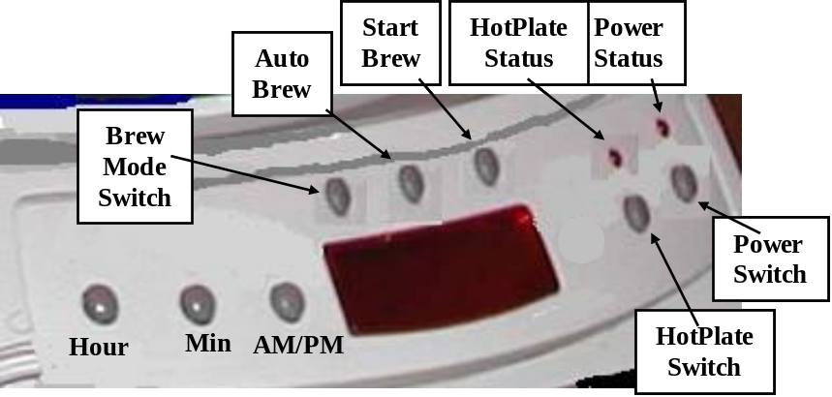
    - For each interface: identify the actors that exercise the interface, the problem data content, flow direction, medium and/or mechanism; e.g. panel with buttons and message displays, a gui window and/or menu, a file, a communication port.
- Use Case Specifications
This section should include a subsection (2.x) for each use case identified in section 1.3. Each use case should have the following format and organization.
  - Purpose: Specify the purpose of the use case – what it accomplishes from the view of the actors involved, or how they participate in the use cases. Support with an external collaboration diagram and/or system state diagram. See the illustration below taken from the CoffeeMaker II System.
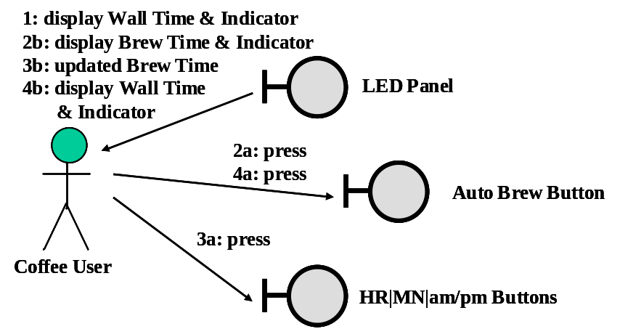
  - Preconditions: Identify and define the system states that must hold before the use case is defined or can begin, AND the triggering event(s) that mark the beginning of the use case.
  - Interaction Scenario: In conjunction with collaboration and state diagrams, present the primary or normal flow of interaction events that accomplish the purpose of the use case. The collaboration diagram identifies the system interface objects(features) involved in the scenario.
  - Alternative Scenarios: In conjunction with collaboration and state diagrams, present possible alternative flows of interaction events. This subsection can be used to describe error handling scenarios and/or alternative sub-use cases.
  - Post conditions: Specify the system states that result after the use case has completed, AND the event(s) that mark the end of the use case.
  - Other Requirements: resource constraints, other qualify factors (e.g. reliability).
- Requirements Traceability.
In this section you identify the sources of requirements and enumerate all
requirements statements. A source must be associated with each requirement. This is best presented in the form of a table.
- List all sources of requirements statements. A source can be a document, an
interview with some individual (customer or user or expert), or a web site, etc.
Each source should be uniquely identified (by number or acronym).
Ref[1] On site interviews with Jiffy Stop employees or data collected by observing Jiffy Stop customers.
Ref[2] Personal interview with Dr. David Workman, CEO of COP 4232.
- A Table should be constructed, such as the one shown below, where a statement
of the requirement is given (“will or shall” statement) and a reference to the
source containing that requirement statement.

Requirements Statments | Requirements  Source
“The system shall simulate a convenience store customer engaged in the activity of purchasing gasoline and refueling his/her vehicle from the time the customer exits the automobile to the time the customer returns to the automobile after refueling.” | Ref[1]. [dates]
“The pay-by-credit scenario shall support credit cards only – no debit cards.” | Ref[2].

- Glossary
The Glossary presents an organized list of problem space terms and their definitions as elicited from the client and system users. This provides the common vocabulary by which all system stake holders communicate. All common synonyms should be included, but the most common synonym should be used consistently through the rest of the document. For example, “clerk” is the most preferred term for the person that processes purchases and interacts with the customer to collect payment for gasoline purchased – this term should be used in the body of the document. However, one should list acceptable synonyms in a format as shown below.
Clerk: the convenience store agent (store employee) who processes each cash transaction for gasoline; the clerk configures the gas pump to dispense the appropriate fuel amount, and to produce a sales receipt of the transaction. Synonyms: cashier.
The Glossary should capture all terms that denote problem objects and system operations or use cases. It should capture all actors that externally interact with the system and the terms that pertain to actor interfaces. The Glossary should be used as a central repository of all information that is known about a particular term.

