Overview: The Mail Program is a simple application designed to act as the client in a client-server interaction where the server is an SMTP Server. The interactive user interacts with the client to define and send an email message. Once a Mail Message has been constructed, the client must connect to the server through a socket. Socket address “25” on the server will give the client access to the email protocol service (SMTP server). Once the connection has been accepted by the server, the client and server maintain a dialog consisting of a sequence of command-reply pairs defined by the SMT protocol. This scenario is defined in detail below.

Figure 1 shows a Functional architecture of the Mail program. Figure 2 shows an OO architecture of the same program.

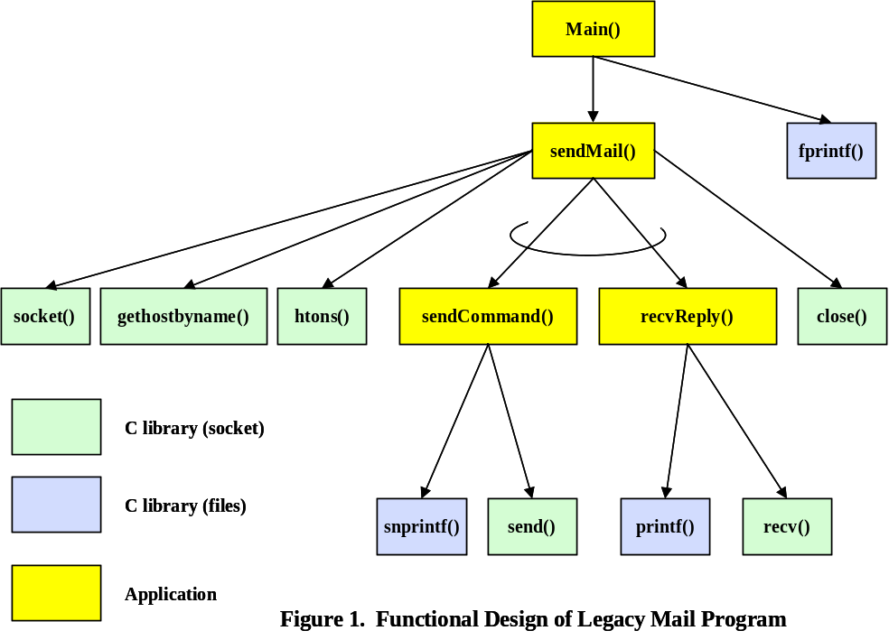

Figure 1 illustrates a functional style design. Observe the following:
- All modules are functions – data is implicit and flows through function parameters and results, or flows to or from an external IO medium.
- The thread and direction of control flow is clear.
- The problem data and its structure are completely hidden in this view.
Each module is realized by a C function. Data is passed by parameters or returned as a function result. Execution flow is left-to-right among functions that are called by the same parent in the hierarchy. Iteration is indicated by special annotations that “circle” one or more call arcs to subordinate functions (e.g. sendMail() calls sendCommand() and recvReply() in a loop ).

Figure 2 illustrates an object-oriented style design. Observe the following:
- All modules are objects – encapsulated data is explicit – the functions that manipulate it are also explicit and are members of the same module.
- Control flow is hidden in this view, just the way data and its organization was hidden in the functional design.
- The organization and relationships among data are clear in this design.

There are two major objects in the design, the Socket and the MailMsg. The Socket encapsulates and hides all details relating to the creation, initialization and use of a network socket provided by the client operating environment (client = operating system the Mail program is running on). It encapsulates the socket id, the socket address, and data about the server host. It hides the calls to C library functions that create and initialize a network socket on the client operating system.

The MailMsg object encapsulates and hides all the details about building an email message and then sending it. It hides the calls that create, interact with, and then finally close the Socket object needed to deliver the email message it represents.

The main() function interacts with the Mail Program user to define the information needed to construct a MailMsg object. Note that there are three layers of abstraction to our design. The lowest level of abstraction is the Socket object – it hides details relating exclusively to the access and use of network sockets as defined by the operating system interface. The next level of abstraction is the MailMsg object – it provides functions that build a valid email message and hides the SMTP protocol involving the Socket object. The highest level of abstraction is defined by the main() function that directly interacts with the Mail User – it is the application layer and implements a user-friendly interface.

In C each of these objects are implemented by two files: a header (.h) file and an implementation (.c) file. The header file contains only function prototype declarations and must be #include’d in any other file that needs access to the given object. The implementation file contains the bodies of all functions defined in the header file and declares static global data that are shared and manipulated by the encapsulated functions.

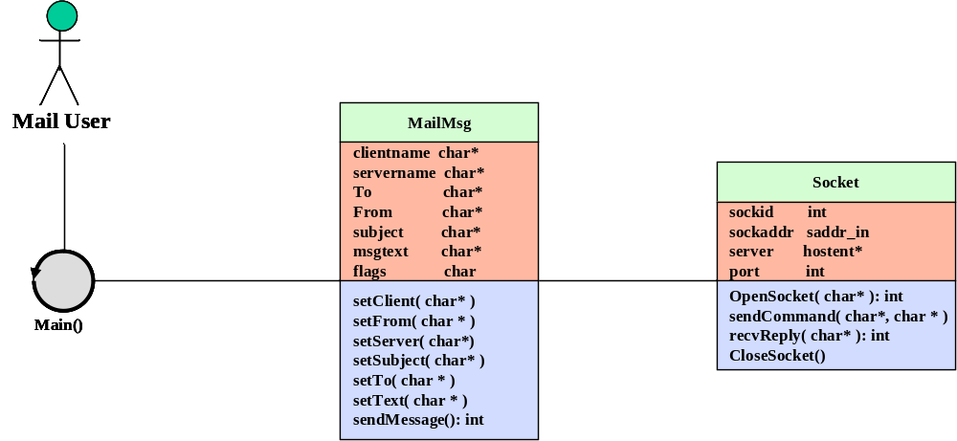

Figure 2. Object-Oriented Design of Mail Program
Figure 3 illustrates an example of a Collaboration Diagram in UML. The purpose of this type of diagram is to show the dynamic flow of messages between interacting objects in the design. This is in contrast to the UML Class Diagram shown in Figure 2, where only static class relationships are depicted along with details about class data and methods.

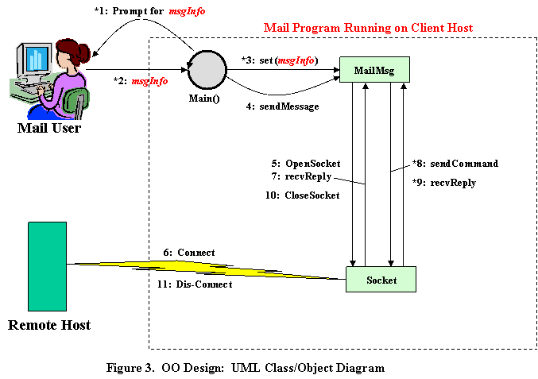

The SMTP Protocol

The Client and Server (hosts) “talk” to one another using the following interaction algorithm:

  - The Client opens a 2-way transmission channel using port 25.
  - The Client sends a MAIL command to the Server.
  - (a) If the Server can accept mail, it sends an OK reply back to the Client
(b) If not, it sends an ERROR reply = { 3-digit code, error text }
  - If the Server responded with OK, the Client sends an RCPT command that identifies the email address of a message recipient (mailbox address).
  - (Same as 3.)
  - Repeat 4-5 for each recipient of the message.
  - When 4-6 have completed successfully, the Client sends the mail message
= { subject, body }
  - (Same as 3.)
  - When 7-8 have completed, the Client closes the transmission channel.

Example of the SMTP Procedure.

This SMTP example shows mail sent by Smith at host Alpha.ARPA, to Jones, Green, and Brown at host Beta.ARPA. Here we assume that host Alpha contacts host Beta directly.
“S:” is the prefix of a command sent by the Client Host (sender host);
“R:” is the prefix of a reply sent by the Server Host (receiver host)

S: MAIL FROM:<Smith@Alpha.ARPA>
R: 250 OK
S: RCPT TO:<Jones@Beta.ARPA>
R: 250 OK
S: RCPT TO:<Green@Beta.ARPA>
R: 550 No such user here
S: RCPT TO:<Brown@Beta.ARPA>
R: 250 OK
S: DATA
R: 354 Start mail input; end with <CRLF>.<CRLF>
S: Blah blah blah...
S: ...etc. etc. etc.
S: <CRLF>.<CRLF>
R: 250 OK The mail has now been accepted for Jones and Brown.
Green did not have a mailbox at host Beta.

Client OPEN Command
  - HELO <SP> <domain> <CRLF>
Server Response to OPEN:
  - 220 <SP> <domain> <SP> <message> <CRLF>

Client CLOSE Command
  - QUIT <CRLF>
Server Response to CLOSE:
  - 221 <SP> <domain> <SP> <message> <CRLF>

Again by way of introducing UML, Figure 4 show a Statechart (State Diagram) of the SMTP interaction protocol.

