CST2335 Graphical Interface Programming – v1

# Project Assignment

Due: See Blackboard for due dates

## Overview

This is a group project for groups of 4 members (all in the same lab section). Students will form pairs (within their lab section), and the lab instructors will put pairs together to form teams of 4. If you would like to be assigned a partner, send an email to your lab instructor. If you have chosen a partner yourself, email the names of the pair to your lab instructor. You must work in the group to which you are assigned. Use your assigned group number WITH your names in labeling submissions. Be sure to work through the Group Activity Worksheet together to exchange contact information amongst your group (Algonquin student email addresses at a minimum). You should also determine who would be working on what part of the project. Your group may choose a name for your group if you like. All work must be the work of the group members and ONLY the group members:

* **If a member submits plagiarized work, the whole group will be charged.**
  + **Double-check each other’s work to ensure sources are cited within program comments.**
* Each person will be responsible for their own part of the project and graded on this separately
* A portion of the grade will come from an evaluation of your participation as a group member

## Purpose:

The Project is assigned to give you experience in:

* Developing software in a group environment.
* Dividing workload to meet deadlines.
* Designing modular software that allows for that division.
* Learning from the work of others

## The Project

Your team's task is to develop a multi-function Android application with a tabbed Action Bar navigation system.

* There should be one Action Bar with buttons that navigate between functions
  + Include in your documentation the names of the group members and what application each person worked on
* Each person should choose one application (a different one each) and create a window for it
  + Also, include a help screen that displays simple instructions and the name of the component's author
* The final team deliverable is a single Android Studio project that incorporates each person's application
* Note: Please feel free to bounce ideas off each other, ask for help debugging etc.
* User interface design is up to you, but Fragments should be used to make best use of the screen real-estate of a variety of devices (phones and larger-screened tablets, with support for both portrait and landscape modes)

## Hints

* Create a new GitHub repository for one of the group members. Everyone else can then clone that project and start making branches for their work. INTEGRATE EARLY.
* As early as possible:
  + Decide who will work on which application.
  + Determine the additional tasks and decide who will take on each, for example: Technical Lead, Action Bar, Project Management and Communication Lead, Code Custodian, Documentation, Test Plan Integrator, Integration Tester, and any others you can determine
  + **Discuss and document a code-freeze date for the group project**, I recommend **72 hours before the actual due date** so final code files can be merged into the project in preparation for upload to Blackboard.
* Help each other with debugging
* Attempt to merge code modules into the larger project to ensure that things are working at least once a week.

## Requirements

Here is a list of the requirements for the final project:

1. The software must have 1 different activity written by each person in your group. The activity must be accessible by selecting a graphical icon from a Toolbar.
2. Each Activity must use a fragment in its graphical interface.
3. Each Activity must have a ListView to present items. Selecting an item from the ListView must show detailed information about the item selected.
4. The items listed in the ListView must be stored by the application so that appear the next time the application is launched. The user must be able to add and delete items, which would then also be stored.
5. Each activity must use an AsyncTask in the code. This can be to open a Database, retrieve data from a server, save data, or any other reasonable circumstance.
6. Each activity must have at least 1 progress bar
7. Each activity must have at least 1 button
8. Each activity must have at least 1 edit text with appropriate text input method.
9. Each activity must have at least 1 Toast, Snackbar, and custom dialog notification.
10. A help menu item that displays a dialog with the author’s name, Activity version number, and instructions for how to use the interface.
11. There must be at least 1 other language supported by your Activity. If you are not bilingual, then you must support both British and American English (words like colour, color, neighbour, neighbor, etc). If you know a language other than English, then you can support that language in your application and don’t need to support American English.

***Milestones:***

Bonus marks will be awarded for displaying correct functionality by the following dates:

|  |  |  |
| --- | --- | --- |
| Milestone # and date | Requirements implemented # | Bonus Marks available |
| #1 – Thursday March 30, 2017 | 3, 7, 8 | 1 |
| #2 – Thursday April 6, 2017 | 2, 5, 6, 9 | 1 |
| #3 – Thursday April 13, 2017 | 1, 4, 10, 11 | 1 |

## Grading Guide

* Grading in 3 parts
* Arrange a single submission of the group deliverable by one of the group members on behalf of the entire group.
* Each student is graded on his or her application separately (80%)
  + Each student should upload a short word document indicating what sub-application and other tasks they worked on. (also upload the Grade Activity Worksheet, see below)
* Each student is graded on his or her team participation (15%)
  + 7.5% is based on your self-evaluation
  + 7.5% is based on the average of your team members peer review
  + Note: If you do not submit an individual Self and Peer form your self-evaluation becomes zero
  + Note: If a team member does not submit their self and peer form, the other team members will not be penalized.
* Group activity worksheet (5%) -  ***upload the filled in worksheet by March 16th***

Project Team Activity Worksheet:

**Please fill in the Excel “CST2335_FinalProject_Team_Activity_Workbook.xlsx”**

1. By March 16th – submit the Excel worksheet with the “Group Worksheet” page completed. **5% of your project mark**
2. By March 30th – demonstrate the Milestone 1 requirements for bonus

By April 6th – demonstrate the Milestone 2 requirements for bonus

By April 13nd – demonstrate the Milestone 3 requirements for bonus

Final project demonstration **80% of final mark**

3)By April 20th – submit the Excel worksheet with the “Group Participation Grading” page completed. – worth **15% of your project mark.**

## The Applications

Each of the applications (as they are intended) requires similar programming techniques. Each application takes information from the user, and stores it in a database. Each application also provides functionality to summarize or analyze the whole body of data entered into the application. Beyond that you are free to get creative.

**Living room smart environment remote interface**

* Include an instruction window that the user can access from a menu on the navigation bar
* You should use fragments to show a ListView displays several items that you would find in a living room. Selecting one of these items should display detailed controls for the item. You must design this interface yourself:
  + Lamp 1 – a simple on/off light, lamp 2 - a dimmable light, lamp 3 – a smart light strip that can be dimmable, as well as the colour of light.
  + A television – this should be a simple interface which has: on/off, channel entry, a direction pad (DPad) with “Enter” in the middle:
  + 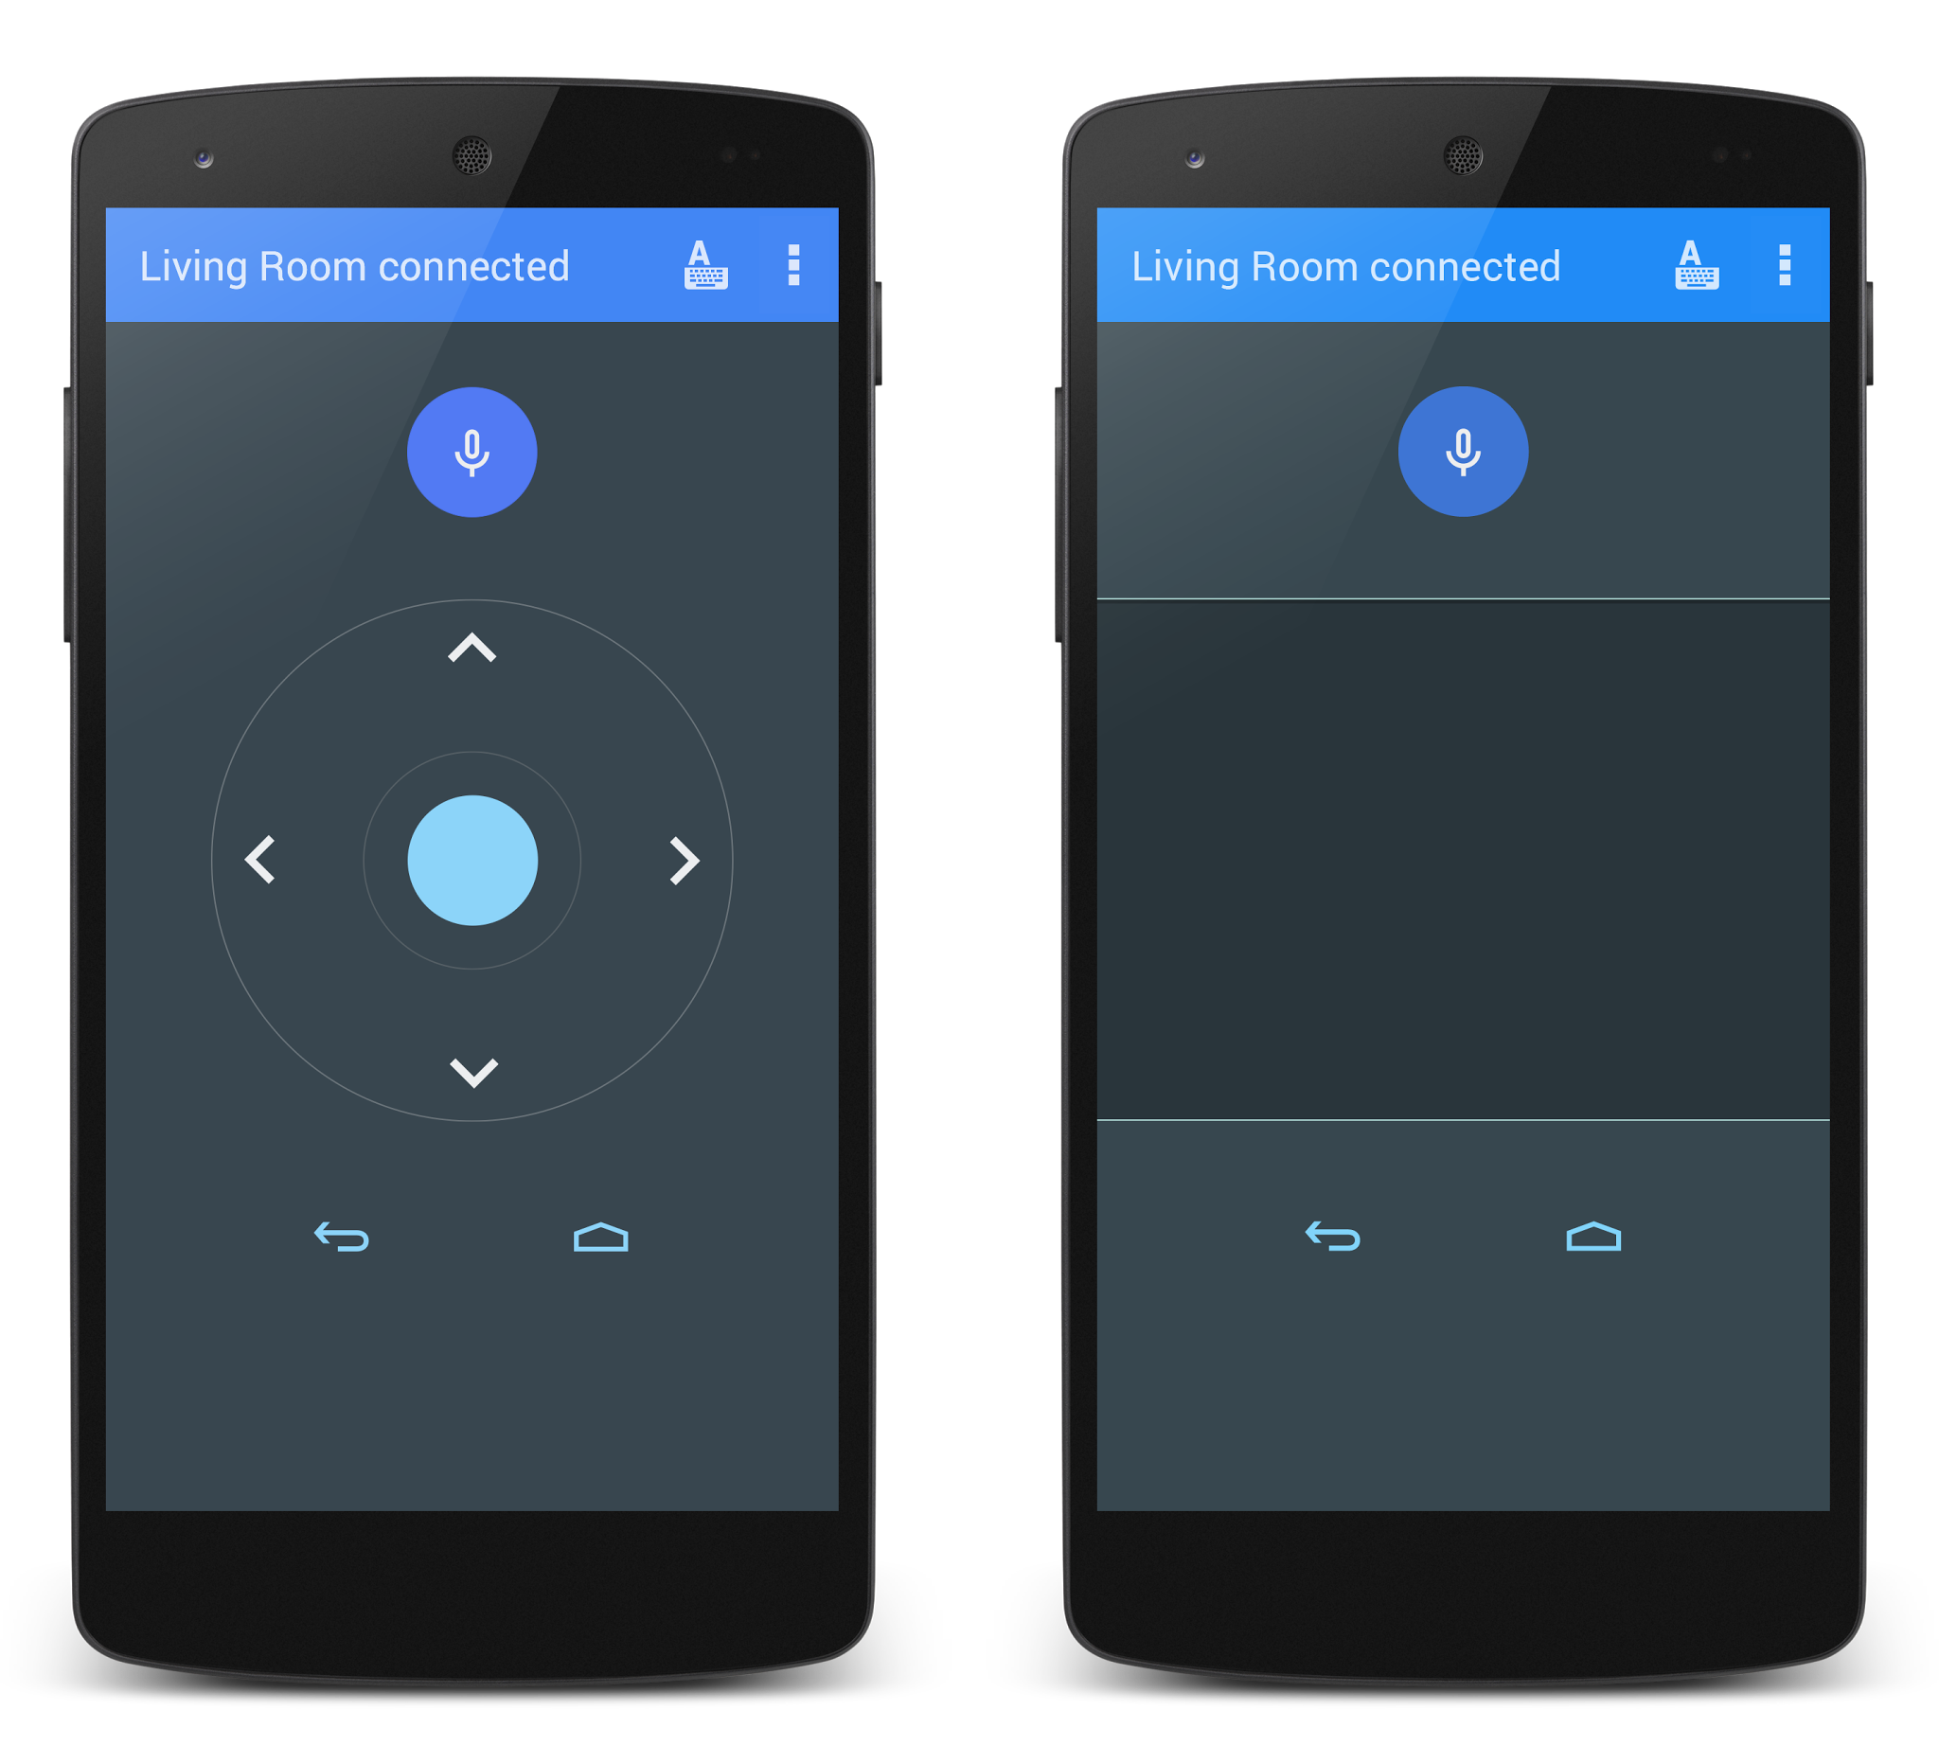
  + Smart window blinds. Use a slider to simulate opening and closing blinds on a window:



The items in the device list should be in order of most frequently used to least used. You must store the number of times each item was selected in a database. You should also store the last settings of the devices in the database (channel number, blinds position, etc.)

**Kitchen smart environment remote interface**

* Include an instruction window that the user can access from a menu on the navigation bar
* You should use fragments to show a ListView displays several items that you would find in a kitchen. Selecting one of these items should display detailed controls for the item. You must design this interface yourself:
  + Microwave: The use can enter the cooking time, reset the clock, stop the microwave, or start. You must enable/ disable the buttons as your interface transitions from entering the cooking time to starting to cook: disable reset and start buttons. The clock should actually count-down to 0, and then use the vibration motor to vibrate the phone to show that the microwave is done.
  + Fridge: The user should be able to see the current temperature of the fridge and freezer sections. The user should also be able to change the temperatures within certain limits (maybe a slider or spinner?).
  + Main light: should be on/off and dimmable.
* You should also have a button to add a new device to the room. Clicking the button should bring a dialog asking which of the 3 types of devices to add.
* Store the elements found in the room in a database, as well as their last knows settings. For example, create a table:

|  |  |  |
| --- | --- | --- |
| Type | Name | Setting |
| FRIDGE | Samsung Fridge | 5 oC |
| FREEZER | Samsung Freezer | -20 oC |
| LIGHT | Main Ceiling light | 60% |

**House settings**

* Include an instruction window that the user can access from a menu on the navigation bar.
* You should use fragments to show a ListView displays the settings of a house. Selecting one of these items should display detailed controls for the item. You must design this interface yourself:
  + Garage – allow the user to open / close the door, and turn on a light. Opening the garage door should also turn on the light automatically. The user should be able to turn the light on and off afterwards.
  + House temperature – the user should be able to view and set the house temperature. The user should also be able to create a schedule by adding time/temperature settings that should appear in a list.
  + Outside weather – use your work from the lab to display the current temperature outside.
* Save the schedule in a database and let the user add, remove, or update rules. For example:
  + 6:00 Temp -> 20
  + 9:00 Temp -> 16
  + 16:00 Temp -> 20
  + 22:00 Temp -> 18

**Automobile**

* Include an instruction window that the user can access from a menu on the navigation bar.
* You should use fragments to show a ListView displays the settings of a car. Selecting one of these items should display detailed controls for the item. You must design this interface yourself:
  + Temperature settings – allow the user to set the temperature in the front
  + Radio controls – include preset radio stations (6) that can be configured by the user. There should also be a volume control, and a mute button
  + GPS directions – This should launch the google navigation Intent
  + Lights – There should be a setting for turning on the headlights (normal, high), as well as a dimmable light inside the car.
  + The user should be able to save the settings for temperature, radio settings, and lights. Their settings
* Use a database to store all of the “drive” entries that the user has entered. The user should be able to view all previous entries in a list, but not modify or delete the entries. Also use the database to store the radio station presets, and the user should be able to add, remove, update stations presets.