CST2335 – Graphical Interface Programming

Lab 7

Introduction:

The goal of this lab is become familiar with Fragments. We will modify a layout so that it uses an activity with fragments instead.

References:

1. <https://developer.android.com/training/basics/fragments/index.html>
2. Chapter 4 in the Textbook, the second part is about Fragments

Steps:

1. From the command line, create a branch of your software from Lab 6. If you have a windows computer, open the “Git Bash” program. If you have an Apple or Linux computer, just open a terminal. On the command line, navigate to your AndroidStudioProjects folder, and then to your Labs folder. Once there, type “git branch” to list the branches on your computer. Now type “git branch Lab7” to create a new branch. Then type “git checkout Lab7” to move to that branch. Now type “git branch” to list all the branches, and there should be a star (*) next to Lab7 to show it is your current branch.
2. In the Android project view on the left side of Android Studio, right-click on your layout file for your chat window from Lab 4, and select “copy”. Make sure that AndroidStudio is using the “Project Files” view of your project so that you can see if there is a “layout-sw600dp” folder under the “res” folder. If there is not one, then create the folder. Paste your copy of the layout of the chat activity into that folder. From this new layout, add a “FrameLayout” to the RelativeLayout so that it is to the right of the existing ListView. You should change the ListView width to be 300dp instead of wrap_content. Align the right side of the Send button to the left side of the ListView. Then add the FrameLayout to the right of the ListView and SendButton:

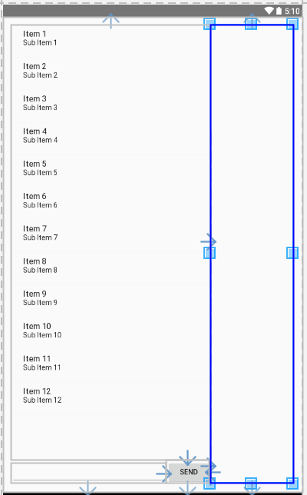

Figure 1 The tablet layout with a FrameLayout to the right of the chat messages list

1. Give the FrameLayout an id so that you can check to see if it has been loaded after setting the contentView in onCreate. Go to your ChatActivity.java file and add a boolean variable to check if the FrameLayout exists on the screen. You should check by calling findViewById with the id that you put in the layout. If it returns null, then it wasn’t loaded and you are using the phone layout. If it is not null, then it was loaded on the screen, and you are using the tablet layout, and the screen is at least 600 pixels wide.
2. Create a new EmptyActivity called MessageDetails, that only has a FrameLayout which uses the entire screen. Create another layout for your fragment, which should have a TextView to show a message, a TextView to show the id number, and a button at the bottom for “Delete this message”. This will be used for showing the Fragment on a phone.

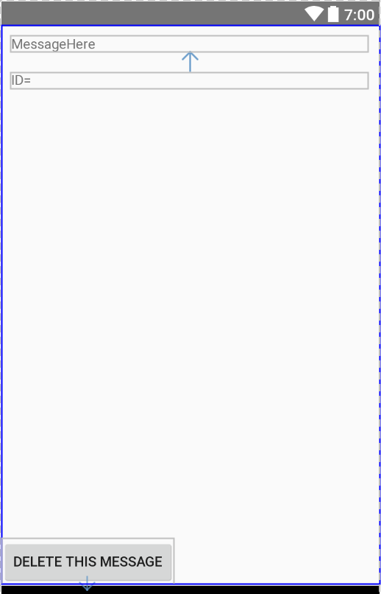

Figure 2 The layout for the Fragment object

1. Create a subclass of Fragment, called MessageFragment, which will be loaded into the empty FrameLayout of either the phone or tablet layouts. In the onCreateView function of the MessageFragment class, use the LayoutInflater to inflate the layout for the fragment from step 4.
2. Add an onItemClickListener to your ListView in the chat window. When the user clicks on a message, you should show the details of the message in a fragment. If you are running on a tablet, then start a FragmentTransaction to add a fragment to the FrameLayout. If you are running on a phone, then start your new activity from step 4. If you are on a tablet, use a Bundle to pass the message string, and the database id of the selected item to the fragment in the FragmentTransaction.
3. If you are on a phone, then send the bundle to the next activity using startActivityForResult(). In the onCreate function of the new activity, it should create a FragmentTransaction to add the Fragment to the empty FrameLayout, and pass the Bundle with the information about which message was clicked from the Intent, and pass it to the Fragment. Also add an onClickListener to the “Delete this message” button. If the button is clicked, then use the getActivity().setResult(int resultCode, Intent data) function to pass the id of the message to delete, and return a resultCode back to the ChatActivity to indicate that this message id should be deleted. Lastly, finish the Activity for displaying the message details. Remember, this is only for running on a phone.

 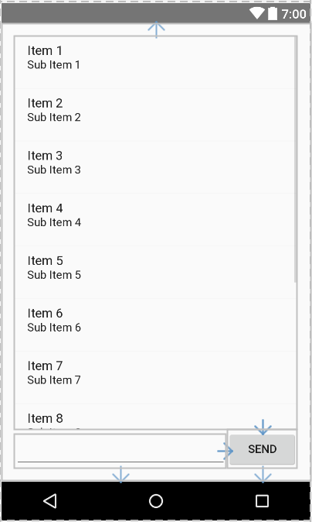

Figure 3 On a phone, clicking a message should launch a new Activity and reuse the Fragment.

1. Add an onActivityResult() function to the ChatActivity to test the resultCode so that if it’s the value set by pressing the delete button, then you should delete the message with the id passed back using the Intent, and then update the ListView. If this activity is running on a Tablet, then you can use a reference to the ChatActivity to call a function which will delete the message, and remove the Fragment using a FragmentTransaction. As a hint, create a constructor for your Fragment subclass which takes a ChatActivity object. If you are running on a Tablet, pass the ChatActivity object in the constructor. If you are running on a phone, then this Fragment will be constructed in the Activity from step 4, and you can pass null in the Fragment constructor so that the Fragment can know if it is running on a phone or tablet.

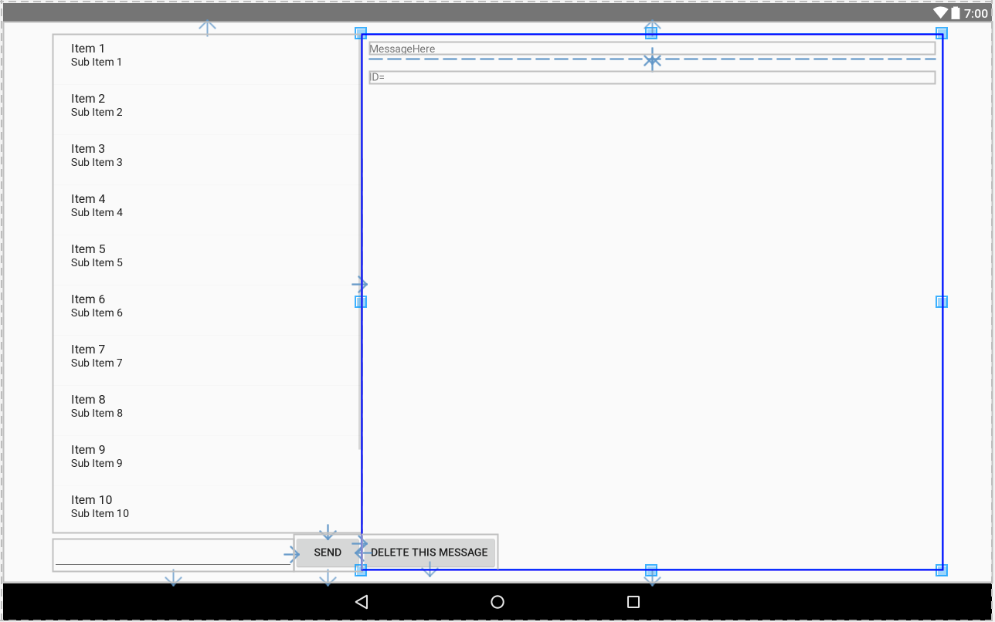

Figure 4 On a Tablet, the Activity should load the Fragment on the same screen.

1. There is a strange bug with the emulators where they don’t use the layout-w900dp if the device frame is enabled, and if there is a custom skin definition. You might have to create a new emulator with “No Skin”. Open the virtual device manager and select “Create Virtual Device”. Select Category: Tablet and then 10.1” WXGA Tablet. Next select Lollipop or newer Android version. On the next screen, click Show Advanced Settings and make sure “No Skin” is selected and then Finish.

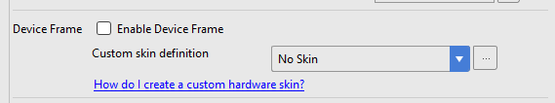

Demonstrate your work to the lab professor showing the following parts of your lab work: **5 marks**

* 1. Launch the application and navigate to the MessageListActivity. Show that your messages saved in the database still display like in the previous lab. **+1**
  2. Rotate the device 90 degrees in to landscape mode. When you select a message, you should see it text on the right of the ListView. **+1**
  3. Rotate the device back to portrait mode and select a message. It should launch a new activity instead of displaying the text to right of the ListView. **+1**
  4. Go to the MessageFragment layout and modify the TextView so that the gravity is set to right: android:gravity="right"
  5. Run your application again, and show that now selecting a message shows the message’s text, but now it’s on the right side of the text view. Show that it works in both landscape and portrait modes. **+1**
  6. Delete a message and it should be removed from the list **+1**

1. From the command line, commit your work with Git. From git bash, or your Apple/Linux terminal, type **git commit –m “Finished lab 7”**. This should commit your work to git. Next type **git push** to upload your work (either to local directory on your computer or your Github account).