**Replica Island**

Work Done(In brief)

For Increment 3, we made changes in the source code of Replica Island. There are four motions in the game: Flying, move left, move right, attack(stomp). We made necessary changes to the code so that the actions of the droid in the game depends on the sensor tag motion. We took four motions as training data, 8 times each. Now, it can detect if it’s fly or left or right or attack gesture.

Source Code Changes

Integrated the Sensor Tag data generation to the Replica Island project and to evaluate and detect if the accelerometer data from the ongoing gesture to perform the appropriate action in the game.

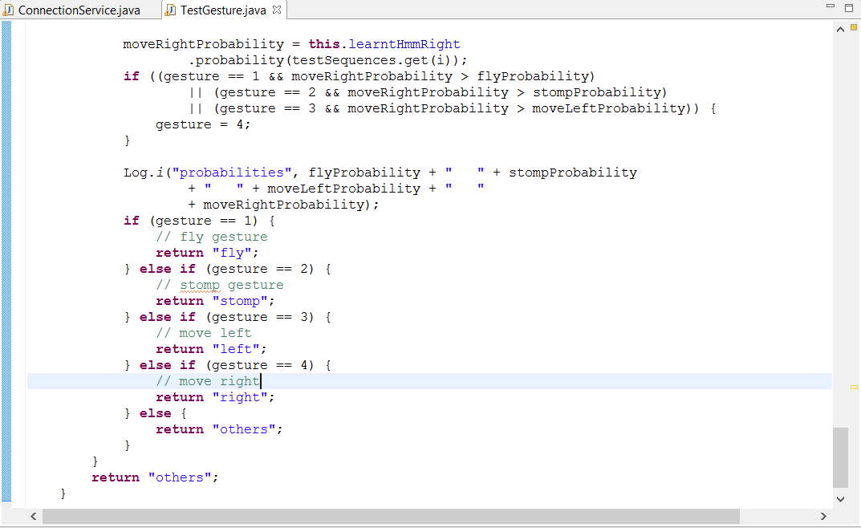

InputGameInterface.java -> update(float timeDelta, BaseObject parent)

In the original code, this function contains all the events for the different actions in the game.

Here we want to use the fly, left,write and stomp gestures to trigger the events.

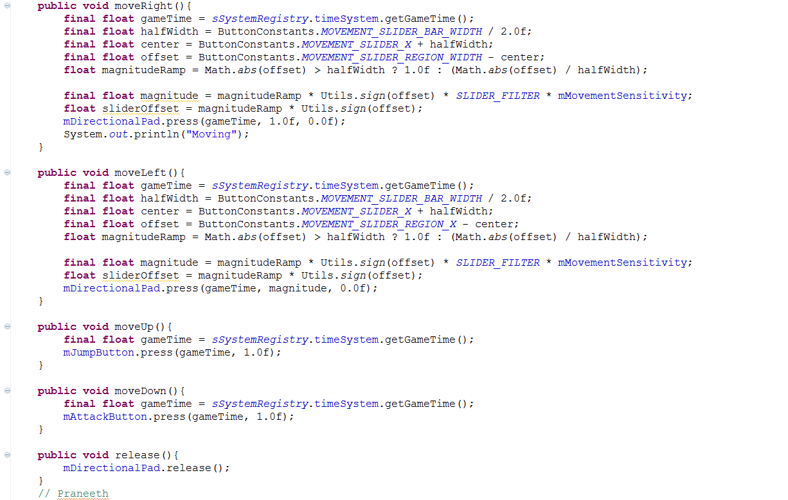

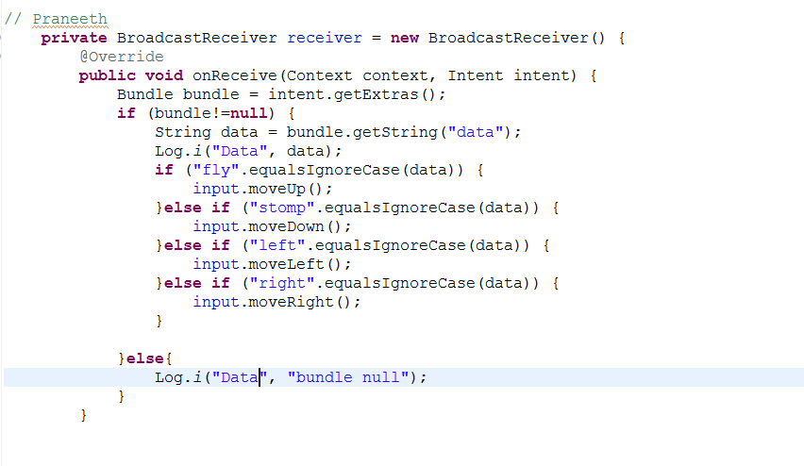

Activity Recognition & BigData Analytics:

For the third increment we also spent our time on activity recognition.HMM model was used to detect the different gestures.K means clustering is used to detect the activity. We start with k as 10 and if there is no error, k is 10, but if there’s an error the value of k is decreased and so on. We collected the data for four gestures using hand movements, trained the data for 8 times. We deployed the HMMWS war file into our local glassfish and converted the txt files into sequence files with the recognition of the start and end of every gesture.

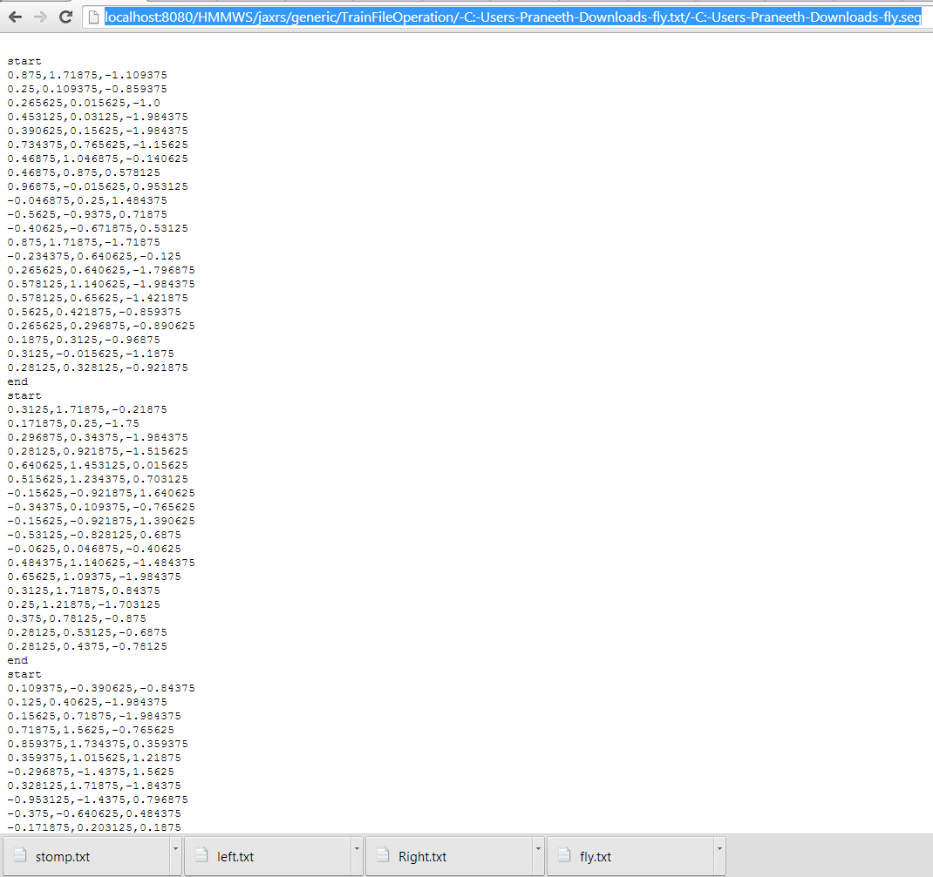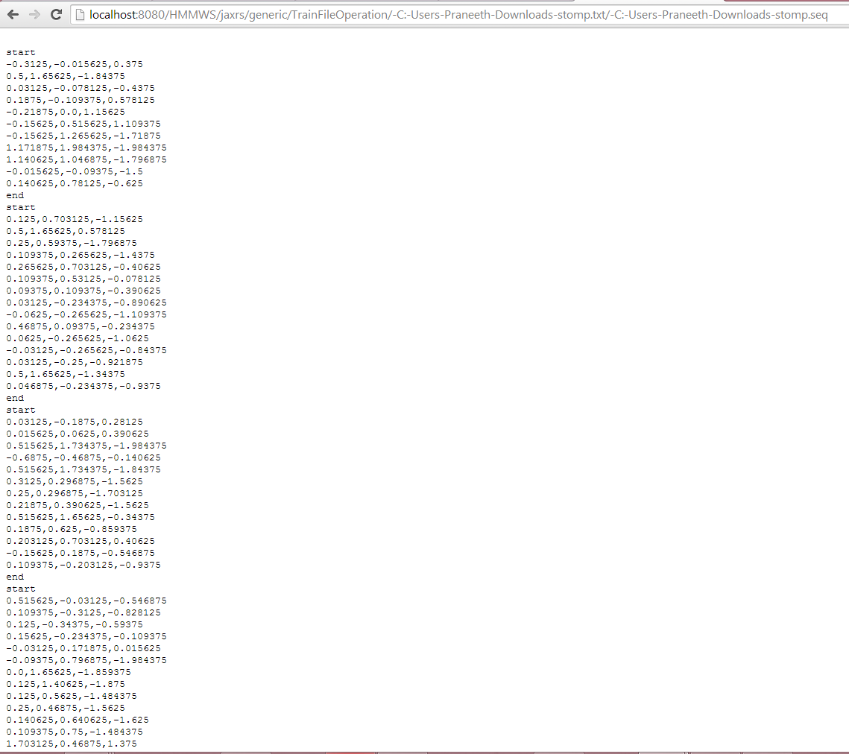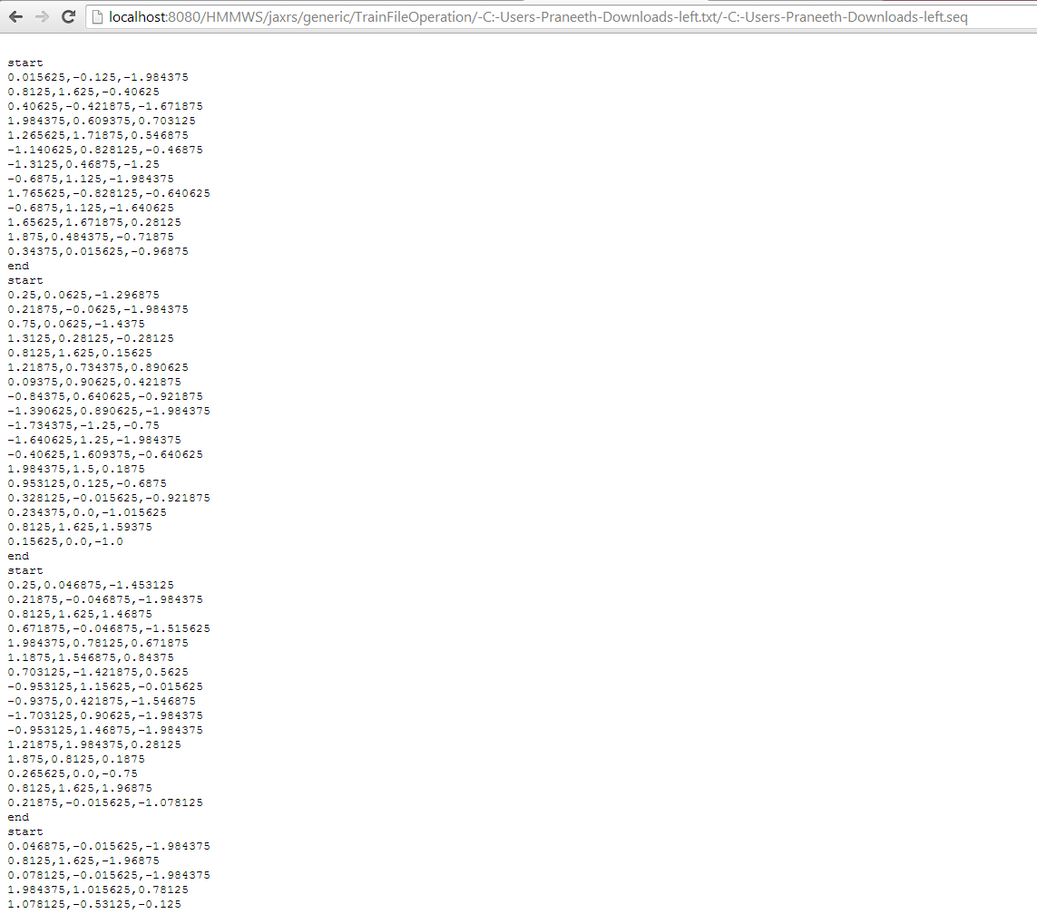

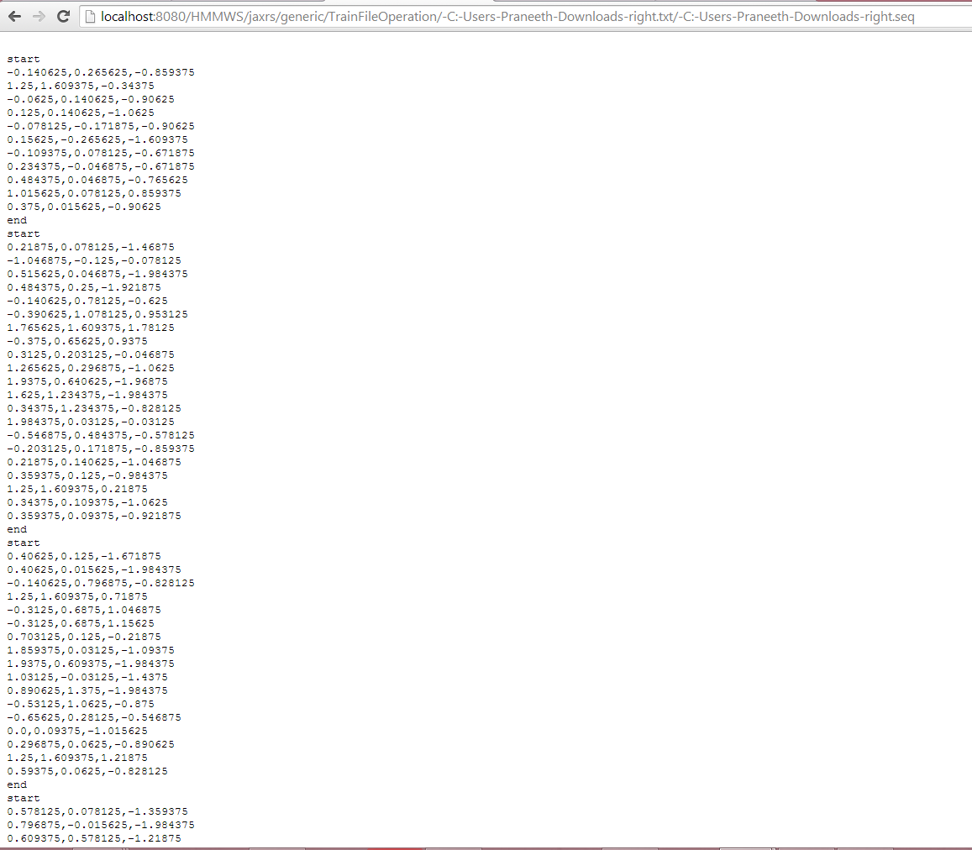

We generated a test file with all the gestures and when we applied the test sequence file on all the trained data sequence files, we got the desired output. Next step is integration of the live sensor data to detect the gesture and perform the appropriate action in the game.

To Do(Increment 5):

1. There is some problem with the modified code, the droid isn’t moving with the max magnitude when the gesture is performed, instead there is a very slow movement and breaks in the motion.

2. In the game the droid movement is continuous only on continued touch on the screen. However this is not possible by gestures. So, we modified the code in such a way that the droid motion is continuous for the corresponding gesture. To break the motion we have to implement another gesture.