Lab 2

Modified the code to get accelerometer, humidity and gyroscope values.

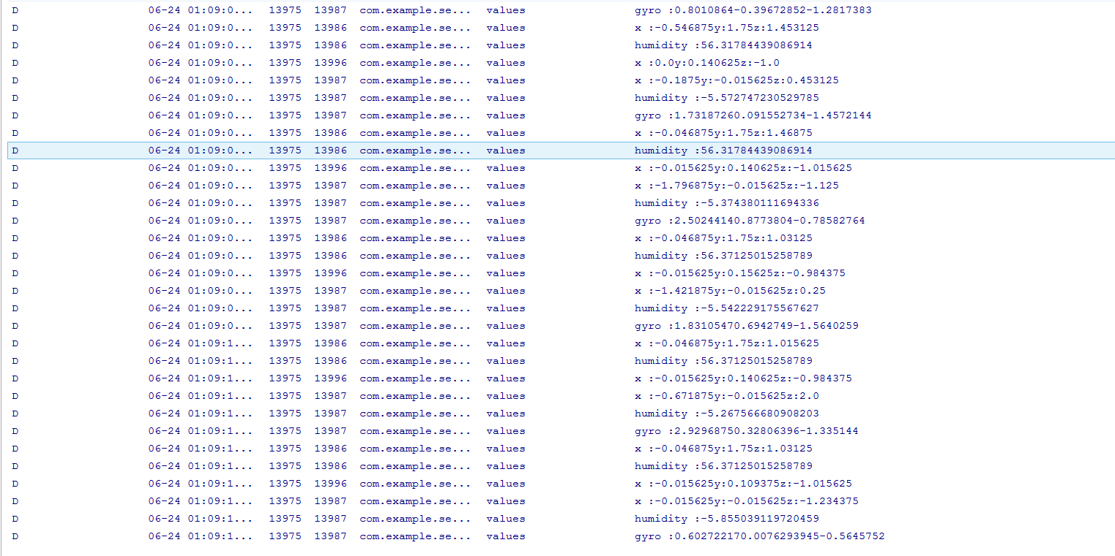

Snapshot of the txt file.

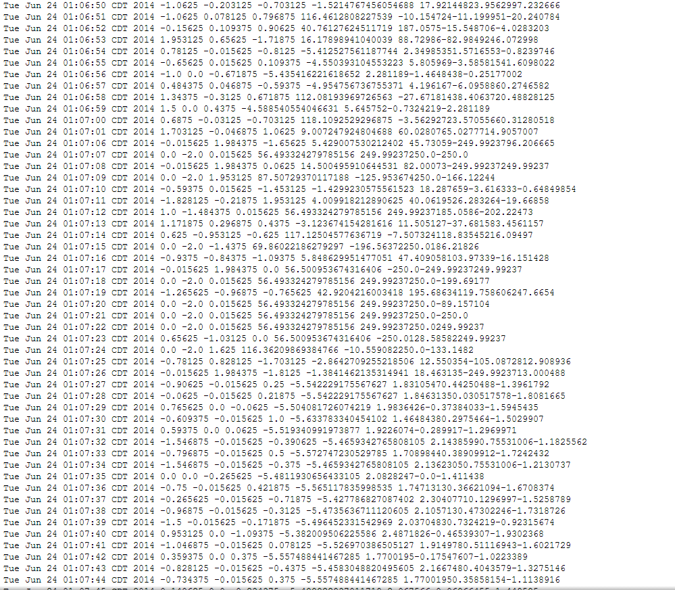

After I we get the values, it is time to create a table in Hbase.



Inserting data into the table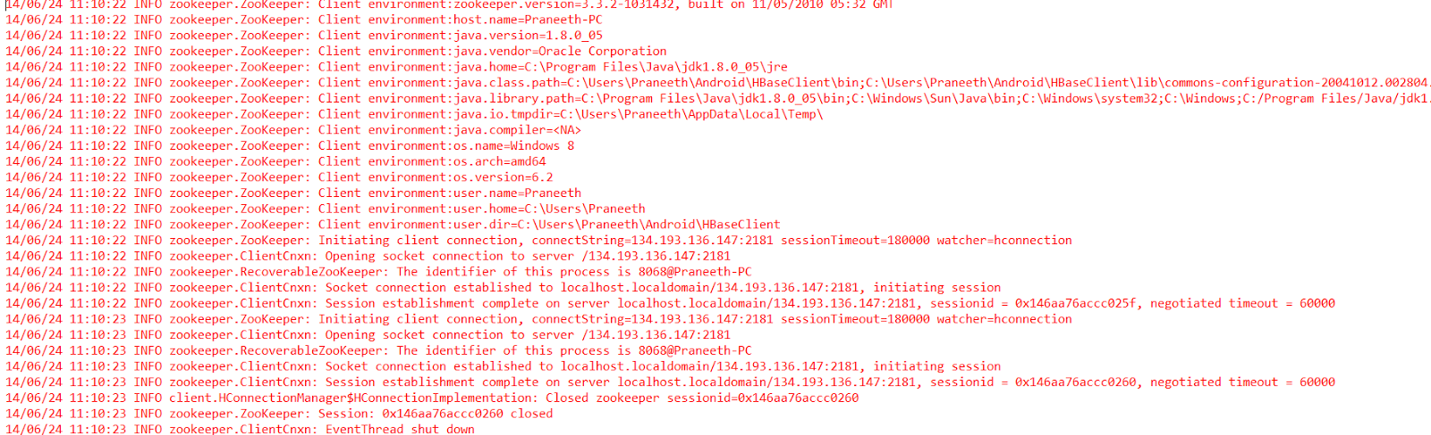

Retrieving data from the table.

