**Lab-3**

Task-1

Similar to what we’ve done in Lab-2, data (Accelerometer, Humidity, Gyroscope and time) is collected in the form of a text file.

“Sensortag.txt”

Task-2

Installed Glassfish successfuly.

Using the Web Services the file is transferred into cloudera.

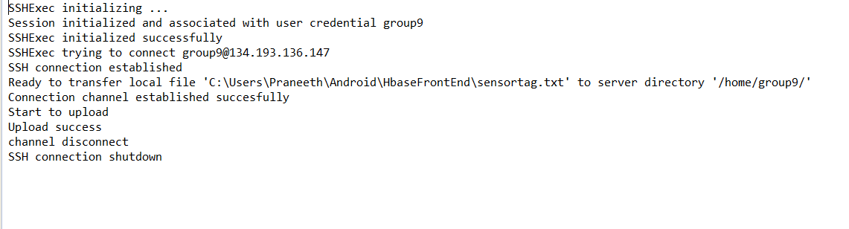

Task-3

Hbase CRUD operations using web services on an android device.

Successfully performed the operations. Source code is uploaded on Github.

