**LAB-4**

When the Retrieve button is clicked the data will be saved as a text file.

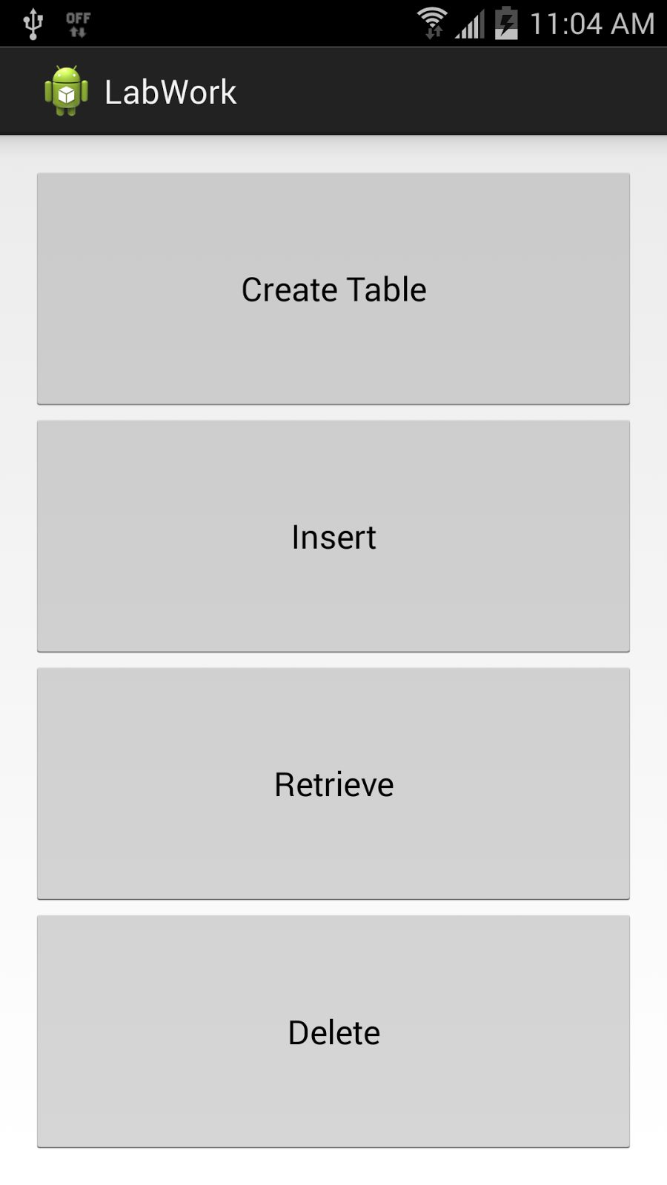

Generated the text files for three actions to train (Punch, right to left and left to right) and a combination of the three in one text file.

Pushed these files into group9 folder in cloudera using WinSCP.

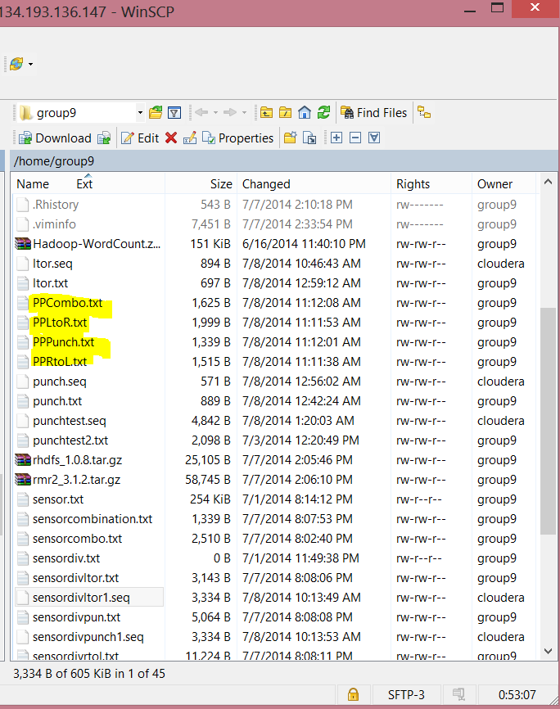

To generate sequence files..

<http://134.193.136.147:8080/HMMWS/jaxrs/generic/TrainFileOperation/-home-group9-PPPunch.txt/-home-group9-PPPunch.seq/>

[http://134.193.136.147:8080/HMMWS/jaxrs/generic/TrainFileOperation/-home-group9-PPRtoL.txt/-home-group9-PPRtoL.seq/](http://134.193.136.147:8080/HMMWS/jaxrs/generic/TrainFileOperation/-home-group9-PPPunch.txt/-home-group9-PPPunch.seq/)

[http://134.193.136.147:8080/HMMWS/jaxrs/generic/TrainFileOperation/-home-group9-PPLtoR.txt/-home-group9-PPLtoR.seq/](http://134.193.136.147:8080/HMMWS/jaxrs/generic/TrainFileOperation/-home-group9-PPPunch.txt/-home-group9-PPPunch.seq/)

[http://134.193.136.147:8080/HMMWS/jaxrs/generic/TrainFileOperation/-home-group9-PPCombo.txt/-home-group9-PPCombo.seq/](http://134.193.136.147:8080/HMMWS/jaxrs/generic/TrainFileOperation/-home-group9-PPPunch.txt/-home-group9-PPPunch.seq/)

The server is down all the time I tried. I always got the error “No Data Recieved”

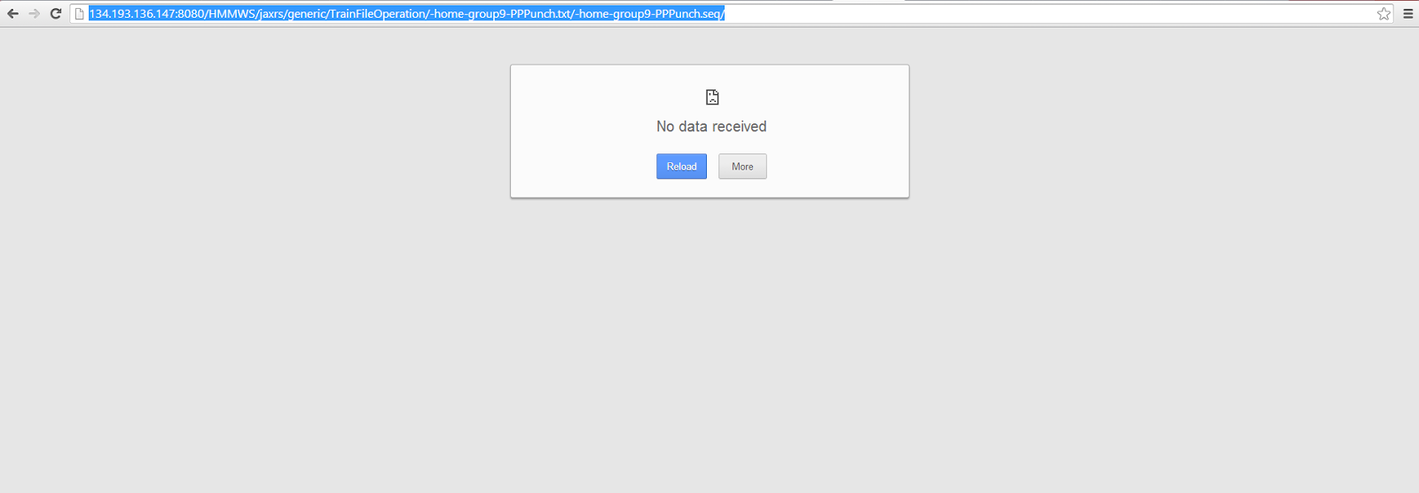

For testing and recognition

[http://134.193.136.147:8080/HMMWS2/jaxrs/generic/HMMTrainingTest/-home-group9-PPPunch.seq:-home-group9-PPRtoL.seq:-home-group9-PPLtoR.seq/punch:ltor:rtol/-home-group9-PPCombo.seq](http://134.193.136.147:8080/HMMWS2/jaxrs/generic/HMMTrainingTest/-home-cloudera-punchtrain.seq:-home-cloudera-rtoltrain.seq:-home-cloudera-ltortrain.seq/punch:ltor:rtol/-home-cloudera-Combination.seq)